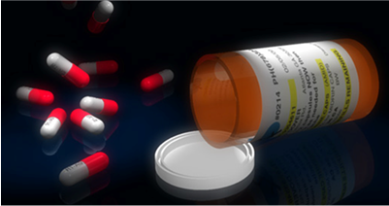
Presented To:
Professor Dick Barr
Mike Bordelon, Achieve Healthcare

Presented By:
Kristin March
Laura Bailey
Rachel Potter
Allison Bass

“Helping you today—with a clear vision of tomorrow.”
Team Achieve
Final Report
May 11, 2006

TABLE OF CONTENTS

BACKGROUND 3
OBJECTIVES 4
SCOPE 7
SUCCESS CRITERIA 8
KEY PEOPLE 9
OVERVIEW OF APPROACH 10
MODEL SOLUTION 11
STATUS REPORT APRIL 4, 2006 20
STATUS REPORT APRIL 11, 2006 21
STATUS REPORT APRIL 18, 2006 23
STATUS REPORT APRIL 25, 2006 25
STATUS REPORT MAY 2, 2006 26

BACKGROUND

Achieve Healthcare Technologies is the largest privately held provider of information system products and services to the long-term care industry. They serve clients across the U.S. and have long stood for higher quality and improved bottom lines for sub-acute long-term care, skilled nursing, assisted living, and continuing care retirement facilities and communities. Additionally, they have consistently led the industry in introducing new, innovative products and services.

Achieve provides any facility, no matter size or number, with the services needed to run successful organizations. One such service Achieve provides to all facilities is the Achieve Matrix system. The Achieve Matrix system is a revolutionary IT solution that allows any complex long-term care facility to effectively manage the resident, clinical, and business sides of operations - all via a Web-based platform. Some advantages of the Achieve Matrix system are:

- It is the only Web-based solution designed for large long-term care enterprises

- Aids in event management

- Computerizes a physician's order entry

- Provides an electronic health record

- Fully-integrated financial management system

- Easy Internet browser interface

However, along with the system advantages come some disadvantages. The Matrix system is used in conjunction with an oral solid dispensing machine. This machine contains prescription drugs approved by various health insurance plans. Achieve Healthcare is having an issue deciding which prescription drugs to put into each machine. Achieve Healthcare approached our team with the following problem of creating a general integer programming model of which drugs and how much of each drug should be put into the oral solid dispensing machines.

Easy Internet browser interface

OBJECTIVES

Achieve Healthcare Technologies is innovating a revolutionary oral solid dispensing machine that hopes to replace traditional methods of prescribing and administering medications to residents of long-term care facilities. The oral solid dispensing machine is revolutionary in that it uses a web-based interface to electronically integrate all aspects of the medication ordering process. The process is as follows:
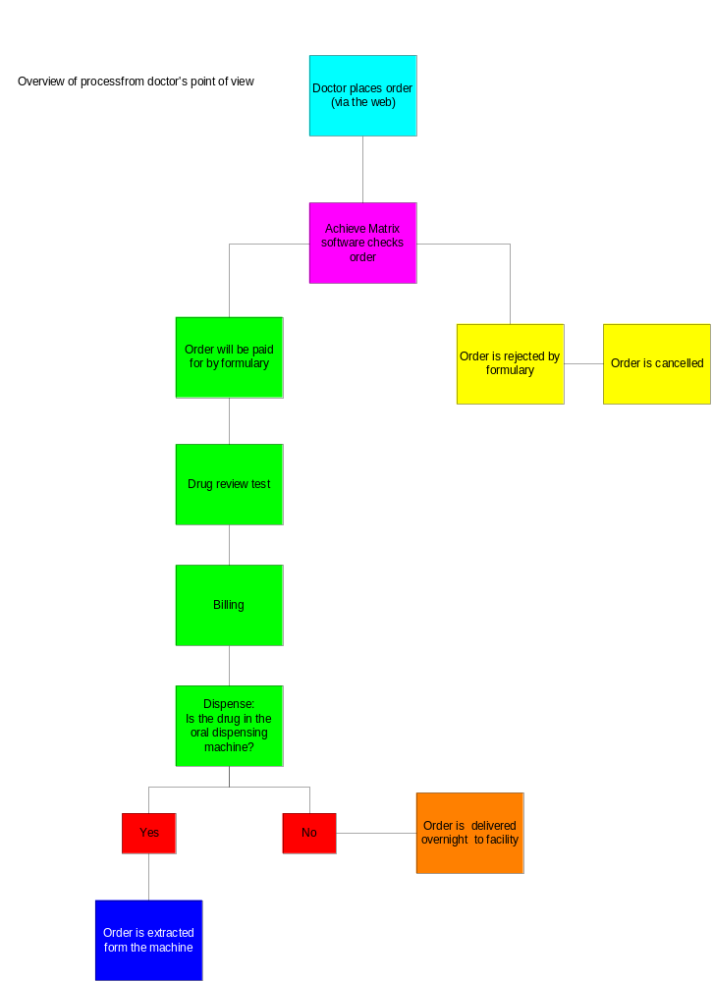
Previously, drugs were being slotting into the machine using no particular method. It is our goal that by examining and analyzing previous data trends and patterns, that we will reach an optimal recipe for filling the machine. Currently, Achieve Healthcare Technologies has a machine, much like a vending machine, that contains 240 slots for different prescriptive drugs. Some of these container slots are normally left empty in case a prescription needs to be slotted urgently. Like indicated earlier, the machine is not being filled to optimality because a model does not exist to determine the most effective filling methods. In the past, the facilities have not taken into account drug ordering habits, facility, drug name, drug form, drug availability, drug dosage (strength), number of pills per day, and drug formulary. Therefore, our team seeks to find an optimal solution that will maximize the machine space thus leading to a more efficient way of business.

Given these issues, Team Achieve has been given the challenge of creating a general integer programming model of which drugs and how much of each drug should be put into the oral solid dispensing machines. Upon delivery of this model, Achieve Healthcare should be able to find the optimal inventory for these machines. Although it sounds relatively easy to solve this problem (fill machine with the most used/popular drugs), we were faced with variables and boundaries that must be factored in while seeking an optimal solution.

The following variables were discussed:

- Replacing generic drugs with a brand name drug
  - This would cultivate cost efficiency and ordering efficiency
  - This would shrink the list of drugs available for a slot in the machine
  - We were unable to incorporate this component into the solution. In order for this to be taken into account, the brand name drugs and their substitutes must be provided by the client
- Taking the dosage of the drug into account
  - A certain drug could be distributed in the machine in multiple sizes by milligram amount
  - If one amount was out in the machine, the software could recommend the same drug in a different amount (but in an equivalent quantity) in order to fill a prescription (i.e. 20 mg of Tylenol = 2x10 mg of Tylenol)
  - This variable was unable to be applied to our model. Perhaps future models could incorporate this aspect
- Creating a generic model for all facilities
  - Since every facility is different, our team instead created a generic model for a specific facility
  - Each facility will need past ordering habits and drug history examined before an optimal solution is reached for that particular facility
- Ordering Costs
  - The ordering costs were assumed
  - If the client can provide more exact costs, then a more optimal solution could be possible
- Holding Costs
  - The holding costs were assumed
    - Does the client want to hold a drug at all? If not, then just order the drug every day and only allow for one slot for each drug. However, this would mean ordering costs would increase and may not be optimal. Why not hold a drug that is used most often?
  - If the client can provide more exact costs, then a more optimal solution could be possible
- Pills per canister
  - In knowing the number of pills per canister, our team would be able to perform a more accurate simulation and thus possibly create a more optimal solution
  - This number was assumed in order to determine the reordering point

Our objective was achieved through carrying out an Inventory order simulation by means of an interactive model. By looking at previous data, we forecasted the drug ordering habits to determine which drugs should go in which slots. The simulation integrated cost analysis and inventory depletion in order to create the solution. In addition, we created reports that the user could read and determine exactly how to fill the oral solid dispensing machine.

SCOPE

Although we are creating a generic interactive excel-based user model to be applied on any specific healthcare facility, we will be using data from a single facility’s previous day drug dispensing history to help create the model that can be applied. Additionally, we will simulate the data up to 200 days based on zero variability in the data as specified by the Achieve Healthcare Technologies. For more information on the assumptions made, see the Assumptions section of the report. We will not be coding in SQL to add to the matrix software, but will simply be creating a model to aid in generating the solution via Excel. Our focus will be specifically on the oral solid dispensing machine and will not encompass liquid drugs, injectables, and some ointments. We will place preference on generic drugs rather than brand name ones where applicable in an effort to streamline business operations. In addition, we will not include those drugs that are not covered by formularies. Furthermore, we will limit our scope to only the oral solid dispensing machine problem and its solution while bypassing problems unrelated to the machine.

In addition to the scope discussed above, we will not be able to incorporate all of the variables requested by the client into our model. We will not be able to factor in generic drugs vs. brand name drugs nor will we base our decisions according to the milligram amount of the pill.

SUCCESS CRITERIA

The success of Team Achieve will be measured by the following:
- Meeting with Team Achieve 2-3 times per week
  - Individual and team effort outside of class
- Completion of timely reports (i.e. weekly status reports)
- Effectively communicating status and arising problems with professor and client
  - Proactive behavior from team members
  - Drive and dedication to the project
- Seeking help when obstacles arise
- Creation of a model that produces optimal solution for a 240 slot oral drug dispensing machine
  - Organization of data
  - Simulation of previous facility drug ordering habit history
- Model finished in entirety by May 2st, 2006
  - Presentation on May 11, 2006
  - Report completed by May 11, 2006

KEY PEOPLE

- Team Achieve - Allison Bass
- Team Achieve - Rachel Potter
- Team Achieve - Laura Bailey
- Team Achieve - Kristin March
- Achieve Healthcare Technologies – Michael Bordelon
- Southern Methodist University – Dr. Barr
- Achieve Healthcare Technologies – Other representatives

OVERVIEW OF APPROACH

Work Breakdown Structure
  - Gather and analyze data
    - Activity: meet with group on a weekly basis
      - Task: create meeting schedule based on client’s needs
      - Task: communicate effectively in order to be time efficient
    - Activity: educate ourselves on the company history and necessary technical aspects
      - Task: learn Achieve Matrix software as required
      - Task: meet with Jason about technical solution and understanding
      - Task: familiarize ourselves with SQL in order to retrieve data
  - Create generic model
    - Activity: define our constraints
      - Task: incorporate data analysis into plan
      - Task: confirm with client that we have identified all constraints
    - Activity: define our variables
      - Task: incorporate data analysis into plan
      - Task: confirm with client that we have identified all variables
    - Activity: identify objective function
    - Activity: maximize the machine dispensing efficiency using an IP model formulation
      - Task: confirm feasibility
  - Test model with example facility data
    - Activity: Clean individual data to be ready for use
      - Task: confirm with client that cases are relevant
    - Activity: format to specification of the model
      - Task: identify model specifications
    - Activity: test
      - Task: run IP
      - Task: report metrics
  - Present model to clientele
    - Activity: confirm achievement of success requirements
      - Task: concluding meeting with client
      - Task: report metrics
    - Activity: create presentation
      - Task: invite client to presentation
      - Task: demonstrate achievement of success requirements

MODEL SOLUTION

BACKGROUND

Team Achieve’s goal was to create a generic model to be used on any specific healthcare facility, using data from a single facility's previous day drug dispensing history to help create the model that can be applied. Our focus was specifically on the oral solid dispensing machine and did not encompass liquid drugs, injectable, and some ointments.

Initially we created a binary knapsack model (see below). It was discovered that the model needed to be simulated using additional days information. However, Achieve Healthcare was unable to provide this information and advised us to use the same day’s information across multiple days for simulation purposes. They informed us that most facility data has zero variability and the information wouldn’t be as necessarily when developing the model.

We then created an excel model that simulated information; grouping by the most dispensed drugs. However the model did not i) take into consideration different milligrams of the same drugs and ii) replacing brand name with generics. A better model had to be found. Please see approach below.

Binary Knapsack Model

index for different types of drugs, 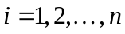
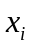 binary variable to determine either to vend (1) or not to vend (0) drug
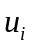 the utility (# of pills dispensed per day)
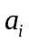 the number of canisters per day per drug: the utility divided the availability (# of pills available in each canister – assume 200 for all canisters), rounded up
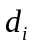 the number of pills per canister of drug

Maximize the number of dispensable drugs (over time):

max 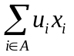

s.t. 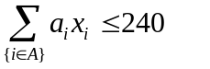

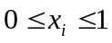 , and integer

Example:
Drug |  | (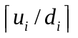)
Abilify 10 mg | 16 | .08 to 1
Accolate 20 mg | 10 | .05 to 1
Acebutolol 200 mg | 1 | .005 to 1
Aceon 2mg | 2 | .01 to 1
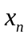 | 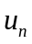 | 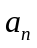

Formulation:

max 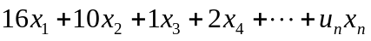

s.t. 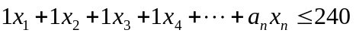

, and integer

APPROACH

As a result of finding the issues found in the initial model, Team Achieve created an excel model that is user interactive and allows for actual data to be replaced with assumed data. The Functionality and Process sections below provide a detailed overview of this model. An Example Solution concludes this section.

ASSUMPTIONS

Achieve Healthcare was unable to provide Team Achieve with the certain and therefore, the following assumptions were made.
- Pills per canister as 200.
    - Drugs are typically defined as small, medium and large. However, a defined list of each category associated to each drug was not provided.
- Cost per unit per pill.
    - This becomes important when determining which drugs should be slotted. More expensive drugs may take precedence over less expensive drugs, or vise versa. As a result, it may be more cost effective to slot drugs according to price.
- Cost to order and ship a canister
- Holding cost per pill per day.
    - This will be important when deciding who holds inventory and what the cost-benefit of holding this inventory to the healthcare facility and to Achieve Healthcare.
- Number of days to simulate per calculations was assumed to be a maximum of 200 days.
- Clean data must be entered into the model in the following format:
    - Single facility data
    - Headers of columns: Drug Name, Strength, Measure, # of Pills Per Day, # of Canisters, Units(pills) per Canister, Cost per Unit (pills)
    - No duplicate entries of the same drug with the same strength – each drug must be totaled.
    - Maximum of 600 different drugs can be entered.
    - Strength must be in mg or g.
    - Data must be sorted by # of Pills Per Day (ascending) and Cost/unit (descending).

DATA GIVEN

Team Achieve was given data for 73 facilities for analysis which included the following information:
- Facility ID
- Drug
- Strength
- Measure
- Number of pills consumed per day

FUNCTIONALITY

The model performs the following functions:
- Allows customer to import clean data for a single facility
- Allows customer to input the following data:
  - Cost to order and ship a canister
  - Holding cost, per pill per day
  - Number of canister slots per machine
  - Maximum # of identical canister slots to allow in each machine
  - Number of days to simulate for calculations (with a maximum of 200 days)
- Simulates data and provides output of i) average number of pills on hand and ii) # of orders (reorder point to have of each drug).
- Creates a cost report providing holding costs and ordering costs.
- Lists slot loading requirements for the oral solid dispensing machine.
- Provides the orders to be placed per drug
PROCESSES

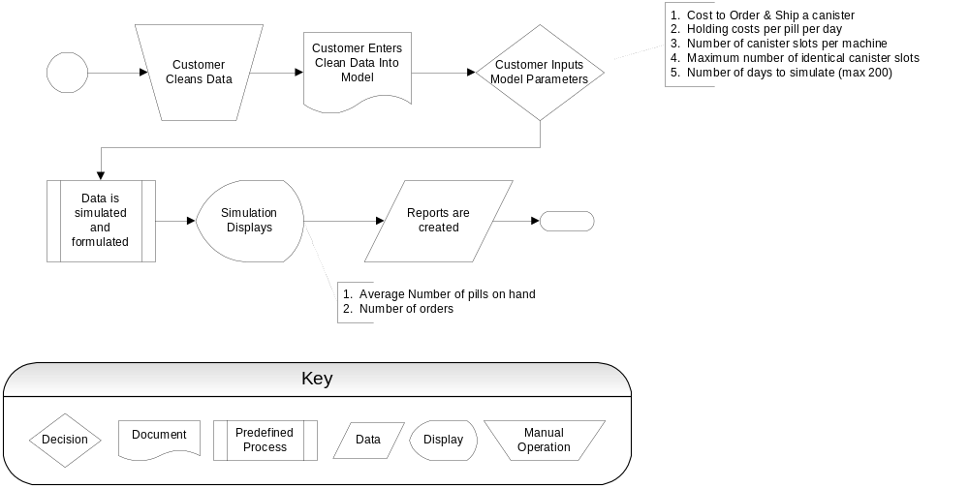

EXAMPLE SOLUTION
Note: The below example uses data for only 21 drugs.

Worksheet 1: Raw Data Input

Raw Data
Drug | Strength | Measure | # PillsPerDay | # of Canisters | Unit/cannister | Cost/unit (per pill)
Acetaminophen | 500.00 | mg | 138 | 2 | 200 | $0.51
Acetaminophen | 325.00 | mg | 84 | 2 | 200 | $0.52
Lorazepam | 0.50 | mg | 25 | 2 | 200 | $0.53
Colace | 100.00 | mg | 23 | 2 | 200 | $0.54
Pepcid | 20.00 | mg | 17 | 2 | 200 | $0.55
Namenda | 10.00 | mg | 14 | 2 | 200 | $0.56
Tramadol | 50.00 | mg | 13 | 2 | 200 | $0.58
Furosemide | 40.00 | mg | 13 | 2 | 200 | $0.57
Acetaminophen | 500.00 | mg | 12 | 2 | 200 | $0.63
Acetaminophen | 500.00 | mg | 12 | 2 | 200 | $0.62
Acetaminophen | 500.00 | mg | 12 | 2 | 200 | $0.61
Loperamide | 2.00 | mg | 12 | 2 | 200 | $0.60
Lexapro | 10.00 | mg | 12 | 2 | 200 | $0.59
Aricept | 10.00 | mg | 11 | 2 | 200 | $0.64
Propoxyphene N-Acetaminophen | 650.00 | mg | 10 | 2 | 200 | $0.70
Hydrocodone-Acetaminophen | 5.00 | mg | 10 | 2 | 200 | $0.69
Calcium Carbonate | 500.00 | mg | 10 | 2 | 200 | $0.68
Acetaminophen | 500.00 | mg | 10 | 2 | 200 | $0.67
Loperamide | 2.00 | mg | 10 | 2 | 200 | $0.66
Alprazolam | 0.25 | mg | 10 | 2 | 200 | $0.65
Acetaminophen | 650.00 | mg | 8 | 2 | 200 | $0.75

Worksheet 2: Customer Input Data

User Input Parameters
$ 15.00 | Cost to order and ship a canister
$ 0.0100 | Holding cost, per pill per day
240 | Number of canister slots per machine
3 | Maximum # of identical canister slots
17 | Number of days to simulate for calculations--Max 365 days

Worksheet 3: Simulation

Simulation
Ending inventory level, by day
Drug | Strength | Unit/  canister | # Pills  PerDay | # of Canisters | 1 | 2 | 3 | 4 | 5 | 6 | 7 | 8 | 9 | 10 | Average On Hand | # orders
Acetaminophen | 500.00 | 200 | 138 | 2 | 262 | 324 | 186 | 248 | 310 | 172 | 234 | 296 | 158 | 220 | 241.00 | 6
Acetaminophen | 325.00 | 200 | 84 | 2 | 316 | 178 | 240 | 302 | 164 | 226 | 288 | 150 | 212 | 274 | 235.00 | 6
Lorazepam | 0.50 | 200 | 25 | 2 | 375 | 237 | 299 | 161 | 223 | 285 | 147 | 209 | 271 | 333 | 254.00 | 6
Colace | 100.00 | 200 | 23 | 2 | 377 | 239 | 301 | 163 | 225 | 287 | 149 | 211 | 273 | 335 | 256.00 | 6
Pepcid | 20.00 | 200 | 17 | 2 | 383 | 245 | 307 | 169 | 231 | 293 | 155 | 217 | 279 | 141 | 242.00 | 5
Namenda | 10.00 | 200 | 14 | 2 | 386 | 248 | 310 | 172 | 234 | 296 | 158 | 220 | 282 | 144 | 245.00 | 5
Tramadol | 50.00 | 200 | 13 | 2 | 387 | 249 | 311 | 173 | 235 | 297 | 159 | 221 | 283 | 145 | 246.00 | 5
Furosemide | 40.00 | 200 | 13 | 2 | 387 | 249 | 311 | 173 | 235 | 297 | 159 | 221 | 283 | 145 | 246.00 | 5
Acetaminophen | 500.00 | 200 | 12 | 2 | 388 | 250 | 312 | 174 | 236 | 298 | 160 | 222 | 284 | 146 | 247.00 | 5
Acetaminophen | 500.00 | 200 | 12 | 2 | 388 | 250 | 312 | 174 | 236 | 298 | 160 | 222 | 284 | 146 | 247.00 | 5
Acetaminophen | 500.00 | 200 | 12 | 2 | 388 | 250 | 312 | 174 | 236 | 298 | 160 | 222 | 284 | 146 | 247.00 | 5
Loperamide | 2.00 | 200 | 12 | 2 | 388 | 250 | 312 | 174 | 236 | 298 | 160 | 222 | 284 | 146 | 247.00 | 5
Lexapro | 10.00 | 200 | 12 | 2 | 388 | 250 | 312 | 174 | 236 | 298 | 160 | 222 | 284 | 146 | 247.00 | 5
Aricept | 10.00 | 200 | 11 | 2 | 389 | 251 | 313 | 175 | 237 | 299 | 161 | 223 | 285 | 147 | 248.00 | 5
Propoxyphene N-Acetaminophen | 650.00 | 200 | 10 | 2 | 390 | 252 | 314 | 176 | 238 | 300 | 162 | 224 | 286 | 148 | 249.00 | 5
Hydrocodone-Acetaminophen | 5.00 | 200 | 10 | 2 | 390 | 252 | 314 | 176 | 238 | 300 | 162 | 224 | 286 | 148 | 249.00 | 5
Calcium Carbonate | 500.00 | 200 | 10 | 2 | 390 | 252 | 314 | 176 | 238 | 300 | 162 | 224 | 286 | 148 | 249.00 | 5
Acetaminophen | 500.00 | 200 | 10 | 2 | 390 | 252 | 314 | 176 | 238 | 300 | 162 | 224 | 286 | 148 | 249.00 | 5
Loperamide | 2.00 | 200 | 10 | 2 | 390 | 252 | 314 | 176 | 238 | 300 | 162 | 224 | 286 | 148 | 249.00 | 5
Alprazolam | 0.25 | 200 | 10 | 2 | 390 | 252 | 314 | 176 | 238 | 300 | 162 | 224 | 286 | 148 | 249.00 | 5
Acetaminophen | 650.00 | 200 | 8 | 2 | 392 | 254 | 316 | 178 | 240 | 302 | 164 | 226 | 288 | 150 | 251.00 | 5

Worksheet 4: Reports

Cost Summary
Holding costs | $51.93
Ordering costs | $1,635.00
Total costs | $ 1,686.93
# Pills Dispensed: | 4,660

Worksheet 5: Slot Loading

Optimized Slot Assignment
Slot | Contents | Strength | # Pills  Per Day
1 | Acetaminophen | 500 | 138
2 | Acetaminophen | 325 | 84
3 | Lorazepam | 0.5 | 25
4 | Colace | 100 | 23
5 | Pepcid | 20 | 17
6 | Namenda | 10 | 14
7 | Tramadol | 50 | 13
8 | Furosemide | 40 | 13
9 | Acetaminophen | 500 | 12
10 | Acetaminophen | 500 | 12
11 | Acetaminophen | 500 | 12
12 | Loperamide | 2 | 12
13 | Lexapro | 10 | 12
14 | Aricept | 10 | 11
15 | Propoxyphene N-Acetaminophen | 650 | 10
16 | Hydrocodone-Acetaminophen | 5 | 10
17 | Calcium Carbonate | 500 | 10
18 | Acetaminophen | 500 | 10
19 | Loperamide | 2 | 10
20 | Alprazolam | 0.25 | 10
21 | Acetaminophen | 650 | 8

Worksheet 6: Orders Placed

Orders Placed
 |  |  |  | Days
Drug | Strength |  |  | 2 | 3 | 4 | 5 | 6 | 7 | 8 | 9 | 10 | Orders placed
Acetaminophen | 500 |  |  | 1 | 0 | 1 | 1 | 0 | 1 | 1 | 0 | 1 | 6.000
Acetaminophen | 325 |  |  | 0 | 1 | 1 | 0 | 1 | 1 | 0 | 1 | 1 | 6.000
Lorazepam | 0.5 |  |  | 0 | 1 | 0 | 1 | 1 | 0 | 1 | 1 | 1 | 6.000
Colace | 100 |  |  | 0 | 1 | 0 | 1 | 1 | 0 | 1 | 1 | 1 | 6.000
Pepcid | 20 |  |  | 0 | 1 | 0 | 1 | 1 | 0 | 1 | 1 | 0 | 5.000
Namenda | 10 |  |  | 0 | 1 | 0 | 1 | 1 | 0 | 1 | 1 | 0 | 5.000
Tramadol | 50 |  |  | 0 | 1 | 0 | 1 | 1 | 0 | 1 | 1 | 0 | 5.000
Furosemide | 40 |  |  | 0 | 1 | 0 | 1 | 1 | 0 | 1 | 1 | 0 | 5.000
Acetaminophen | 500 |  |  | 0 | 1 | 0 | 1 | 1 | 0 | 1 | 1 | 0 | 5.000
Acetaminophen | 500 |  |  | 0 | 1 | 0 | 1 | 1 | 0 | 1 | 1 | 0 | 5.000
Acetaminophen | 500 |  |  | 0 | 1 | 0 | 1 | 1 | 0 | 1 | 1 | 0 | 5.000
Loperamide | 2 |  |  | 0 | 1 | 0 | 1 | 1 | 0 | 1 | 1 | 0 | 5.000
Lexapro | 10 |  |  | 0 | 1 | 0 | 1 | 1 | 0 | 1 | 1 | 0 | 5.000
Aricept | 10 |  |  | 0 | 1 | 0 | 1 | 1 | 0 | 1 | 1 | 0 | 5.000
Propoxyphene N-Acetaminophen | 650 |  |  | 0 | 1 | 0 | 1 | 1 | 0 | 1 | 1 | 0 | 5.000
Hydrocodone-Acetaminophen | 5 |  |  | 0 | 1 | 0 | 1 | 1 | 0 | 1 | 1 | 0 | 5.000
Calcium Carbonate | 500 |  |  | 0 | 1 | 0 | 1 | 1 | 0 | 1 | 1 | 0 | 5.000
Acetaminophen | 500 |  |  | 0 | 1 | 0 | 1 | 1 | 0 | 1 | 1 | 0 | 5.000
Loperamide | 2 |  |  | 0 | 1 | 0 | 1 | 1 | 0 | 1 | 1 | 0 | 5.000
Alprazolam | 0.25 |  |  | 0 | 1 | 0 | 1 | 1 | 0 | 1 | 1 | 0 | 5.000
Acetaminophen | 650 |  |  | 0 | 1 | 0 | 1 | 1 | 0 | 1 | 1 | 0 | 5.000

STATUS REPORT APRIL 4, 2006

Project: Achieve Healthcare Senior Design Project
Period: Project Kick-Off – Tuesday, April 04, 2006
From: Achieve Team (Kristin March, Rachel Potter, Laura Bailey, Allison Bass)
To: Mike Bordelon, Jason Spears, Richard Barr

Accomplishments:
- Meet with client on Friday, March 24th.
- Meet with client onsite at client’s office on Wednesday, March 29th.
- Received two sets of data on 3/30 that was discussed on 3/29 meeting: 1) daily medication consumption for a single facility (consumption.xls) and 2) medications that cannot be stocked in the machine (contaminants.xls)
- Received additional set of data on 3/31, containing data across 86 different facilities for a single day.
- Updated project plan to align with adjusted project scope.
  - Project Scope:
Create a generic model to be used on any specific healthcare facility, using data from a single facility's previous day drug dispensing history to help create the model that can be applied. We will not be coding in SQL to add to the matrix software, but will simply be creating a model to aid in generating the solution. Our focus will be specifically on the oral solid dispensing machine and will not encompass liquid drugs, injectable, and some ointments. We will place preference on generic drugs rather than brand name ones where applicable in an effort to streamline business operations. In addition, we will not include those drugs that are not covered by formularies. Furthermore, we will limit our scope to only the oral solid dispensing machine problem and its solution while bypassing problems unrelated to the machine.

- Reviewed data.
- Addressed the following questions:
  - With regards to the data, how is “500mg-5mg” interpreted?
    - The strength of each is given as the strength of the drug.
  - What does PRN mean?
    - As Needed
  - What is the number of units of each type of medicine can each canister hold?
    - Assume arbitrary value like 200 pills per canister for all drugs.
  - Since all of the Strength measures are in milligrams, why don't you just show the numerical value?
    - Not all strengths are measured in mg.

Activities Next Period: (Items in red reflect Scheduled Items Not Completed/Issues/Concerns)
- Make contact with Dr. Barr to begin data/model requirements | Due: 04/04/06 & 04/06/06
- Analyze Data  - Brainstorm approaches to generic model approaches | Due: 04/03/06-4/09/06  Due: 04/09/06-4/12/06

Scheduled Items Not Completed/Issues/Concerns:
- Due to the late assignment and start date of the oral solid dispensing machine project, Team Achieve is concerned with the final completion and delivery of a generic integer programming model of the problem.

Impending Time Off /Holidays:

None

Next scheduled Project Status Report will be provided on Tuesday, April 11, 2006

STATUS REPORT APRIL 11, 2006

Project: Achieve Healthcare Senior Design Project
Period: Wednesday, April 5, 2006 - Tuesday, April 11, 2006
From: Achieve Team (Kristin March, Rachel Potter, Laura Bailey, Allison Bass)
To:
Achieve Contacts | SMU
Mike Borland | Richard Barr
Jason Spears

Accomplishments:
- Met with Dr. Barr on April 4th and discussed different types of constraints and the appropriate objective function for the problem. We also reviewed the data and deciphered different approaches to the problem based on the data received.
- Met with Dr. Barr on April 6th and determined that the model we will start with is a binary knapsack problem with normalized data based on the number of containers per day per drug (name and amount)
- Created generic model – the binary knapsack problem. The current model doesn’t take into consideration any other constraints except the usage and size of machine. (see page 2)
- Cleaned data for Facility 23.

Activities Next Period: (Items in red reflect Scheduled Items Not Completed/Issues/Concerns)
- Meet with Dr. Barr and review formulation of current model | Due: 04/11/2006
- Create model in AMPL | Due: 04/11/2006
- Test current model with facility 23 data. | Due: 04/13/2006
- Meet with Dr. Barr to discuss constraints to add the following:  - determine replacements on each drug (brand vs. generic)  - determine priority of drugs that have the same “per container per day value” (if necessary) | Due: 04/13/2006
- Finalize model with added constraints | Due: 04/16/2006
- Begin discussion/formulation of simulation model | Due: 04/18/2006

Scheduled Items Not Completed/Issues/Concerns:
- Due to the late assignment and start date of the oral solid dispensing machine project, Team Achieve is concerned with the final completion and delivery of a generic integer programming model of the problem.

Impending Time Off /Holidays:

Easter – March 16th

Next scheduled Project Status Report will be provided on Tuesday, April 18, 2006

SENIOR DESIGN
BINARY KNAPSACK PROBLEM

index for different types of drugs,
binary variable to determine either to vend (1) or not to vend (0) drug
the utility (# of pills dispensed per day)
the number of canisters per day per drug: the utility divided the availability (# of pills available in each canister – assume 200 for all canisters), rounded up

Maximize the number of dispensable drugs (over time):

max

s.t.

, and integer

Example:

Drug |  | (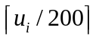)
Abilify 10 mg | 16 | .08 to 1
Accolate 20 mg | 10 | .05 to 1
Acebutolol 200 mg | 1 | .005 to 1
Aceon 2mg | 2 | .01 to 1

Formulation:

max

s.t.

, and integer

STATUS REPORT APRIL 18, 2006

Project: Achieve Healthcare Senior Design Project
Period: Wednesday, April 12, 2006 - Tuesday, April 18, 2006
From: Achieve Team (Kristin March, Rachel Potter, Laura Bailey, Allison Bass)
To:
Achieve Contacts | SMU
Mike Borland | Richard Barr
Jason Spears

Accomplishments:
- Met with Dr. Barr on April 11th and discussed our current model and how the canisters will no longer have a constant amount of 200 pills. In addition, we analyzed facility 23 clean data and assigned facility clean-up for other facilities to members of the team.
- Determined that AMPL file is unnecessary at this time; can use an excel spreadsheet instead.
- Determined that a correct model depended on more than a single days data vs. a single day; requested this information from Jason Spears. Client was not able to provide this data because clean-up was too time consuming. Achieve Team will discuss alternative method for simulation on Tuesday, April 18, 2006. (May need to create data)
- Cleaned up data for various facilities in preparation for Tuesday’s meeting.

Activities Next Period: (Items in red reflect Scheduled Items Not Completed/Issues/Concerns)
- Meet with Dr. Barr to discuss constraints to add the following:  - determine replacements on each drug (brand vs. generic) | Due: 04/18/2006
- Finalize model with added constraints | Due: 04/20/2006
- Begin discussion/formulation of simulation model | Due: 04/20/2006

Scheduled Items Not Completed/Issues/Concerns:
- Due to the late assignment and start date of the oral solid dispensing machine project, Team Achieve is concerned with the final completion and delivery of a generic integer programming model of the problem.

Impending Time Off /Holidays:

None

Next scheduled Project Status Report will be provided on Tuesday, April 25, 2006

SENIOR DESIGN
BINARY KNAPSACK PROBLEM

index for different types of drugs,
binary variable to determine either to vend (1) or not to vend (0) drug
the utility (# of pills dispensed per day)
the number of canisters per day per drug: the utility divided the availability (# of pills available in each canister – assume 200 for all canisters), rounded up
the number of pills per canister of drug

Maximize the number of dispensable drugs (over time):

max

s.t.

, and integer

Example:

Drug |  | ()
Abilify 10 mg | 16 | .08 to 1
Accolate 20 mg | 10 | .05 to 1
Acebutolol 200 mg | 1 | .005 to 1
Aceon 2mg | 2 | .01 to 1

Formulation:

max

s.t.

, and integer

STATUS REPORT APRIL 25, 2006

Project: Achieve Healthcare Senior Design Project
Period: Wednesday, April 19, 2006 - Tuesday, April 25, 2006
From: Achieve Team (Kristin March, Rachel Potter, Laura Bailey, Allison Bass)
To:
Achieve Contacts | SMU
Mike Borland | Richard Barr
Jason Spears

Accomplishments:
- Met with Dr Barr on Thursday, April 20th and Tuesday, April 25th and discussed our excel model. The excel model was originally designed for a single-day, single-facility input data. It was discovered that the model needed to be simulated using additional days information. However, Achieve Healthcare was unable to provide this information and advised us to use the same day’s information across multiple days for simulation purposes. They informed us that most facility data has zero variability and the information wouldn’t be as necessarily when developing the model.
- Created a model that simulated out 60-days of information; grouping by the most dispensed drugs. However the model did not i) take into consideration different milligrams of the same drugs and ii) replacing brand name with generics.

Activities Next Period: (Items in red reflect Scheduled Items Not Completed/Issues/Concerns)
- Meet with Dr. Barr to discuss problems discovered during initial model formulation | Due: 05/02/06
- Prepare final generic model and prepare simulation worksheets. | Due: 05/04/06
- Begin formulating processes and information for final report. | Due: 05/04/06
- Begin preparing final presentation | Due: 05/07/06

Scheduled Items Not Completed/Issues/Concerns:
- None

Impending Time Off /Holidays:

None

Next scheduled Project Status Report will be provided on Tuesday, May 2, 2006

STATUS REPORT MAY 2, 2006

Project: Achieve Healthcare Senior Design Project
Period: Wednesday, April 26, 2006 - Tuesday, May 2, 2006
From: Achieve Team (Kristin March, Rachel Potter, Laura Bailey, Allison Bass)
To:
Achieve Contacts | SMU
Mike Borland | Richard Barr
Jason Spears

Accomplishments:
- Prepared final generic model and prepared simulation worksheets which includes the following:
  - Worksheet 1: Clean data input for a single-day, single-facility
  - Worksheet 2: Customer input data – ordering costs, holding costs, number of canister slots per machine, maximum number of canister slots per drug and number of days to simulate for calculation
  - Worksheet 3: Simulation
  - Worksheet 4: Cost Report
  - Worksheet 5: Slot loading – identifies which drugs to be loaded into the machine
  - Worksheet 6: Orders Placed per drug
- Began formulating processes and information for final report.
- Began preparing final presentation
- Met with Dr. Barr to discuss the problems with the original model and variables associated with the model. Dr. Barr helped create final model template.

Activities Next Period: (Items in red reflect Scheduled Items Not Completed/Issues/Concerns)
- Prepare final presentation and report. | Due: 05/11/06
- Give final presentation in scheduled final exam class period | Due: 05/11/06
- Provide client and Dr. Barr with final report which includes: report and model solution | Due: 05/11/06

Scheduled Items Not Completed/Issues/Concerns:
- None

Impending Time Off /Holidays:

None

Final Project Presentation will be held on Thursday, May 11, 2006 at 3:00 p.m.

