Traffic Flow

Exploring dynamic vs. static toll pricing in
a traffic network simulation model

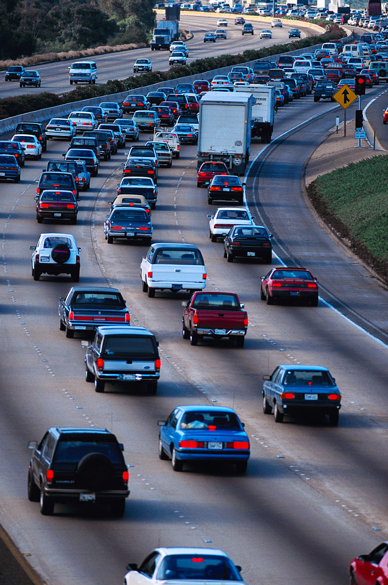

Nora Shora
Laura Tatsch

Spring 2006
EMIS 4395
Senior Design
Dr. Barr

Table of Contents

Management Summary 3

Background & Description of the Problem 3

Analysis of the Situation 4

Technical Description of the Model 5

Analysis & Managerial Interpretation 6

Conclusions & Critique 15

Appendix A 17

Appendix B 18

Appendix C 19

Appendix D 20

Appendix E 23



Management Summary

Many cities across the world have experienced, and are currently experiencing, increased traffic on highways and urban networks. At the same time, roads and highways have a limited capacity and are only capable of transporting a limited number of travelers. An increase in the number of travelers has increased all of the following factors associated with travel:

- Travel time
- Number of stops
- Travel costs
- Delays
- Air pollution
- Accidents
- Noise level

The first four on this list are factors that we will use in our investigation of the traffic flow problem.

Road pricing is one tactic used as an effective demand management strategy to reduce traffic congestion and improve performance during peak periods in many cities. In our simulation model of Knoxville, TN we added tolls to certain roads in the network in order to acquire data that would help us distinguish whether changing tolls during peak hours would improve average travel time.

Several sets of simulations were run and the data was recorded. It was concluded that changing the toll prices in general did not have a major impact on the average travel time and average travel distance. However, static and dynamic pricing structure comparisons showed that dynamic prices yielded lower average travel and stop times than static prices.

Background and Description of the Problem Situation

When driving down a toll road in any major city, people may wonder why they would pay money to drive on a specific road that may not actually get them to their destination any faster. Do toll road improve the average travel time of drivers in a traffic network? It seems as if toll road would help traffic spread out over more roads, as not all people are willing to pay tolls. If this is true, then adding tolls to certain major freeways should help average travel times decrease for drivers in the network, but is this really the case? We wanted to look at this specific problem.

To answer this question, we acquired a simulation model of the traffic flow network of Knoxville, TN. We wanted to modify the simulation by adding tolls to roads in the network to see if this would change the average travel time for drivers in the network. In addition, we wanted to see if dynamic toll prices would have an impact on travel time through the network, as this is a new strategy being implemented around the country. By increasing toll prices during peak traffic hours, perhaps the average travel time would decrease as well.

To set this problem up, we had to add some code to the simulation to enable us to place toll prices on certain arcs in the simulation. We had to decide which arcs to place tolls on, and what the standard prices should be. We also had to designate which zones of people to make price sensitive versus insensitive and time sensitive versus insensitive. With toll prices applied to specific arcs, and groups of travelers given time and cost sensitivities, we were able to run the simulation and determine average travel times and distances.

Analysis of the Situation

When we initially acquired the simulation code and installed the necessary software need to run this program, we were unsure of how to solve the original problem we had in front of us. We met with our client to discuss how to begin solving the problem of dynamic toll prices and multiple organizations controlling these prices. We decided that this problem was too complicated and would require more modifications to the code. Time was also an important factor and we realized that realistically we had put too much on our shoulders. We settled on looking at the effect of a dynamic toll pricing strategy on the traffic network.

We modified the code to allow us to determine arcs to apply tolls to. We ran the simulation many times with color-coded system to determine where the freeway arcs were on the simulation’s road map. After plotting these nodes and arcs, we picked several major arcs to turn in to toll roads.

Next, we modified the code to essentially set a price for traveling on our designated arcs. After making different zones of people have different price and time sensitivities, we ran the simulation, modifying the toll prices each time and documented our results.

We were required to make several assumptions in this problem, as this is a simulation. We assumed a reasonable toll price for a given arc would be $0.50, as most of the toll roads in the Dallas area have a range of $0.45 to $0.75 for any particular segment of toll road traveled on. We also assumed that a company choosing what prices to set for its tolls would not have any huge jumps in dynamic pricing throughout the day, such as starting at $0.50 and then jumping to $3.00 for a given segment of road. We tried to gradually increase our prices during a given day.

Another set of assumptions we made involved the travelers themselves. We needed to give different people different price and time sensitivities. To do this, we mapped out the nine zones of people that the simulation had set up. Next, we picked a socioeconomic status for residents in each zone based on similar areas in Dallas. For example, in the downtown area, we assumed the people to be wealthier, as in the Highland Park or Turtle Creek areas of Dallas. We assumed suburban areas were more upper-middle to middle class families. We also designated an area to be lower-income families in the inner city, etcetera. We assigned price sensitivities to these groups, assuming that upper-class families would be less sensitive to price than lower-income families. Likewise, we assumed that upper-class families tended to be more hurried and busy, and therefore made them more time sensitive than lower-income families.

Technical Description of the Model

The simulation model we used imitated the traffic flow of Knoxville, TN. This simulation has many components, but we only worked with a small fraction of the code. To set up the problem, we had to add or modify code in the following files: PathCalculation.java, NetworkComponent.java, and Road.java. We also had to modify some of the input data in the files Demand.dat and Zone.dat.

In PathCalculation.dat, we increased the number of paths calculated for more accurate results. This section of the code calculates the shortest path for each traveler in the network and the traveler then chooses to take the shortest path. If you calculate more paths for each traveler then you may find a better result from more options.

In NetworkComponent.java, we added a section of code that changed the colors of areas of the map that prints out when the simulation runs. First, we needed to determine which arcs to make into toll roads, so we color-coded a set of node pairs and ran the simulation so that the arcs would appear in different colors and could be identified on the map. Once we had all of the freeway arcs drawn on our map, we picked the ones we wanted to make toll roads.

We also used NetworkComponent.java to create a map of the zones. This helped us to identify which areas of the map were assigned to each zone. We made assumptions about the socioeconomic status of the people living in each zone based on the location of the zone on the map.

In Road.java, we added a section of code that allowed us to add static and dynamic toll prices to the arcs we picked. This is where a majority of our time was spent. We repeatedly changed toll prices and recorded the results. This section of code is essentially the base of the simulation, as it generates the roads in the network.

In the Demand.dat input file, we changed the level of demand going from one zone to another. This increased the flow through those areas in an attempt to give us more meaningful results. If there is a higher demand through an area, then the amount of time spent traveling through this area will increase and people may decide to take alternate routes to reduce the flow. Theoretically, another way the flow could be reduced is by putting tolls on areas of higher demand to discourage some travelers from using certain roads.

In the Zone.dat input file, we changed cost weights and time weights for each of the nine zones. We assumed that certain areas were more affluent than others and those travelers would be less price sensitive, so we gave them a lower cost weight. We also assumed that these more affluent travelers were likely very busy as well, so we gave them higher time weights. Once these weights were set, they remained the same throughout all of our runs of the simulation.

Each of these data files is attached in the appendix section. A sample of the code from the java code files is also attached. There are many other sections of code in this simulation, but these are the only ones that we needed to work with and understand to explore our specific situation.

Analysis and Managerial Interpretation

After running the simulation many times, changing different values each time, we looked at the data that was returned and tried to interpret these results. In the first the set of runs of the simulation, we set the cost and time weights as follows.

Zone | Socioeconomic Group | Cost Weight | Time Weight
1 | Upper | 10 | 90
2 | Upper-Middle | 20 | 80
3 | Middle | 50 | 50
4 | Lower | 90 | 10
5 | Upper-Middle | 20 | 80
6 | Middle | 50 | 50
7 | Middle | 50 | 50
8 | Upper | 10 | 90
9 | Upper-Middle | 20 | 80

We ran the simulation with different toll prices in a dynamic set-up, but the simulation was ignoring the changes in price due to an error in the code. The simulation returned results that used the lowest toll price as a static price for travelers. The following charts depict the average travel time and stop time for travelers as well as the average distance traveled.

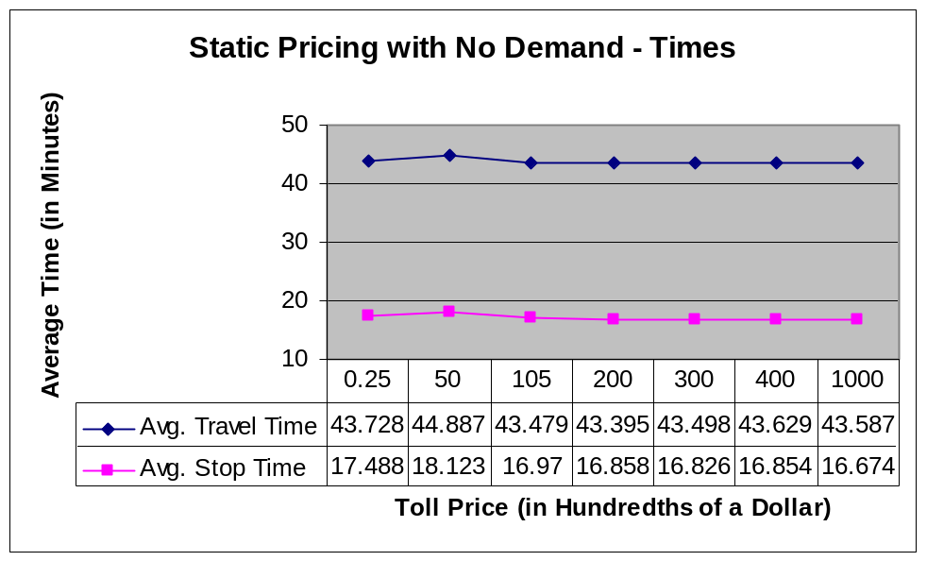
Figure-1

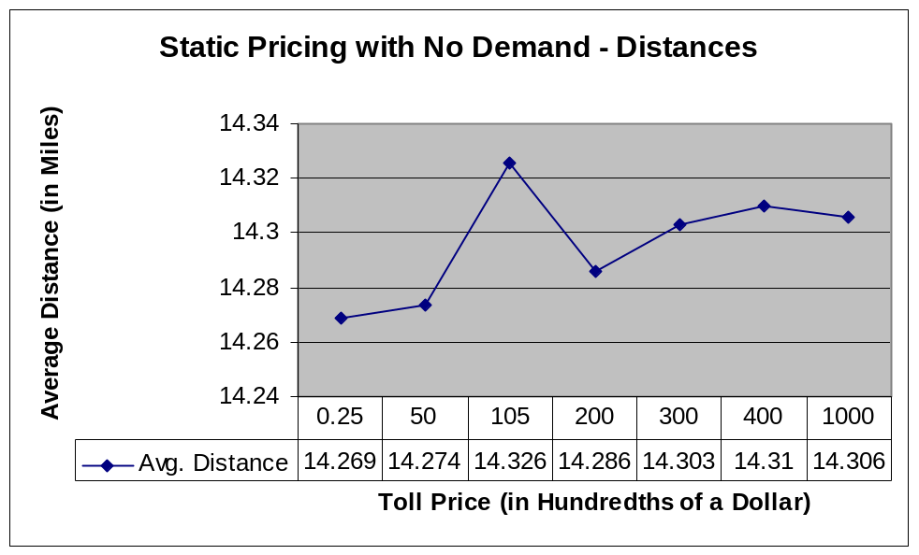
Figure-2

With respect to time, toll prices did not seem to impact the average travel time or stop time. Even with really small numbers and really large numbers, the times remained consistent. The only points on the graph in Figure-1 that stand out are when the toll price is 50, but even this is very subtle.

Looking at average distance in Figure-2, there is an obvious spike in distance at a toll price of 105. This could be explained by travelers choosing alternate routes that are less direct and would therefore increase their distance traveled. It is unclear why a further increase in toll price would cause the distance to drop again. It is worth noting that this graph has a total distance range of 14.24 miles to 14.34 miles, which is relatively insignificant.

Next, we decided to increase the demand from zone 3 to zone 1. First, we looked at this added demand using static prices. When compared to the results without added demand, it is clear to see that an increase in demand causes a significant increase in average travel time and average stop time.

Description of Run | Avg. Travel Time | Avg. Distance | Avg. Stop Time
Static toll: 50 | 44.887383 | 14.273826 | 18.123468
Static toll: 50 (added demand) | 74.45962 | 14.301645 | 44.643955

The following figures show the results of changing the demand from zone 3 to zone 1.

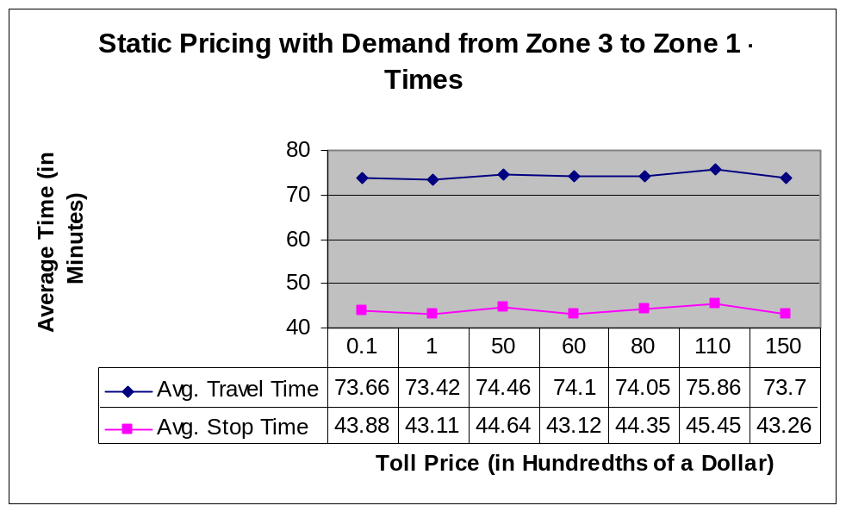
Figure-3

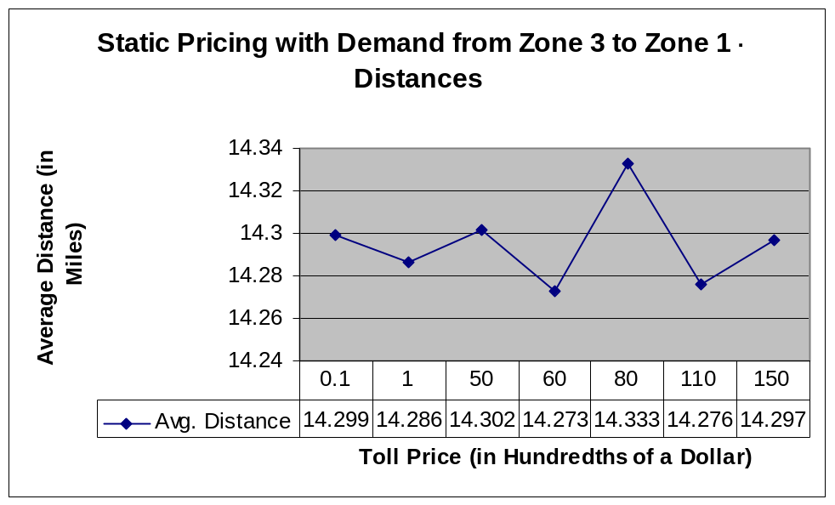
Figure-4

Again, the average travel and stop times do not show any significant change as toll prices change. This average distance changes by a small amount each time, but with no apparent pattern. This could possibly be explained by a single traveler taking an extra long or extra short route (an outlier) in a given run of the simulation, as the average distance is not changing by much each time.

We then looked at the effect of adding dynamic prices to the simulation while there was an increase in demand from zone 1 to zone 3. The following figures show the results.

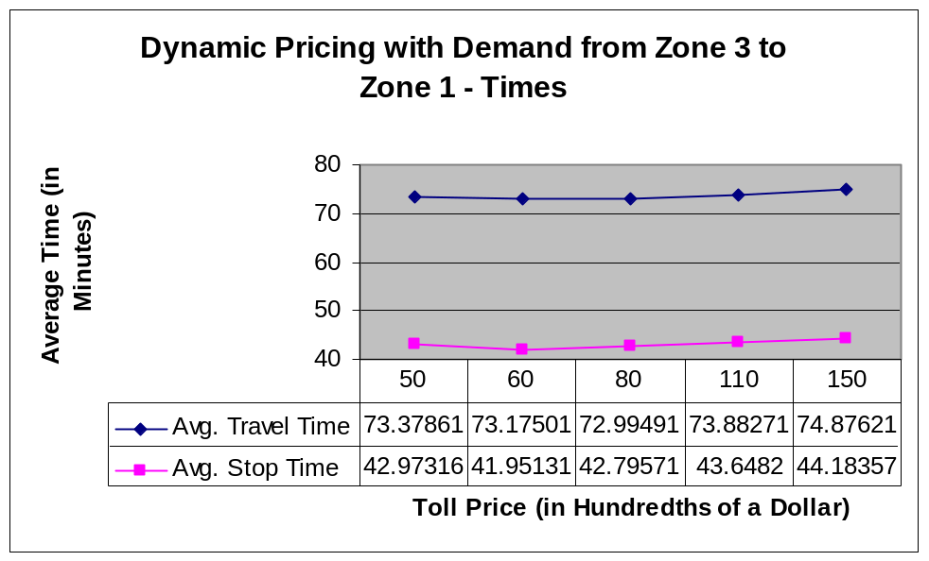
Figure-5

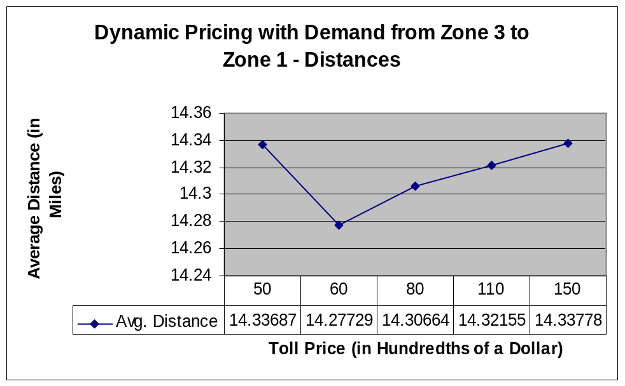
Figure-6

Figure-5 shows yet another insignificant change in travel times and stop times. Figure-6 shows slight changes in the average distance traveled. In general, as the toll price increases the average distance increases, but the first value in the figure remains unexplained. These are still very small changes in average distance.

When comparing the results of the static pricing and the dynamic pricing, we get the following figures.

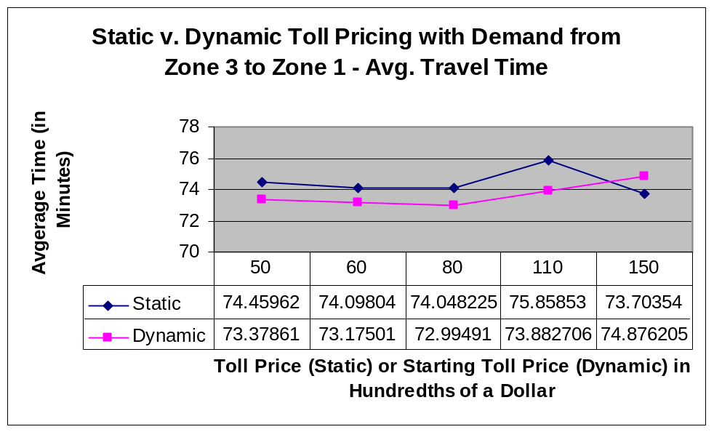
Figure-7

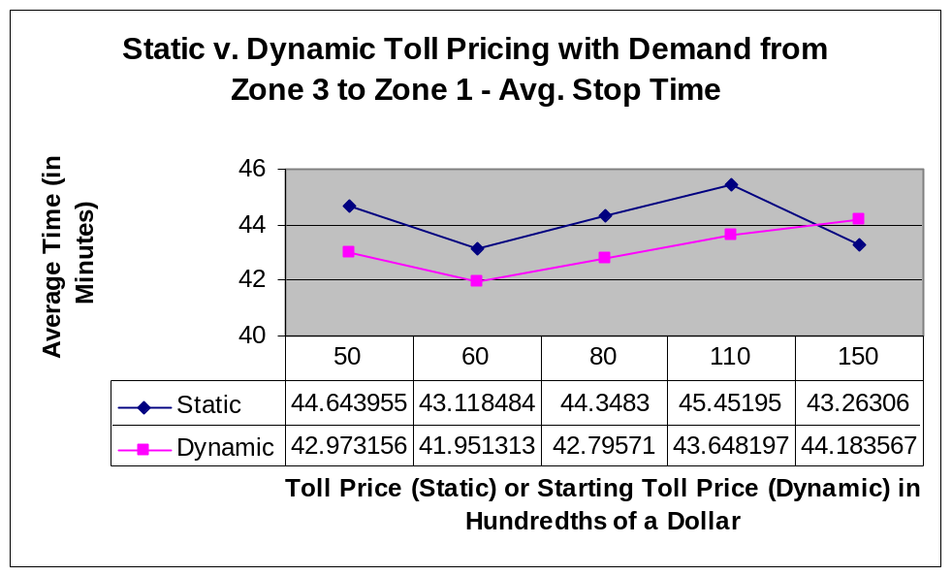
Figure-8

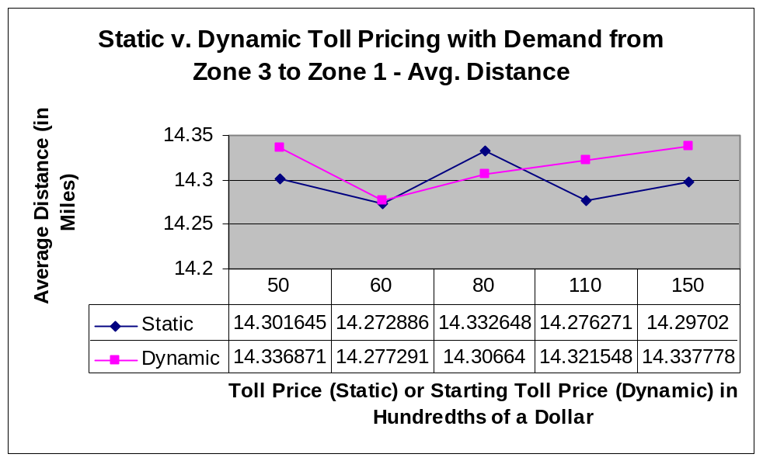
Figure-9

Figure-7 shows a comparison of the average travel times with static and dynamic toll pricing structures. In general, the dynamic pricing reduces the average travel time up to a point. If the initial toll price is more than 130 ($1.30) during non-peak hours, the dynamic pricing no longer reduces the average travel time. Figure-8 shows a similar pattern. When the initial toll price is more than 130 during non-peak hours, the average stop time is no longer reduced by having a dynamic pricing structure.

Figure-9 shows the average distance with static and dynamic pricing. These values did not have much meaning individually, and when compared, they still do not explain anything clearly.

After running the first several groups of data, we noticed some things that could be impacting our results. We increased the demand from zone 3 to zone 1, but not from zone 1 to zone 3. The toll prices were implemented for traffic flowing in both directions on the toll roads, so perhaps the demand should be in both directions as well. We ran the simulation again with this in mind, using a different set of zones.

The following figures show the average times and distances with demand added from zone 8 to zone 1 and from zone 1 to zone 8.

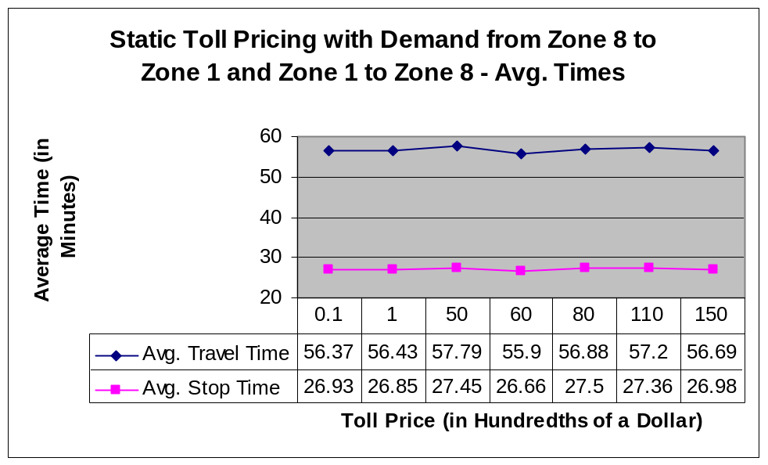
Figure-10

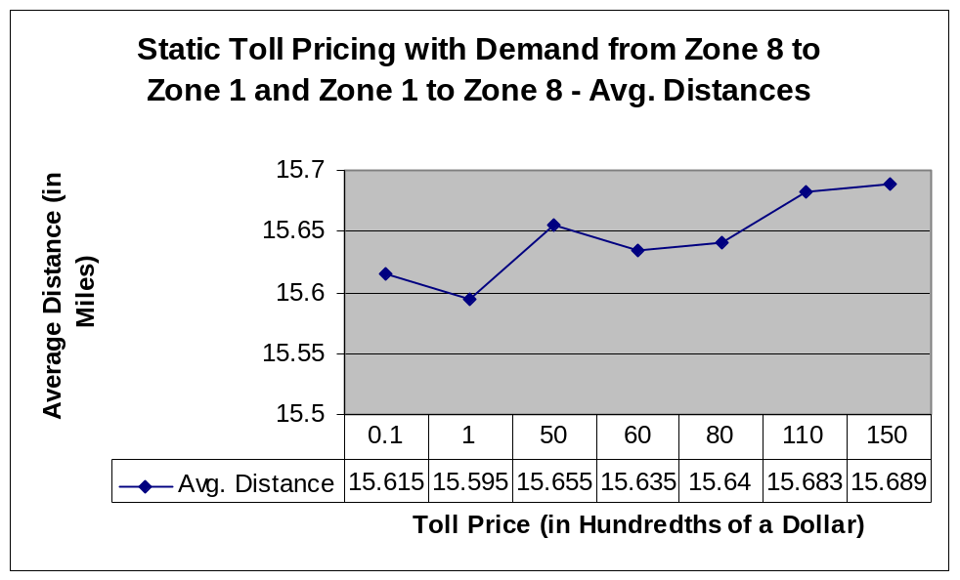
Figure-11

After changing demand in both directions between zones 1 and 8, Figure-10 shows that the average travel times and stop times did not change in a significant way. Figure-11 shows that the average distance generally increased as toll prices increased, but only by very small amounts.

Next, we made the toll prices dynamic with the demand between zones 1 and 8. The following figures show the results.

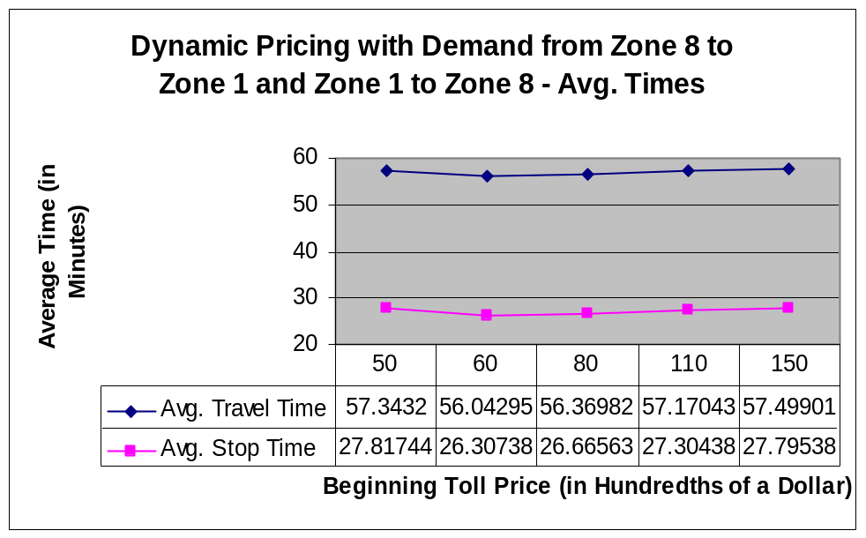
Figure-12

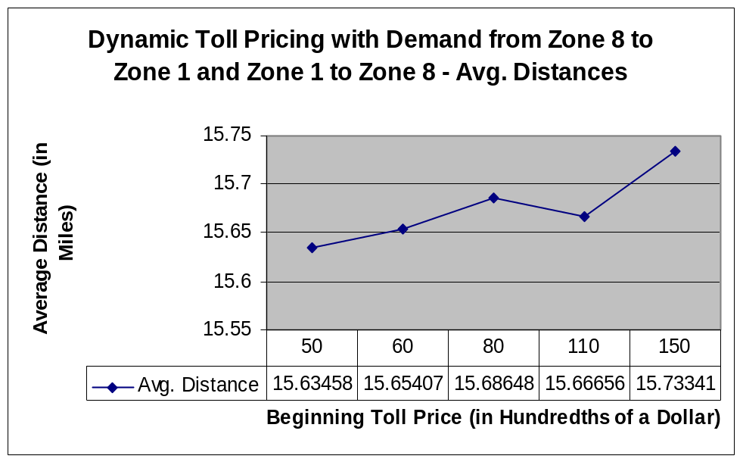
Figure-13

Once again, the average travel times and stop times have relatively insignificant changes as toll prices change, as seen in Figure-12. As toll prices go beyond 60, there seems to be an increase in the average times, but not by much. Figure-13 shows that the average distance generally increases as toll prices increase as well. All of these numbers are so small that it is difficult to determine a cause and effect.

When comparing the static and dynamic pricing strategies with an increased demand between zones 8 and 1, we get the following figures.

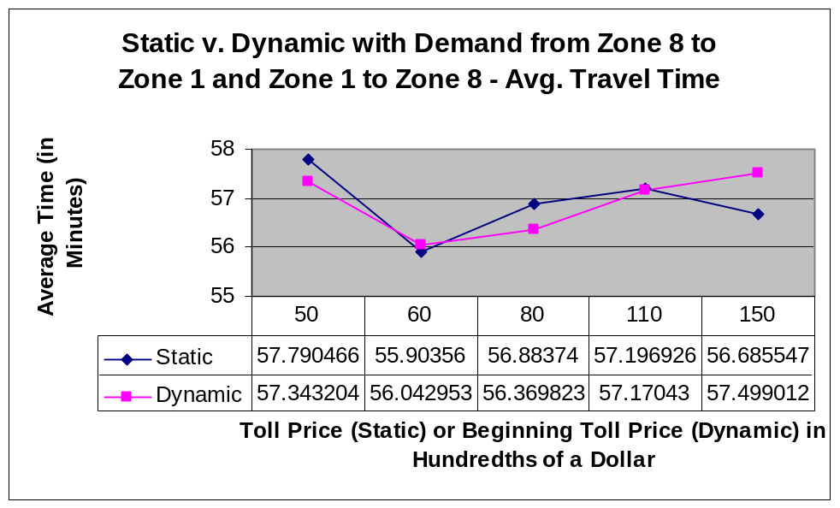
Figure-14

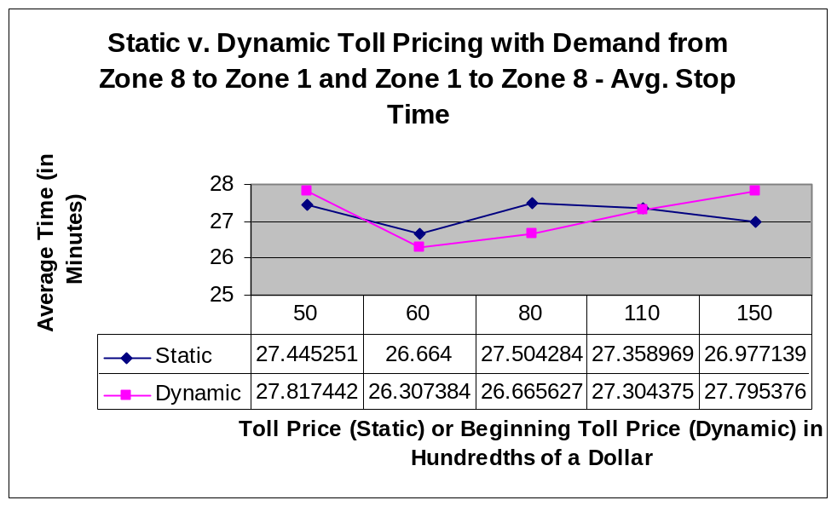
Figure-15

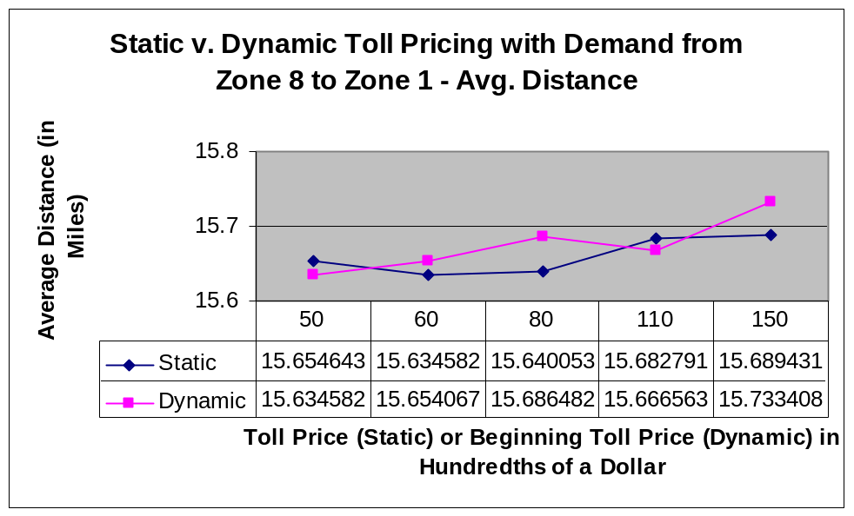
Figure-16

Figure-14 shows a comparison of the average travel time with a demand added between zones 8 and 1. The dynamic pricing scheme seems to yield lower travel times on average, but not by much. At an initial toll of 110, the dynamic pricing scheme no longer produces better average travel times. Similarly, the average stop time is lower with dynamic pricing up to an initial toll value of 110, as shown in Figure-15.

The average distance comparison yields a double-helix graph shape, seen in Figure-16. Static and dynamic pricing schemes seem to move in opposite directions as initial toll prices change. When looked at individually, these curves do not show very significant, explainable patterns. Together, this shape of graph could imply that static and dynamic pricing structures do impact travel distance in an inverse relationship. These value changes still seem insignificant, so it is unclear how much the pricing truly impacts the average travel distance.

Conclusion

After analyzing the data we gathered in many runs of the simulation, some general patterns appear. The average travel times and average stop times do not seem to change very much as toll prices are increased. Average distance values typically seem to be random and unexplainable from what we were able to see. This could be explained by outliers in each individual run of the simulation. If a few people take extra long or extra short routes, the averages will change slightly.

When comparing static and dynamic pricing structures, we noticed some interesting trends. When demand was added from zone 1 to zone 3, dynamic pricing helped reduce the average travel time and average stop time, up to an initial toll price of approximately 130. This suggests that dynamic pricing could possibly help reduce traffic flow on certain arcs in the network. The average distance comparison between static and dynamic pricing did not seem to yield any useful information. This should be looked at further, with a larger variety of prices to determine of a pattern exists.

When demand was added from zone 8 to zone 1 and from zone 1 to zone 8 (without demand from zone 3 to zone 1), some similar effects emerged. The dynamic pricing structure generally yielded lower average travel times and stop times than static pricing, up to a point. At an initial toll price of 110, the static pricing begins to yield lower average travel and stop times. The average distance comparison showed opposite effects. As toll prices increased, if static prices made the average distance increase, then dynamic prices made the average distance decrease, and vice versa.

More runs of the simulation should be completed. Some of our data shows interesting trends, but more data is needed. A larger variety of toll prices should be looked at. Also, with dynamic pricing, we changed the prices throughout the simulation run time, increasing by 20 and then 30 and then reducing again. Larger and smaller increases should be looked at. A comparison should also be done between having tolls and having no tolls to see if the travel and stop times, as well as distances, are affected by implementing tolls.

Appendix A – Zones in Color

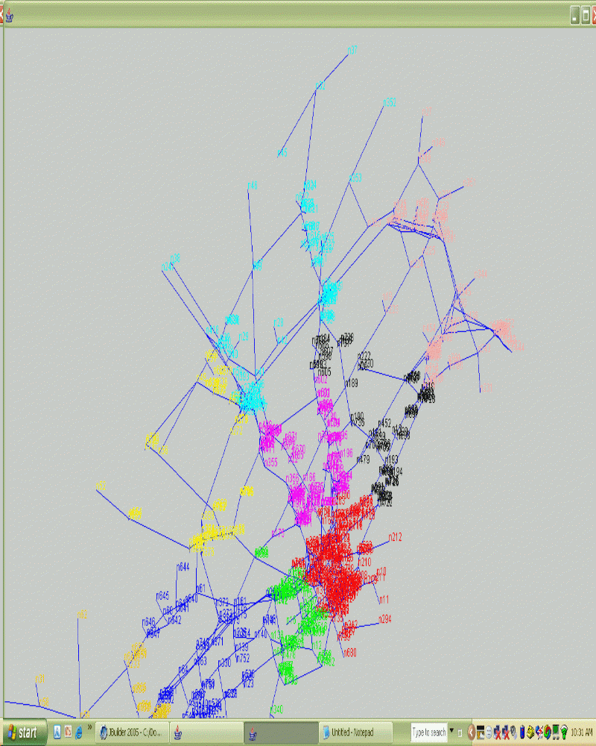

Appendix B – Road.java Sample

//BEGINNING OF PRICING OF ARCS
//TOP Freeway
// pricing scheme for link 396 - 428
if(this.getUpstreamIntersection().getIntersectionName().equalsIgnoreCase("n396") && this.getDownstreamIntersection().getIntersectionName().equalsIgnoreCase("n428")){
if( Master.timeNow <= 60){
travelCostCar = travelCostCar + (new Float(150)).floatValue()/100 ;
}
else if(Master.timeNow > 60 && Master.timeNow > 90){
travelCostCar = travelCostCar + (new Float(150)).floatValue()/100 ;
}
else if(Master.timeNow > 90 && Master.timeNow > 120){
travelCostCar = travelCostCar + (new Float(150)).floatValue()/100 ;
}
else if(Master.timeNow > 120 && Master.timeNow > 180){
travelCostCar = travelCostCar + (new Float(150)).floatValue()/100 ;
}
else if(Master.timeNow > 180 && Master.timeNow > 210){
travelCostCar = travelCostCar + (new Float(150)).floatValue()/100 ;
}

} // end of one link 396 - 428

// pricing scheme for link 428 - 396
if(this.getUpstreamIntersection().getIntersectionName().equalsIgnoreCase("n428") && this.getDownstreamIntersection().getIntersectionName().equalsIgnoreCase("n396")){
if( Master.timeNow <= 60){
travelCostCar = travelCostCar + (new Float(150)).floatValue()/100 ;
}
else if(Master.timeNow > 60 && Master.timeNow > 90){
travelCostCar = travelCostCar + (new Float(150)).floatValue()/100 ;
}
else if(Master.timeNow > 90 && Master.timeNow > 120){
travelCostCar = travelCostCar + (new Float(150)).floatValue()/100 ;
}
else if(Master.timeNow > 120 && Master.timeNow > 180){
travelCostCar = travelCostCar + (new Float(150)).floatValue()/100 ;
}
else if(Master.timeNow > 180 && Master.timeNow > 210){
travelCostCar = travelCostCar + (new Float(150)).floatValue()/100 ;
}

} // end of one link 428 - 396
//===========================
Appendix C – Demand.dat File

Demand Data
===========
StartInterval: 0 EndInterval: 300 Multiplier: 8
From/To 1 2 3 4 5 6 7 8 9
1 24 15 13 13 13 12 14 200 13
2 42 15 13 14 13 13 12 12 13
3 29 15 14 14 12 14 12 12 12
4 23 14 16 12 13 12 13 13 13
5 23 13 15 13 13 14 15 12 14
6 29 13 15 13 12 13 14 13 14
7 23 14 14 13 14 13 12 14 14
8 200 15 14 13 13 13 13 13 12
9 21 13 13 14 13 13 13 12 11
StartInterval: 301 EndInterval: 600 Multiplier: 8
From/To 1 2 3 4 5 6 7 8 9
1 24 15 13 13 13 12 14 200 13
2 42 15 13 14 13 13 12 12 13
3 49 15 14 14 12 14 12 12 12
4 23 14 16 12 13 12 13 13 13
5 43 13 15 13 13 14 15 12 14
6 29 13 15 13 12 13 14 13 14
7 23 14 14 13 14 13 12 14 14
8 200 15 14 13 13 13 13 13 12
9 21 13 13 14 13 13 13 12 11
StartInterval: 601 EndInterval: 900 Multiplier: 8
From/To 1 2 3 4 5 6 7 8 9
1 24 15 13 13 13 12 14 200 13
2 42 15 13 14 13 13 12 12 13
3 49 15 14 14 12 14 12 12 12
4 23 14 16 12 13 12 13 13 13
5 43 13 15 13 13 14 15 12 14
6 29 13 15 13 12 13 14 13 14
7 23 14 14 13 14 13 12 14 14
8 200 15 14 13 13 13 13 13 12
9 21 13 13 14 13 13 13 12 11
StartInterval: 901 EndInterval: 1200 Multiplier: 8
From/To 1 2 3 4 5 6 7 8 9
1 24 15 13 13 13 12 14 200 13
2 42 15 13 14 13 13 12 12 13
3 49 15 14 14 12 14 12 12 12
4 23 14 16 12 13 12 13 13 13
5 43 13 15 13 13 14 15 12 14
6 29 13 15 13 12 13 14 13 14
7 23 14 14 13 14 13 12 14 14
8 200 15 14 13 13 13 13 13 12
9 21 13 13 14 13 13 13 12 11

Appendix D – Zone.dat File

Zone Data
===========
ZoneKeyID: 1
Centroid: 93
CarOwnershipPercent: 100
BikeOwnershipPercent: 50
ActivityPercents: 100 0 0
travelTimeWeight: 90
travelCostWeight: 10
travelDistanceWeight: 1
waitingTimeWeight: 1
walkingDistanceWeight: 1
comfortWeight: 1
safetyWeight: 1
transferWeight: 1
ZoneKeyID: 2
Centroid: 322
CarOwnershipPercent: 100
BikeOwnershipPercent: 50
ActivityPercents: 100 0 0
travelTimeWeight: 80
travelCostWeight: 20
travelDistanceWeight: 1
waitingTimeWeight: 1
walkingDistanceWeight: 1
comfortWeight: 1
safetyWeight: 1
transferWeight: 1
ZoneKeyID: 3
Centroid: 750
CarOwnershipPercent: 100
BikeOwnershipPercent: 50
ActivityPercents: 100 0 0
travelTimeWeight: 50
travelCostWeight: 50
travelDistanceWeight: 1
waitingTimeWeight: 1
walkingDistanceWeight: 1
comfortWeight: 1
safetyWeight: 1
transferWeight: 1
ZoneKeyID: 4
Centroid: 12
CarOwnershipPercent: 100
BikeOwnershipPercent: 50
ActivityPercents: 100 0 0
travelTimeWeight: 10
travelCostWeight: 90
travelDistanceWeight: 1
waitingTimeWeight: 1
walkingDistanceWeight: 1
comfortWeight: 1
safetyWeight: 1
transferWeight: 1
ZoneKeyID: 5
Centroid: 49
CarOwnershipPercent: 100
BikeOwnershipPercent: 50
ActivityPercents: 100 0 0
travelTimeWeight: 80
travelCostWeight: 20
travelDistanceWeight: 1
waitingTimeWeight: 1
walkingDistanceWeight: 1
comfortWeight: 1
safetyWeight: 1
transferWeight: 1
ZoneKeyID: 6
Centroid: 166
CarOwnershipPercent: 100
BikeOwnershipPercent: 50
ActivityPercents: 100 0 0
travelTimeWeight: 50
travelCostWeight: 50
travelDistanceWeight: 1
waitingTimeWeight: 1
walkingDistanceWeight: 1
comfortWeight: 1
safetyWeight: 1
transferWeight: 1
ZoneKeyID: 7
Centroid: 193
CarOwnershipPercent: 100
BikeOwnershipPercent: 50
ActivityPercents: 100 0 0
travelTimeWeight: 50
travelCostWeight: 50
travelDistanceWeight: 2
waitingTimeWeight: 2
walkingDistanceWeight: 2
comfortWeight: 1
safetyWeight: 1
transferWeight: 1
ZoneKeyID: 8
Centroid: 225
CarOwnershipPercent: 100
BikeOwnershipPercent: 50
ActivityPercents: 100 0 0
travelTimeWeight: 90
travelCostWeight: 10
travelDistanceWeight: 1
waitingTimeWeight: 1
walkingDistanceWeight: 1
comfortWeight: 1
safetyWeight: 1
transferWeight: 1
ZoneKeyID: 9
Centroid: 48
CarOwnershipPercent: 100
BikeOwnershipPercent: 50
ActivityPercents: 100 0 0
travelTimeWeight: 80
travelCostWeight: 20
travelDistanceWeight: 1
waitingTimeWeight: 1
walkingDistanceWeight: 1
comfortWeight: 1
safetyWeight: 1
transferWeight: 1

Appendix E – Output from Simulation

Changed What | Toll | Avg. Travel Time | Avg. Distance | Avg. Stop Time
(Cost weights and time weights set)
(Time intervals changed from original code)
(Act as STATIC toll prices)
(No Demand set yet)
Toll: 0.25 | 0.25 | 43.72786 | 14.268671 | 17.488401
Toll: 50 | 50 | 44.887383 | 14.273826 | 18.123468
Toll: 105 | 105 | 43.478764 | 14.325812 | 16.969704
Toll: 200 | 200 | 43.394753 | 14.286124 | 16.85754
Toll: 300 | 300 | 43.497585 | 14.302772 | 16.825716
Toll: 400 | 400 | 43.62904 | 14.309628 | 16.853815
Toll: 1000 | 1000 | 43.586853 | 14.305935 | 16.673674
(Added Demand from zone 3 to 1)
(These were actually acting as STATIC prices)
Tolls 0.1-0.1-0.1 | 0.1 | 73.6593 | 14.298952 | 43.88447
Tolls 1-1-1 | 1 | 73.41586 | 14.286481 | 43.10991
Toll: 50 | 50 | 74.45962 | 14.301645 | 44.643955
Toll: 60 | 60 | 74.09804 | 14.272886 | 43.118484
Toll: 80 | 80 | 74.048225 | 14.332648 | 44.3483
Toll: 110 | 110 | 75.85853 | 14.276271 | 45.45195
Toll: 150 | 150 | 73.70354 | 14.29702 | 43.26306
(Changed Code to Greater Than Again)
(Actually acting DYNAMIC)
Tolls 50-70-100 | 50 | 73.37861 | 14.336871 | 42.973156
Tolls 60-80-110 | 60 | 73.17501 | 14.277291 | 41.951313
Tolls 80-100-130 | 80 | 72.99491 | 14.30664 | 42.79571
Tolls 110-130-160 | 110 | 73.882706 | 14.3215475 | 43.648197
Tolls 150-170-200 | 150 | 74.876205 | 14.337778 | 44.183567
no costweight/timeweight tolls 50, 70, 100 |  | 44.06586 | 14.280819 | 17.391294
added cost + time weights |  | 44.06586 | 14.280819 | 17.391294
(Added demand; Acting DYNAMIC)
Tolls 50-70-100 | 50 | 57.343204 | 15.634582 | 27.817442
Tolls 60-80-110 | 60 | 56.042953 | 15.654067 | 26.307384
Tolls 80-100-130 | 80 | 56.369823 | 15.686482 | 26.665627
Tolls 110-130-160 | 110 | 57.17043 | 15.666563 | 27.304375
Tolls 150-170-200 | 150 | 57.499012 | 15.733408 | 27.795376
(STATIC tolls)
Tolls 0.1-0.1-0.1 | 0.1 | 56.366856 | 15.614966 | 26.932405
Tolls 1-1-1 | 1 | 56.429424 | 15.595125 | 26.854261
Toll: 50 | 50 | 57.790466 | 15.654643 | 27.445251
Toll: 60 | 60 | 55.90356 | 15.634582 | 26.664
Toll: 80 | 80 | 56.88374 | 15.640053 | 27.504284
Toll: 110 | 110 | 57.196926 | 15.682791 | 27.358969
Toll: 150 | 150 | 56.685547 | 15.689431 | 26.977139

