The Wealth of Nations: A Study of Political Institutions and Economic Growth
2009
Kathryn Gotcher
Kyle Merino
Gregory Moran
Southern Methodist University
5/6/2009
Table of Contents
Management Summary 1
Background and Description of Problem 2
Analysis of the Situation 4
Technical Descriptions of Modeling Methods 7
Clustering Self-Organizing Maps 7
Data Envelopment Analysis 10
Analysis and Managerial Interpretation of Data 16
Clustering Self Organizing Maps 16
Data Envelopment Analysis 18
Comparison of DEA and Clustering Models 19
Multiple Regression Analysis 21
Conclusion and Critique 25
Works Cited 27
Appendix A: Self Organizing Map Software Documentation 29
Appendix B: Clustering Data Set 31
Appendix C: DEA Pioneer Documentation 35
Appendix D: DEA Input Chart 62
Appendix E: DEA Model with 8 Inputs 65
Appendix F: DEA Model Output 71
Appendix G: DEA Ranking Model Inputs 82
Appendix H: DEA Ranking Model Output 89
Appendix I: Clusters of Countries 95
Appendix J: Comparison Analysis Graphs for Clusters 97
Appendix K: DEA Countries and Levels 103
Appendix L: DEA Country Ranking 107
Appendix M: Multiple Regression Analysis Graphs 110
Appendix N: Correlational Values of Modeling Variables 111
Appendix O: Scatter Plot Comparison Graphs for Modeling Variables vs. GDP per Capita 112

Management Summary
In the present global economic state, finding ways to improve a nation’s economy is vital to government leaders. The problem presented to us was to study various political institutions and policies of the world’s nations and determine which measures, if any, are accurate predictors of economic health and growth. In particular, we were interested in the effect that measures of free trade would have upon the economy.
We used two modeling methods, Neural Network Clustering and Data Envelopment Analysis to classify and study 126 of the world’s nations. Specifically self organizing maps were used for clustering. We used eight individual data variables in our models and analyzed these eight variables with multiple regression to determine statistical significance to the models.
Based on our findings, we believe that it is possible to reasonably predict economic health based on variables of political institutions. In particular, we discovered that, of the eight variables that we studied, perceived corruption and human development measures are vital to stimulating the health of the economy. In order for economies to grow, it seems that corruption must be kept down within the system and citizens must be provided with opportunities to be educated, live long lives, and have good jobs. We also discovered a substantial link between a strong legal system and these two necessary growth variables. We are unsure of the causal link between the legal systems and corruption and human development, and this will require further study. However, it does seem that one cannot exist without the other.

Background and Description of Problem
Our project revolved around the question of whether there exist national institutions linked to government policies of free trade that encourage economic health and growth in a given country. Given the current state of our nation’s economy and the effect that it is having upon the rest of the world, the question is a rather pressing issue. The focus on institutions surrounding free trade was motivated by previous, less comprehensive studies performed by our project sponsor, Dr. Thomas F. Siems. He had performed similar analysis on 50 countries which seemed to suggest a link between institutions such as entrepreneurship, strong legal protections, trustworthy financial markets, globalization, creative human capital, and technological adeptness and the rates of economic growth that a country experiences.
In order to evaluate these ideas the team needed to decide which measurable and accurate data factors could be used for modeling and analysis, which countries would have enough data and be relevant to the questions posed, and which models would be best suited for the questions that we asked. The specific questions we addressed were:
- Could we reasonably determine factors that determine the economic health of a country?
- Are there rational groups that our countries could be divided into in terms of economic health?
- Which factors weigh most heavily in determining the division of the groups of countries?
- Are the results statistically significant?
This project differs from the others in our class in that the results can broadly affect government officials in any country in the world. It is not narrowly defined to just one company or organization. If our hypothesis proves to be true, the results would be extremely relevant to government policies and the future health of the global economy.

Analysis of the Situation
Our general approach to the problem encompasses identifying possible data factors that could possibly influence national economic health, building a model that would use these data points to group the countries in terms of health, and then find a statistical analysis method that would evaluate whether the results are significant and which factors weigh more heavily into the separation of groups.
The real problems that we felt were presented with the study were the inability to use every factor that could possibly weigh into economic health and the general unavailability of data for some countries. We decided that we would try to focus on factors that would be easily measurable and would factor heavily since it would be impossible to use the hundreds of factors that could relate to economic health. We also decided to limit our study to the 126 countries that had readily available data for our modeling and analysis factors.
We decided to use a Neural Network clustering model to group our countries into groups for analysis. An artificial neural network is a mathematical model that is based on biological neural networks. It consists of a group of artificial neurons that are interconnected and process information using a connectist approach. A neural network changes its structure based on internal and external information. A clustering neural network assigns objects into groups so that objects in the same cluster are more similar to one another than those in other clusters. The similarities are assessed due to distance measures of different factors.
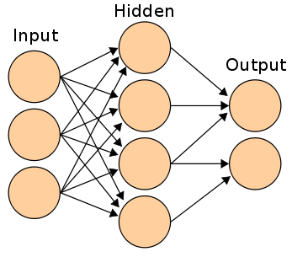
Figure 1. A possible Neural Network Clustering Model
To make sure that the model is well designed, we also decided to use a DEA or Data Envelopment Analysis Model. DEA is a method used in Operations Research and Economics to measure “production frontiers”. It is based on economic production theory that uses a firm’s input and output combinations to depict a production frontier. It can be used to show the theoretical maximum output of the various inputs. However we decided to use it as a way to measure economic health by grouping the outermost countries into the first group which would represent the healthiest countries and then continue “peeling off layers” to represent different groups.

Figure 2. Example Data Envelopment Analysis with 1 input and 1 output

Technical Descriptions of Modeling Methods

Clustering Self-Organizing Maps
As previously discussed in the Analysis section, the decision was made that a neural network clustering model would be used to separate the countries into groups that could be classified according to economic health. A self-organizing map was presented as the best option.
Self-organizing maps are a type of unsupervised neural network developed by a Finnish scientist Nuevo Kohonen. Self-organizing maps (hereafter referred to as SOMs) do not adapt to a given desired output by the user, but rather adapt to the inputs alone.
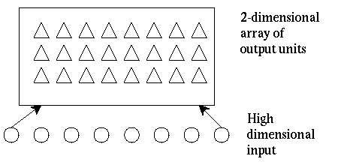
Figure 3. Simplified Self-Organizing Map Model
This diagram gives a very simple depiction. The input data vectors are placed within the two-dimensional array based on relative distance. Once the inputs are placed, the output area can be divided into equal sections that represent the individual clusters.
SOMs consist of components called neurons or nodes that are associated with a weight vector and a position in a rectangular grid. The nodes are initially regularly spaced in the grid. During the training phase of the algorithm, data vectors are individually fed into the network and their relative distance to the weight vectors is computed. The neuron associated with the closest weight vector is called the Best Matching Unit. This neuron is then adjusted towards the input vector with the update formula of:
Wv(t+1)=Wv(t) + Ω(v,t)α(t)(D(t)-Wv(t))
where α(t) is a decreasing learning coefficient, D(t) is the input vector, and Ω(v,t) is a function dependent on the lattice or neighborhood distance between the Best Matching Unit and the neuron v.
This process is repeated for a number of cycles selected by the user and when finished the algorithm will move on to the actual mapping. During this phase a winning neuron will be selected as the neuron whose weight vector lies closest to the input vector.
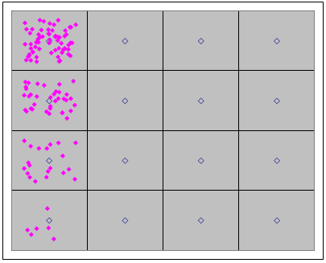
Figure 4. Map of Clustering Neurons
We used an excel-based program to model our clusters (See Appendix A). The model included eight different variables for 126 countries, or observations (See Appendix B). We chose n, or the square root of the number of neurons in the map, to be four so that there would be 16 neurons in our map. After playing with the number of clusters we selected the number of training cycles to be 500. The learning parameter, α, had a start value of 0.92 which exponentially decreased through the algorithm to an ending value of 0.1. The software used a Gaussian function for the Ω neighborhood function with a value of σ that began at 50% and ended at 5%. A Gaussian function is developed by applying an exponential function to a quadratic function and provides a normal distribution on a bell curve. During modeling the α, σ, and number of training cycles were varied in different combinations to give us the number of clusters that were needed. To perform the analysis necessary to validate our hypothesis, we needed approximately three to four clusters; some combinations of parameters gave too few and some gave too many.
The size of government variable measures size and scope of government control over the economy while the legal system variable tracks the strength of the legal system in protecting individual rights and property. The access to sound money measure follows access to stable currency as a means of exchange, and the free trade data measures policies promoting fewer restrictions on international trade. The regulation variable surveys government regulation of privately owned businesses, the Corruption Perceptions Index is an inverse measure of corruption of government officials, and literacy measures the proportion of a population that can read and write. The Human Development Index weighs factors representing quality of life for citizens.
All sources of data were taken from 2006 historical data. No theoretical values were assumed in the data set and no simplifying assumptions were made. Data to measure the size of government, legal structure and property rights, access to sound money, freedom to trade internationally, and regulation of business were taken from data for the Fraser Institute. The information for the Corruption Index was obtained from Transparency International, and the measures of literacy and Human Development Index were taken from data derived from research by the United Nations.

Data Envelopment Analysis
Data Envelopment Analysis (DEA) is a method for determining the relative efficiency of a Decision Making Unit (DMU) by determining the relationship between inputs and outputs. A DMU can be any entity that makes decisions about inputs with the goal of influencing outputs. Common DMUs include firms in the same industry, stores owned by a chain retailer, or in the case of this study, countries.
Unlike regression methods, DEA is not concerned with the central tendencies of a population. Instead, the most efficient DMUs are identified, and other DMUs are compared to them. DEA can run through several iterations. For each iteration, a subset of the DMUs is selected as most efficient. These DMUs are then removed from the analysis, and another iteration begins. This process continues until there are no DMU’s left.
For this particular study, DEA is an abstract method of analysis. The inputs in this case do not represent quantities of resources used to produce final products. Instead, the inputs are ratings, on a scale of zero to ten, representing the goodness of certain policies of a country relative to those policies of other countries. The output in this study, GDP per capita, is more closely related to the actual quantity of finished product. Thus, better policies can be viewed as a smaller number of inputs, and higher GDP per capita represents higher output.
DEA analysis identifies the most efficient DMUs as those with the highest ratio of outputs to inputs. Thus, for a given output, lower input is better. For a given input, higher output is better. Many of the ratings that are used as inputs in this study define ten as best and 0 as worst. In order to make these ratings consistent with the DEA model, they were replaced with a value equal to ten minus the original rating, so that lower ratings would indicate better policies.
Formal Mathematical Statement
Maximize: E_{k} = (Σ_{i} w_{i} y_{ik} ) / (Σ_{j} v_{j} x_{jk} )
subject to: (Σ_{i} w_{i} y_{ip} ) / (Σ_{j} v_{j} x_{jp} ) <= 1, for each DMU p
E = efficiency rating
w_{i} = weight of output i, > 0
y_{i} = value of output i
v_{j} = weight of input j, > 0
x_{j} = rating of input j
i = 1,2,…,m; m = number of outputs in model
j = 1,2,…,q; q = number of inputs in model
For each DMU, an efficiency rating is calculated using the above formula. The output for this model is the measure of economic health, GDP per capita. The inputs are the eight policy ratings outlined below. Countries are placed into levels of economic health or ranked individually based on their efficiency score relative to those of other countries. For a more comprehensive mathematical statement, see Appendix C.
The DEA model used in this study consists of eight input variables: size of government (sizGov), legal system (legSys), sound money (sound$), free trade (freeTr), regulation (reg), Corruption Perceptions Index (CPI), literacy (lit), Human Development Index (humDev). All input variables are ratings from zero (best) to ten (worst). Many of the input variables had to be adjusted to fit this scale. Literacy was originally on a scale of zero to one hundred, so we divided it by ten. Human Development was originally on a scale of zero to one, so we multiplied it by ten. The following variables were originally on scales of zero (worst) to ten (best): legSys, sound$, freeTr, reg, CPI, lit, humDev. These variables were adjusted by taking the difference of ten and the original value of the variable. To see a list of countries and their input and output values, see Appendix D.
The DEA model used in this study consists of one output variable, GDP per capita (GDPcap). Unlike the inputs, the actual value of GDP per capita is used instead of a rating. No special adjustments were made to these values. GDP per capita measures average income in a country , and in this model, GDP per capita is measured in constant 2000 USD.
This model consists of 126 DMUs, each representing a different country. Each country makes decisions in the form policies, which are represented by the input variables. These decisions affect measures of economic health, which is represented by the output variable.
Constraints in DEA are used as bounds to the weights that can be assigned to separate input and output variables in determining the total input and output values for each DMU. DEA assigns weights to input and output variables in order to give each DMU the highest efficiency possible. To avoid assigning unreasonable weights, the following constraint is used in this model: each input variable may only carry a weight less than or equal to twenty percent of the total input value.
v_{i} / ( v₁ + v₂ + v₃ + v₄ + v₅ + v₆ + v₇ + v₈ ) <= 0.2; for all i = 1 – 8
For use in the model, this constraint must be rewritten. An example follows:
0.8v₁ - 0.2v₂ - 0.2v₃ - 0.2v₄ - 0.2v₅ - 0.2v₆ - 0.2v₇ -0.2v₈ <= 0
To see how these constraints are entered into the model, see Appendix E. An extra zero is entered in place of the output variable to fill all fields.
Since there is only one output in this model, no constraint is placed on the weight that output carries relative to the total output value. This output carries a weight of 100 percent.
DEA was run using the stated inputs, outputs, DMUs, and constraints in order to establish levels of efficiency and indentify the countries at each level. The following settings were used while running the model: Model set to BCC, Hierarchical Decomposition checked, Use Defaults checked, Orientation set to Input, Scaling set to Geometric Mean, Extremal unchecked, Levels set to fifteen. For information about these settings, see Appendix C. The model was run with these settings to obtain a set of up to 15 levels with corresponding countries for each level. See Appendix E for input and Appendix F for output of model.
DEA was not only useful for establishing levels of efficiency and identifying corresponding countries, but also for ranking countries on an individual basis. Every time DEA is run, each DMU that is not on the most efficient level is assessed a value representing its distance from the efficient frontier. In order to rank countries individually, a set of hypothetical, extremely efficient countries was introduced to the model. A list of those countries and their input and output values follows (name – inputs; output):
Dummy1 – 0.1, 0.5, 0.5, 0.5, 0.5, 0.5, 0.5, 0.5; 40000
Dummy2 – 0.5, 0.1, 0.5, 0.5, 0.5, 0.5, 0.5, 0.5; 40000
Dummy3 – 0.5, 0.5, 0.1, 0.5, 0.5, 0.5, 0.5, 0.5; 40000
Dummy4 – 0.5, 0.5, 0.5, 0.1, 0.5, 0.5, 0.5, 0.5; 40000
Dummy5 – 0.5, 0.5, 0.5, 0.5, 0.1, 0.5, 0.5, 0.5; 40000
Dummy6 – 0.5, 0.5, 0.5, 0.5, 0.5, 0.1, 0.5, 0.5; 40000
Dummy7 – 0.5, 0.5, 0.5, 0.5, 0.5, 0.5, 0.1, 0.5; 40000
Dummy8 – 0.5, 0.5, 0.5, 0.5, 0.5, 0.5, 0.5, 0.1; 40000
The model was run to establish only a single, most efficient level. This level consisted of the hypothetical countries, and all real countries were assessed values representing their distance from this level. These values were then used to rank the real countries individually. Countries with higher values were closer to the efficient level, so they were ranked higher. See Appendix G for input and Appendix H for output of model.
A program called PIONEER, Version 2.0, developed by Richard Barr and Thomas McCloud, was used to perform DEA. It is a free, non-commercial DEA software tool. The program was run on a Windows platform. Input files for the model must be in text form, and the output is also viewed in text form. The program uses the Hierarchical Decomposition (HDEA) algorithm and the Tiered DEA (TDEA) procedure.

Analysis and Managerial Interpretation of Data

Clustering Self Organizing Maps
The data that was produced by the clustering model was able to effectively split countries into groups that made for simple analysis (See Appendix I for listing of country clusters). Based on the cluster sizes and means, we combined clusters 1 and 2 and determined that cluster 3 represented the group of countries that were mostly open to trade, cluster 4 represented the group of countries that were partially open to trade, and clusters 1 and 2 were the group of countries that were mostly closed to trade. When observing the cluster variances, literacy and HDI appeared to be a problem, but upon further examination, the deviances were due to the scale that the data was presented upon and did not affect the clusters as the data is normalized before the training process begins.
 | Cluster Sizes
 |  | Cluster 1 | Cluster 2 | Cluster 3 | Cluster 4
 |  | 6 | 20 | 36 | 64
 | Cluster Position on the grid
 |  | Cluster 1 | Cluster 2 | Cluster 3 | Cluster 4
 | Row | 1 | 1 | 1 | 1
 | Column | 1 | 2 | 3 | 4
 | Cluster Means
 | Overall | Cluster 1 | Cluster 2 | Cluster 3 | Cluster 4
size of govt | 6.2 | 6.0 | 5.6 | 5.8 | 6.6
legal system | 5.7 | 3.6 | 3.8 | 7.7 | 5.4
sound money | 8.0 | 6.7 | 6.4 | 9.2 | 7.9
free trade | 6.7 | 5.2 | 5.8 | 7.5 | 6.8
regulation | 6.6 | 5.4 | 5.9 | 7.5 | 6.4
CPI(Corruption) | 4.3 | 2.5 | 2.5 | 7.4 | 3.4
Literacy | 82.9 | 30.9 | 57.7 | 97.8 | 87.3
Human Develop | 0.7 | 0.4 | 0.5 | 0.9 | 0.7
 | Cluster Variances
 | Overall | Cluster 1 | Cluster 2 | Cluster 3 | Cluster 4
size of govt | 2.1 | 2.5 | 3.3 | 1.7 | 1.7
legal system | 2.8 | 0.8 | 0.8 | 0.8 | 0.9
sound money | 2.3 | 0.1 | 3.1 | 0.4 | 1.4
free trade | 1.0 | 0.7 | 1.2 | 0.6 | 0.3
regulation | 1.0 | 0.5 | 0.5 | 0.5 | 0.7
CPI(Corruption) | 5.1 | 0.2 | 0.1 | 2.6 | 0.9
Literacy | 412.4 | 92.3 | 238.3 | 8.5 | 128.5
Human Develop | 0.0 | 0.0 | 0.0 | 0.0 | 0.0
Table 1 Clustering Model Output
Before we began comparing the clusters to other measures of data, we performed a “sanity check” on the clusters. When we discussed the different countries and the groups that they fell into, they seemed to make sense based on our limited economic knowledge. There were some outliers presented that either fell into a lower group than expected like China, or countries like Israel that ended up in the mostly open group. We then compared the clusters on various other measures of a nation’s health (See Appendix J for these analysis graphs). When compared on GDP per capita, GDP growth, GDP stability, economic sectors, burden and regulation, unemployment, fertility, savings, and urbanization rates, the original classifications were confirmed. The healthiest countries had highest GDP per capita, less agricultural economies, lower burden and regulation, unemployment, fertility, and urbanization. The only unpredicted result was that the mostly open nations had a lower savings rate than that of the partially open nations. One possible explanation is the prevalent use of credit as a purchasing power in the mostly open nations’ economies.
We then used each cluster group to perform another clustering and form “mini-clusters” to help further rank the data. This idea proved more difficult to implement since the data fields were already comparably close. The mini-clusters were formed, but did not compare as well to other data as the original clusters had and the DEA ranking proved to be a much more useful way to further classify the countries and will be discussed in greater depth later.

Data Envelopment Analysis
Data envelopment analysis effectively split the 126 countries into thirteen levels consisting of a range of three to fourteen countries. Each level represents the economic health of a group of countries relative to other levels. The higher levels consist of economically healthier countries, which are highly concentrated in Western Europe and North America. The lower levels consist of countries typically viewed as underdeveloped or unhealthy from an economic perspective. Many of these countries are located in Africa and Asia as well as South America. Countries that are currently in intermediate stages of development are found throughout the middle levels, and their geographic locations vary widely.
The results of the DEA model indicate that those countries that promote policies of economic freedom and openness have healthier economies than other countries. For instance, Denmark is part of the highest level of economic health. This is because it has good policy ratings for all of the input values in conjunction with a high output value, GDP per capita. Sierra Leone, which has poor ratings for most input values and very low GDP per capita, is part of the lowest level of economic health. For a full list of countries and the levels to which they are assigned, see Appendix K.
By using DEA to rank countries individually, we were able to gain more insight concerning the economic health of each country relative to all others. These rankings reflected the levels established in the original DEA model very well, with economically healthy countries ranked highly and less healthy countries ranked lower. These results indicate that the collection of input variables in this study is useful as a predictor of the economic health of nations; however, since the weights of these inputs used for each country are adjusted to maximize that country’s level, DEA provides little insight into which of these variables are most significant as predictors of economic health.
Because the DEA ranking system provides factors by which countries fall short of a hypothetical economic health frontier, it allows for direct comparison between individual countries. Luxembourg, the healthiest country, has a factor of 1, whereas Chad, the least healthy country, has a factor of 0.07885. This means Luxembourg is about 12.68 times healthier than Chad relative to the hypothetical frontier. For the full ranking of countries, see Appendix L.

Comparison of DEA and Clustering Models
Clustering and DEA were both useful tools for separating countries into groups reflecting the economic health of each country; however, both methods also have limitations. The clustering model served as a good method for dividing countries into three large groups, which could then be analyzed for correlation between policies and institutions, and economic health. Running cluster analysis on each of the three main clusters provided further breakdown into smaller, more homogeneous groups. The neural network clustering model grouped countries based on all eight input factors, but it did not show the relative importance of each factor. Multiple regression analysis was used to gain further insight regarding the significance of these factors. The clustering method grouped countries based on the similarity of their policies. Further analysis was needed to establish correlation between these policies and economic health. Although the results of this further analysis did indicate strong correlations between health and some policies, no causal relationship could be drawn from it.
DEA was another useful method for grouping countries. One strength of this method was that the weights placed on the input variables, or policy ratings, were allowed to vary. The model assigned these weights to maximize the level of economic health for each country on an individual basis. Thus, the economic health of each country was linked more closely to its own policies. Although this characteristic allows for economic health via different policy routes, it makes DEA less useful for determining the importance of the different policy inputs as they relate to economic health in general. The DEA model included GDP per capita as a measure of each country’s health, so correlation could be drawn without further analysis. Like the clustering model, DEA does not provide a causal relationship between policies and economic health.
The use of the DEA model solidified the findings of the clustering model and gave additional insight regarding the relative economic health of each country. The levels and corresponding countries established with the DEA model closely mirrored the results from the original clustering model. Some correlation was lost when the clusters were divided into mini-clusters, but it remained fairly strong. The individual rankings assigned by the DEA ranking model further differentiate countries and makes cross-country comparison easier.

Multiple Regression Analysis
We started the multiple linear regression by including all eight of the variables used during clustering and DEA analysis. Through six iterations, we removed the least relevant variables with the lowest p-values in order to make the model as parsimonious as possible. This also allowed us to identify which variables had the strongest correlation and influence on GDP per capita. Free trade and regulation dropped out after the first iteration, as their correlation to GDP per capita was very weak compared to the other variables. Sound money fell out after the next iteration for the same reason, as did literacy. The last variable to drop from the analysis was size of government, possibly due to its low level of correlation to the remaining two variables. After the removal of these several variables our R squared value dropped, but the reduction was not significant: because R squared drops automatically when variables are removed, the fact that the drop was negligible told us that the variables left were highly relevant. The corruption index and the human development index emerged as the two most influential variables.
This chart tracks the multiple regression models that we reviewed. Model 1 is the favorite model that we came up with. The p and t values were all within the specified parameters and had the best R squared, F, and Significance F values. Models 2 & 3 trace the evolution of this model until we came to a parsimonious conclusion. Models 4 & 5 were developed by random selection rather than backwards substitution. Model 4 was parsimonious but did not have as high of R squared, F, and Significance F values. Model 5 had a comparable R squared value, but was not parsimonious and did not have as high of F and Significance F values. Model 6 represents inclusion of all clustering and DEA models and is present for comparison since it was not parsimonious either. For each independent variable, the equation coefficient and T-stat are provided.
 | 1 | 2 | 3 | 4 | 5 | 6
Intercept | -18024.5 | -15070.4 | -14182.8 | -20352.1 | -17366.5 | -11487.2
size of govt |  | -527.708 | -623.233 | -1303.24 |  | -621.667
 |  | (-1.76) | (-2.08) | (-2.95) |  | (-1.92)
legal system |  |  |  | 5199.963 | -216.61 | -30.0399
 |  |  |  | (11.32) | (-0.379) | (-0.051)
sound money |  |  |  | 1352.44 |  | 520.165
 |  |  |  | (2.56) |  | (1.23)
free trade |  |  |  |  |  | -770.45
 |  |  |  |  |  | (-1.23)
regulation |  |  |  |  |  | -352.53
 |  |  |  |  |  | (-0.53)
CPI(Corruption) | 3802.982 | 3715.94 | 3466.785 |  | 3721.12 | 3574.214
 | (13.64) | (13.23) | (11.35) |  | (8.83) | (7.87)
Literacy |  |  | -91.5157 |  | -75.3979 | -80.0276
 |  |  | (-1.96) |  | (-1.61) | (-1.66)
Human Develop | 18565.83 | 19487.13 | 30821.26 |  | 28298.64 | 30025.23
 | (5.298) | (5.55) | (4.56) |  | (4.14) | (4.13)
Adjusted R squared | 0.845 | 0.849321 | 0.853936 | 0.693585 | 0.848901 | 0.856921
F | 336.5 | 229.2228 | 176.8516 | 92.05108 | 169.9498 | 87.59132
Significance F | 1.33E-50 | 5.94E-50 | 1.5E-49 | 3.43E-31 | 1.16E-48 | 9.35E-46
Table 2 Various Multiple Regression Models
The corruption index is an inverse variable; as the index increases, the amount of corruption in a country decreases. Countries with higher corruption indices seemed to have higher GDPs more often than not (See Appendix M for a scatter plot of Corruption vs. GDP per capita). The corruption index is based on 16 expert polls and surveys and is therefore inherently somewhat subjective. However, since only data from 2006 was used the subjectivity of the variable is eliminated somewhat as the standards of evaluation within the same year are constant. HDI is an aggregate metric made up of five different weighted parts: life expectancy, adult literacy rate, the ratio of gross enrollment in secondary education, gross domestic product per capita and purchasing power parity. At the beginning of our MLR analysis, we had not looked at the aggregate parts of HDI individually, instead choosing to use the whole metric as a general evaluation factor. Because literacy was a factor in addition to the HDI in the early MLR analyses its coefficient came out negative due to the model compensating for its double inclusion. However, in the final MLR analysis, literacy dropped from relevance, leaving only the corruption index and the human development index as the major influencing variables.
This also raises the question: is the correlation between HDI and GDP purely because HDI uses GDP per capita as an evaluating factor (see Appendix M for a scatter plot of HDI vs. GDP per capita and Appendix N for a table of correlational values for each variable) ? The answer lies in the calculation of the HDI metric: GDP per capita itself is not actually used in the final calculation of the human development index: instead, the HDI is an average of three individual indices: the life expectancy index, a function of life expectancy over an equalizing factor (Life expectancy - 25 ÷ 85 – 25); the education index, a function of the adult literacy index and the gross enrollment index (2/3 * adult literacy rate + 1/3 * gross enrollment ratio); and the GDP index, a logarithmic function of GDP per capita over an equalizing factor (log(GDP per capita) – log(100) ÷ log(40000) – log(100)). GDP per capita ends up being only a fractional part of the overall human development index. Because of this we feel HDI is still a valid variable for use in an MLR analysis.
The other variable that was highly correlative to GDP per capita was the legal system index. Individually, its high correlation value of .815 indicates that it is highly influential on GDP ( See Appendix N). However, when looked at through multiple linear regression analysis, its low p value indicated to us that it was not as significant an influence as originally thought. We believe that this is the result of multi-colinearity and that the legal system index is made less significant by the influences of the corruption index and the human development index. This may be caused by the real-world interactions between these variables. We believe that a strong legal system is a prerequisite for the eradication of corruption and a high human development index, which lead to GDP growth and a healthy economy.

Conclusion and Critique
Our study consisted of 2 models, 126 countries, with 8 observation variables each. We performed clustering and data envelopment analysis on this data set, and each produced similar classifications of the country set. Further analysis was performed by comparison of variables outside the data set and multiple regression analysis on each of the 8 variables and their different combinations.
As a result of this study, we would conclude that it is possible to make a reasonable prediction model of economic health based on political institutions and policies. Our models are by no means perfect, as a topic as complex as economic health cannot be limited to so few variables. The variables are also open to argument as there are many variables of economic health that were not used in this study and could potentially be better predictors than the ones we found.
Our recommendations to those in a position to affect economic change in government would be to focus on limiting corruption within the system and on creating opportunities to better the lives of the citizens of the country. One possible way to bring this about would be to strengthen the legal system and put protections in place against corruption and unfair practices that hurt the chances of citizens to succeed. When a good legal system is in place and corruption is limited, entrepreneurial citizens feel free to pursue ideas that lead to growth within the economy.
Some possible areas of further study include further analysis to determine a causal relationship between corruption and human development and a strong legal system. Multiple regression and correlational relationships are unable to determine which comes first: a strong legal system or less corruption among officials and better opportunities for the masses. Another future area of study would be the breakdown and analysis of the various data pieces that form the Human Development Index. It is difficult to be sure which pieces of the function have the greatest effect as a predictor.
With regards to DEA, more work could be conducted on the weight constraints on input variables, such as using regression results to formulate new weights. Also, other variables besides GDP per capita could be used to rank the countries. We also developed our own ranking system by using hypothetically “perfect” countries in the model, but other ranking systems could be explored.
With regards to critique of our work as a team and the tools that we used, there are many areas that could be improved upon. A more thorough examination of variables at the beginning of the modeling process would have saved us a great deal of effort later on. Also, we struggled with the modeling of the project as none of us had any previous experience with neural networks, data envelopment, or multiple regression before the project. The models that we used were sufficient for our efforts and were helpful since they were open source. However, they were unable to determine causal relationships between variables leading us to question the effects of multi-colinearity. Also, the clustering model limits the number of variables that can be used and is slow in comparison to other commercial options. Lastly data envelopment analysis uses weight constraints that are completely arbitrary and provided by the user. There is no objective method to select the right weight values.
Overall, we believe the project was a success, both in answering our initial questions and in providing further areas of study for the field.

Works Cited
“2008 Corruptions Perceptions Index”. 2008 CPI Table. Transparency International. Retrieved 3 March 2009. <http://www.transparency.org/news_room/in_focus/2008/cpi2008/ cpi_2008_table>.
Barr, R., DEA Software Tools and Technology: A State-of-the-Art Survey, which appeared in slightly different form in W.W. Cooper, L. M. Seiford, and J. Zhu, eds. Handbook on Data Envelopment Analysis, Kluwer Academic Publishers, Boston, 2004, pp. 539-566, <http://faculty.smu.edu/barr/pubs/tr04-05.pdf>.
Barr, Richard. Individual Lecture. “Benchmarking and Performance Data Analysis: Data Envelopment Analysis (DEA) for Determining Best/Worst Performers.” Department of Engineering Management, Information, and Systems; Southern Methodist University, Dallas. 30 April 2009.
Barr, Richard, Robert Jones, Thomas McCloud. “Pioneer 2, Data Envelopment Analysis System: A User’s Guide.” Department of Engineering Management, Information, and Systems; Southern Methodist University, Dallas. 2009.
“Economic Freedom of the World 2008 Report.” FreetheWorld.com. Fraser Institute. Retrieved 2 March 2009. <http://www.freetheworld.com/release.html>.
Honkela, Timo. “Description of Kohonen’s Self Organizing Map”. 2 January 1998. Retrieved 2 April 2009. <http://mlab.taik.fi/~timo/som/thesis-som.html>.
“Indicator Tables HDI 2008”. Getting and Using the Data. Human Development Reports. UNDP. Retrieved 3 March 2009. <http://hdr.undp.org/en/statistics/data/>.
“Neural Network Based Clustering using Self Organizing Map (SOM) in Excel”. Retrieved 26 March 2009. <http://www.geocities.com/adotsaha/NN/SOMinExcel.html>.
Siems, Thomas. Individual Interview. “Multiple Regression and Other Analysis Methods”. Department of Engineering Management, Information, and Systems; Southern Methodist University, Dallas. 1 May 2009.
Smith, Leslie. “An Introduction to Neural Networks”. 2 April 2003. Retrieved 5 April 2009. <http://www.cs.stir.ac.uk/~lss/NNIntro/InvSlides.html#what>.

Appendix A: Self Organizing Map Software Documentation
Instructions on Using the tool |  |  |  | ( Clustering using Self Organizing Maps)
Step 1: Enter Your Data
(A) Enter your data in The Data worksheet, starting from the cell C13
(B) The observations should be in rows and the variables should be in columns.
(C) Above each column, choose appropriate Type (Use , Omit)
 | To drop a column from the clustering process - set the type = Omit
 | To use a column for clustering, set type = Use
You can use atmost 50 variables for Clustering. Application will automatically treat them all as continuous variables.
 | Make sure that the number variables entered in Input sheet exactly matches total no. of columns in your data with type = Use
 | Make sure that the number of observations entered in Input sheet is <= no. of rows in your Data Sheet
(D) Please make sure that your data does not have blank rows or blank columns.
(E) All the variables to be used in the Clustering needs to be necessarily numeric
 | Any non-number in the clustering variables will be treated as missing value.
 | Application will replace it by the respective column mean
Step 2: Fill up the inputs in the Inputs page
(A) Note that the SOM is a square grid of n-sqaure neurons, arranged in n rows and n columns
 | You need to specify n. n should be between 2 and 10
(B) Once cycle consists of presenting ALL the observation to the map - once.
 | You need to specify number of cycles
(C) In each cycle all the observations are presented to the map once.
Order in which they are presented could be random - hence varies from cycle to cycle
or could be in the original order in which you have entered the data in Data sheet. Select the option you want.
(D) Make sure that the end value of the learning parameter is less than the start value and both the values are strictly between 0 and 1
(E) Make sure that the end value of Sigma is less than the start value and both the values are strictly between 0% and 100%
(F) As the training of the map progreses, both Learning Parameter and Sigma is decreased from the start value to the end value
you may choose the rate of this decay as linear or exponential.
Step 3: Click on the Build Clusters button
(A) While training the map actual variables in the data are scaled so that for each variable - values are between -1 and 1.
This is called Normalization of data. Normalization takes a long time - specially for large data sets.
If you are training the map same data set on two succesive runs - you may skip the normalization for the second run.
Application will ask you whether to skip normalization or not. Skipping normalization saves a lot of time.
However application only checks the number of rows and columns of your data to determine whether it has changed since last run
It does not check the individual values in the data set.
So if you are not sure whether you have changed the data since last run - it's a better idea to normalize the data again.
(B) If you are training the map on same variables and the map size is same as that in the just previous run
the application will ask you whether to start with the weights obtained in the previous run.
Starting with previous weights provide incremental learning.
Using this option you can build upon what has been already learned by the map so far.
However - if you have changed your data set or the variables or the ordering of the variable you should start with fresh weights
Step 4: Output of Clustering
(A) Outputs will be generated in Output sheet. You can only see it but can't modify since the sheet is protected.
(B) Application gives you an option of saving the results in a separate workbook where you can edit the output
(C) In that new workbook, the data along with Cluster labels, cluster means and variances will be saved
Also, a Radar plot will be created to let you visually compare the means of the variables across different clusters.
(D) In that Weights sheet a plot will be generated to visually depict which portion of the map captured how many data points.

Appendix B: Clustering Data Set
Country | size of govt | legal system | sound money | free trade | regulation | CPI | Literacy | HDI
Burkina Faso | 5.52 | 4.03 | 6.80 | 5.36 | 6.45 | 3.2 | 23.6 | 0.37
Central Afr. Rep. | 6.32 | 2.99 | 6.80 | 4.03 | 4.91 | 2.4 | 48.6 | 0.384
Chad | 6.45 | 2.28 | 6.12 | 5.93 | 4.81 | 2 | 25.7 | 0.388
Mali | 7.33 | 4.51 | 6.47 | 6.25 | 6.09 | 2.8 | 24 | 0.38
Niger | 3.04 | 4.32 | 6.55 | 4.46 | 4.98 | 2.3 | 28.7 | 0.374
Sierra Leone | 7.13 | 3.17 | 7.24 | 5.26 | 5.43 | 2.2 | 34.8 | 0.336
Angola | 0.85 | 3.16 | 4.06 | 6.97 | 5.44 | 2.2 | 67.4 | 0.446
Bangladesh | 8.04 | 3.12 | 6.60 | 5.82 | 6.10 | 2 | 47.5 | 0.547
Benin | 7.20 | 4.33 | 6.86 | 5.25 | 5.78 | 2.5 | 34.7 | 0.437
Burundi | 4.68 | 3.06 | 7.30 | 4.31 | 6.78 | 2.4 | 59.3 | 0.413
Cameroon | 6.52 | 3.69 | 7.07 | 5.80 | 5.71 | 2.1 | 67.9 | 0.532
Congo, Rep. Of | 3.90 | 2.35 | 5.71 | 6.02 | 5.22 | 2.2 | 84.7 | 0.548
Cote d'Ivoire | 7.35 | 3.36 | 6.88 | 5.97 | 6.21 | 2.1 | 48.7 | 0.432
Ethiopia | 5.86 | 4.66 | 5.76 | 5.67 | 6.25 | 2.4 | 35.9 | 0.406
Madagascar | 6.92 | 3.32 | 7.33 | 6.46 | 5.77 | 3.1 | 70.7 | 0.533
Malawi | 5.41 | 5.25 | 5.31 | 4.96 | 6.18 | 2.7 | 64.1 | 0.437
Mauritania | 5.78 | 5.44 | 7.09 | 6.58 | 6.67 | 3.1 | 51.2 | 0.55
Mozambique | 4.67 | 4.13 | 7.51 | 6.58 | 5.96 | 2.8 | 38.7 | 0.384
Nepal | 5.26 | 3.96 | 6.58 | 5.49 | 5.46 | 2.5 | 48.6 | 0.534
Nigeria | 3.97 | 3.98 | 7.38 | 7.22 | 6.86 | 2.2 | 69.1 | 0.47
Pakistan | 7.01 | 4.31 | 6.45 | 5.91 | 6.56 | 2.2 | 49.9 | 0.551
Rwanda | 4.87 | 3.04 | 6.79 | 4.39 | 7.08 | 2.5 | 64.9 | 0.452
Senegal | 6.07 | 3.55 | 6.94 | 6.13 | 5.57 | 3.3 | 39.3 | 0.499
Togo | 6.36 | 2.46 | 6.90 | 6.17 | 4.77 | 2.4 | 53.2 | 0.512
Zambia | 8.19 | 5.58 | 8.57 | 7.11 | 6.00 | 2.6 | 68 | 0.434
Zimbabwe | 2.66 | 3.61 | 0.00 | 2.73 | 4.35 | 2.4 | 89.4 | 0.513
Australia | 6.77 | 8.68 | 9.46 | 7.17 | 8.12 | 8.7 | 99 | 0.962
Austria | 5.18 | 8.67 | 9.54 | 7.68 | 7.22 | 8.6 | 99 | 0.948
Barbados | 5.22 | 6.86 | 6.23 | 5.25 | 7.20 | 6.7 | 99 | 0.892
Belgium | 4.31 | 7.02 | 9.51 | 8.06 | 7.09 | 7.3 | 99 | 0.946
Canada | 6.88 | 8.39 | 9.60 | 7.14 | 8.22 | 8.5 | 99 | 0.961
Chile | 7.50 | 6.99 | 9.14 | 8.40 | 8.24 | 7.3 | 95.7 | 0.867
Cyprus | 7.44 | 7.49 | 9.19 | 6.84 | 5.81 | 5.6 | 96.8 | 0.903
Czech Rep. | 4.49 | 6.16 | 9.30 | 7.92 | 6.88 | 4.8 | 99 | 0.891
Denmark | 4.39 | 8.96 | 9.36 | 7.77 | 8.44 | 9.5 | 99 | 0.949
Estonia | 7.03 | 7.35 | 9.32 | 8.14 | 7.59 | 6.7 | 99.8 | 0.86
Finland | 5.03 | 9.01 | 9.52 | 7.43 | 7.47 | 9.6 | 99 | 0.952
France | 4.11 | 7.53 | 9.51 | 7.38 | 7.40 | 7.4 | 99 | 0.952
Germany | 5.82 | 8.59 | 9.47 | 7.88 | 6.47 | 8 | 99 | 0.935
Hungary | 5.70 | 6.68 | 9.48 | 8.24 | 7.18 | 5.2 | 99 | 0.874
Iceland | 6.94 | 8.80 | 8.62 | 5.90 | 8.76 | 9.6 | 99 | 0.968
Ireland | 6.38 | 7.89 | 9.52 | 8.31 | 7.49 | 7.4 | 99 | 0.959
Israel | 3.83 | 6.22 | 9.14 | 7.56 | 6.38 | 5.9 | 97.1 | 0.932
Italy | 5.99 | 6.26 | 9.42 | 7.24 | 6.84 | 4.9 | 98.4 | 0.941
Japan | 6.23 | 7.90 | 9.72 | 5.87 | 7.69 | 7.6 | 99 | 0.953
Kuwait | 6.63 | 7.43 | 9.51 | 6.73 | 7.81 | 4.8 | 93.3 | 0.891
Latvia | 5.98 | 6.89 | 8.74 | 7.40 | 7.35 | 4.7 | 99.7 | 0.855
Lithuania | 6.67 | 6.82 | 8.87 | 7.51 | 7.11 | 4.8 | 99.6 | 0.862
Luxembourg | 4.93 | 8.11 | 8.99 | 8.16 | 7.72 | 8.6 | 99 | 0.944
Malta | 5.91 | 7.75 | 9.53 | 7.43 | 7.02 | 6.4 | 87.9 | 0.878
Netherlands | 4.06 | 8.49 | 9.69 | 8.33 | 7.69 | 8.7 | 99 | 0.953
New Zealand | 6.70 | 8.90 | 9.35 | 7.79 | 8.65 | 9.6 | 99 | 0.943
Norway | 5.80 | 8.91 | 8.90 | 6.62 | 7.48 | 8.8 | 99 | 0.968
Portugal | 5.71 | 7.21 | 9.32 | 7.33 | 6.22 | 6.6 | 93.8 | 0.897
Singapore | 7.86 | 8.43 | 8.99 | 9.35 | 8.22 | 9.4 | 92.5 | 0.922
Slovenia | 2.48 | 6.05 | 8.94 | 7.23 | 7.20 | 6.4 | 99.7 | 0.917
Spain | 6.69 | 6.71 | 9.49 | 7.16 | 6.86 | 6.8 | 99 | 0.949
Sweden | 3.73 | 8.41 | 9.61 | 7.72 | 7.26 | 9.2 | 99 | 0.956
Switzerland | 7.89 | 8.66 | 9.56 | 6.79 | 8.12 | 9.1 | 99 | 0.955
Unit. Arab Em. | 6.21 | 6.96 | 8.32 | 8.51 | 7.45 | 6.2 | 88.7 | 0.868
United Kingdom | 6.64 | 8.33 | 9.40 | 7.76 | 8.25 | 8.6 | 99 | 0.946
United States | 7.13 | 7.58 | 9.66 | 7.53 | 8.31 | 7.3 | 99 | 0.951
Albania | 8.07 | 4.94 | 9.57 | 5.93 | 5.80 | 2.6 | 98.7 | 0.801
Algeria | 4.93 | 5.15 | 6.33 | 6.30 | 5.15 | 3.1 | 69.9 | 0.733
Argentina | 7.48 | 4.35 | 6.17 | 6.32 | 4.94 | 2.9 | 97.2 | 0.869
Armenia | 6.26 | 5.56 | 9.43 | 6.53 | 6.37 | 2.9 | 99.4 | 0.775
Azerbaijan | 3.64 | 5.67 | 7.10 | 6.38 | 5.86 | 2.4 | 98.8 | 0.746
Bahrain | 6.52 | 6.13 | 9.38 | 7.30 | 7.29 | 5.7 | 86.5 | 0.866
Belize | 4.34 | 5.84 | 8.04 | 5.47 | 8.43 | 3.5 | 75.1 | 0.778
Bolivia | 6.20 | 4.11 | 8.66 | 7.29 | 5.63 | 2.7 | 86.7 | 0.695
Bosnia and Herzegovina | 6.09 | 3.46 | 7.99 | 5.81 | 6.61 | 2.9 | 96.7 | 0.803
Botswana | 5.04 | 6.80 | 8.62 | 6.91 | 7.45 | 5.6 | 81.2 | 0.654
Brazil | 6.65 | 5.19 | 7.77 | 6.51 | 4.69 | 3.3 | 88.6 | 0.8
Bulgaria | 4.95 | 5.61 | 8.76 | 7.64 | 7.11 | 4 | 98.2 | 0.824
China | 5.00 | 5.93 | 8.22 | 7.47 | 4.83 | 3.3 | 90.9 | 0.777
Colombia | 4.44 | 4.49 | 7.85 | 6.05 | 6.05 | 3.9 | 92.8 | 0.791
Costa Rica | 8.01 | 6.79 | 8.89 | 7.62 | 6.59 | 4.1 | 94.9 | 0.846
Croatia | 4.34 | 5.74 | 8.32 | 6.73 | 6.64 | 3.4 | 98.1 | 0.85
Dominican Rep. | 7.80 | 4.63 | 5.58 | 6.96 | 6.37 | 2.8 | 87 | 0.779
Ecuador | 8.03 | 4.06 | 5.06 | 6.58 | 5.60 | 2.3 | 91 | 0.772
Egypt | 7.29 | 5.66 | 8.74 | 6.63 | 4.93 | 3.3 | 71.4 | 0.708
El Salvador | 8.96 | 4.83 | 9.37 | 7.18 | 7.23 | 4 | 80.6 | 0.735
Gabon | 4.26 | 4.27 | 6.03 | 5.48 | 6.82 | 3 | 84 | 0.677
Georgia | 7.42 | 4.95 | 9.07 | 7.44 | 7.55 | 2.8 | 100 | 0.754
Ghana | 6.60 | 5.74 | 8.21 | 6.79 | 6.85 | 3.3 | 57.9 | 0.553
Greece | 6.82 | 6.56 | 9.53 | 6.21 | 6.05 | 4.4 | 96 | 0.926
Guatemala | 7.77 | 5.22 | 9.17 | 6.84 | 6.27 | 2.6 | 69.1 | 0.689
Honduras | 8.94 | 4.85 | 8.94 | 7.23 | 6.79 | 2.5 | 80 | 0.7
India | 7.14 | 6.12 | 6.70 | 6.82 | 6.17 | 3.3 | 61 | 0.619
Indonesia | 6.36 | 3.93 | 7.18 | 7.29 | 5.83 | 2.4 | 90.4 | 0.728
Iran | 6.79 | 6.11 | 8.24 | 6.42 | 4.76 | 2.7 | 82.4 | 0.759
Jamaica | 8.51 | 5.36 | 8.86 | 7.05 | 6.87 | 3.7 | 79.9 | 0.736
Jordan | 5.53 | 6.40 | 8.94 | 7.60 | 7.45 | 5.3 | 91.1 | 0.773
Kazakhstan | 7.77 | 6.21 | 8.21 | 6.86 | 7.11 | 2.6 | 99.5 | 0.794
Kenya | 7.85 | 5.07 | 8.49 | 6.61 | 6.80 | 2.2 | 73.6 | 0.521
Kyrgyz Republic | 8.05 | 4.61 | 8.69 | 6.78 | 6.68 | 2.2 | 98.7 | 0.696
Lesotho | 7.10 | 4.65 | 7.91 | 6.19 | 6.44 | 3.2 | 82.2 | 0.549
Macedonia | 6.05 | 4.35 | 8.18 | 6.33 | 7.14 | 2.7 | 96.1 | 0.801
Malaysia | 5.50 | 6.85 | 6.02 | 7.55 | 7.66 | 5 | 88.7 | 0.811
Mauritius | 7.16 | 5.86 | 8.54 | 7.38 | 7.35 | 5.1 | 84.3 | 0.804
Mexico | 7.33 | 5.45 | 8.24 | 7.14 | 6.72 | 3.3 | 91.6 | 0.829
Moldova | 6.84 | 5.72 | 6.97 | 6.79 | 6.24 | 3.2 | 99.1 | 0.708
Mongolia | 7.52 | 5.80 | 8.67 | 7.01 | 7.09 | 2.8 | 97.8 | 0.7
Morocco | 6.68 | 6.10 | 6.89 | 5.87 | 5.64 | 3.2 | 52.3 | 0.646
Namibia | 6.09 | 7.32 | 6.24 | 6.45 | 7.75 | 4.1 | 85 | 0.65
Nicaragua | 7.52 | 4.32 | 9.06 | 7.09 | 6.98 | 2.6 | 76.7 | 0.71
Oman | 5.51 | 7.05 | 9.33 | 7.13 | 7.56 | 5.4 | 81.4 | 0.814
Panama | 8.37 | 5.21 | 9.11 | 7.41 | 6.98 | 3.1 | 91.9 | 0.812
Paraguay | 7.50 | 3.43 | 8.20 | 7.72 | 5.14 | 2.6 | 93.5 | 0.755
Peru | 8.27 | 5.00 | 8.76 | 7.31 | 6.44 | 3.3 | 87.9 | 0.773
Philippines | 7.12 | 4.90 | 8.13 | 7.17 | 6.28 | 2.5 | 92.6 | 0.771
Poland | 5.34 | 5.83 | 9.54 | 6.84 | 6.36 | 3.7 | 99 | 0.87
Romania | 5.54 | 5.51 | 8.69 | 7.12 | 6.45 | 3.1 | 97.3 | 0.813
Russia | 5.64 | 5.73 | 7.46 | 6.00 | 5.79 | 2.5 | 99.4 | 0.802
South Africa | 6.97 | 6.55 | 7.76 | 6.70 | 7.15 | 4.6 | 82.4 | 0.674
Sri Lanka | 7.03 | 4.92 | 6.10 | 6.35 | 6.17 | 3.1 | 90.7 | 0.743
Tanzania | 5.20 | 5.94 | 9.01 | 5.93 | 6.26 | 2.2 | 69.4 | 0.467
Thailand | 7.33 | 6.20 | 6.61 | 7.51 | 7.37 | 3.6 | 92.6 | 0.781
Trinidad & Tob. | 7.24 | 5.04 | 8.53 | 7.16 | 7.38 | 3.2 | 98.4 | 0.814
Tunisia | 5.31 | 6.90 | 6.98 | 6.14 | 6.85 | 4.6 | 74.3 | 0.766
Turkey | 7.82 | 6.29 | 5.42 | 6.77 | 5.47 | 3.8 | 87.4 | 0.775
Uganda | 7.23 | 4.28 | 8.80 | 6.33 | 7.29 | 2.7 | 66.8 | 0.505
Ukraine | 4.06 | 5.25 | 6.60 | 6.38 | 5.92 | 2.8 | 99.4 | 0.788
Uruguay | 7.52 | 5.57 | 7.98 | 6.99 | 6.58 | 6.4 | 96.8 | 0.852
Venezuela | 4.99 | 3.08 | 5.64 | 5.35 | 4.75 | 2.3 | 93 | 0.792
Vietnam | 4.58 | 5.82 | 6.37 | 6.95 | 6.00 | 2.6 | 90.3 | 0.733

Appendix C: DEA Pioneer Documentation
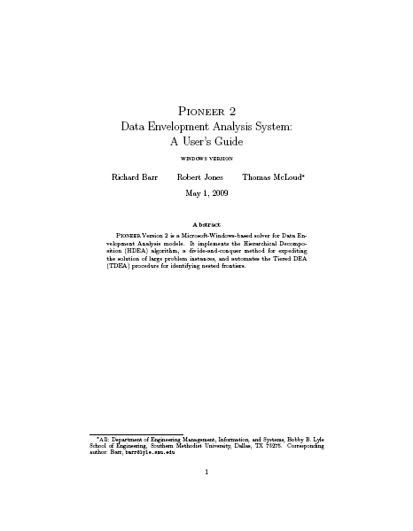
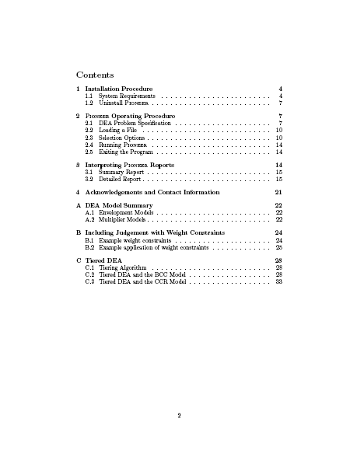
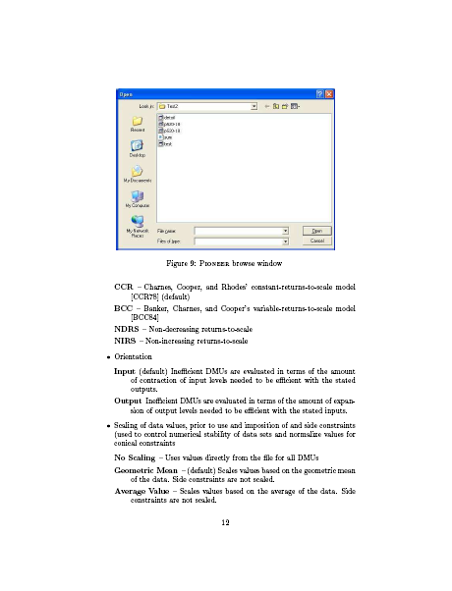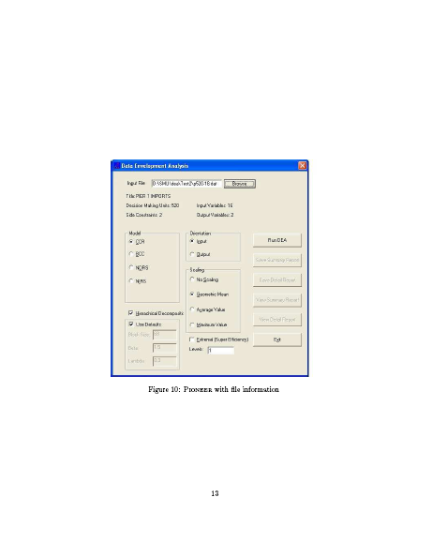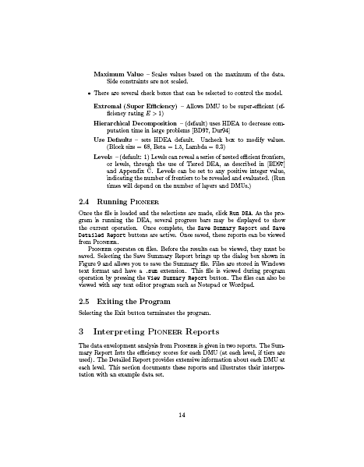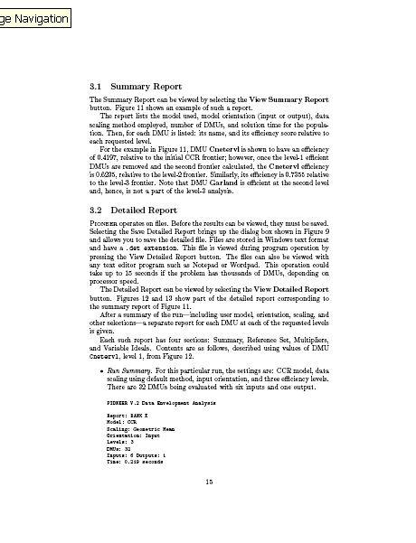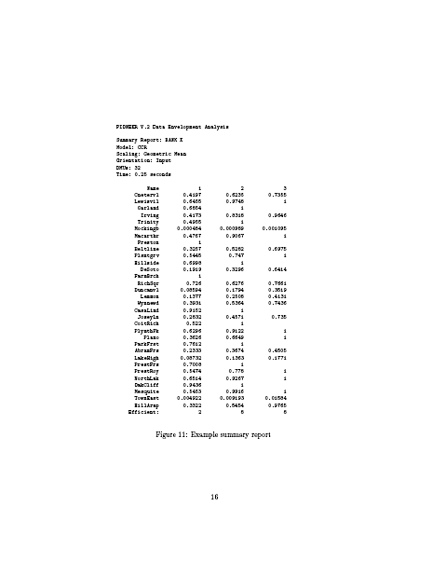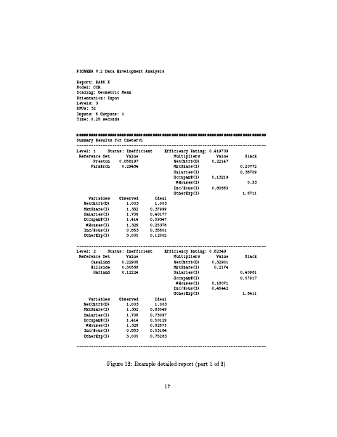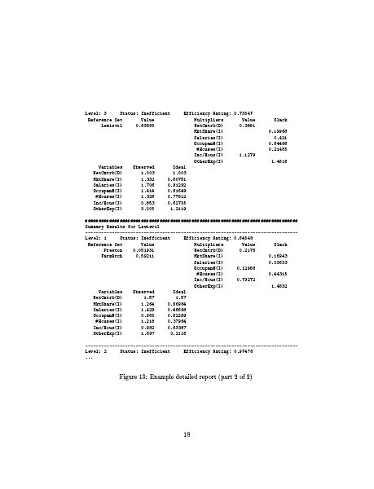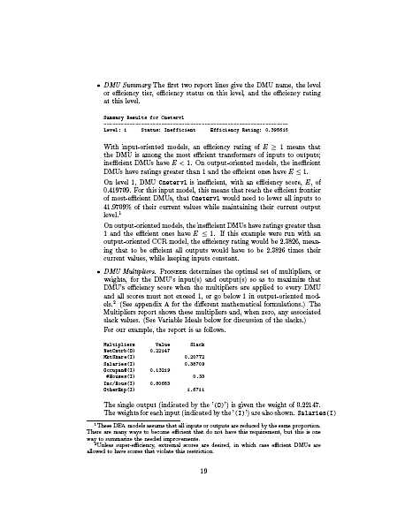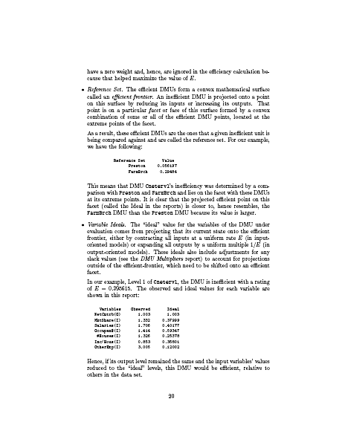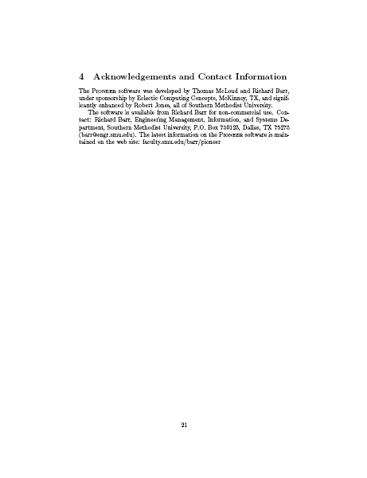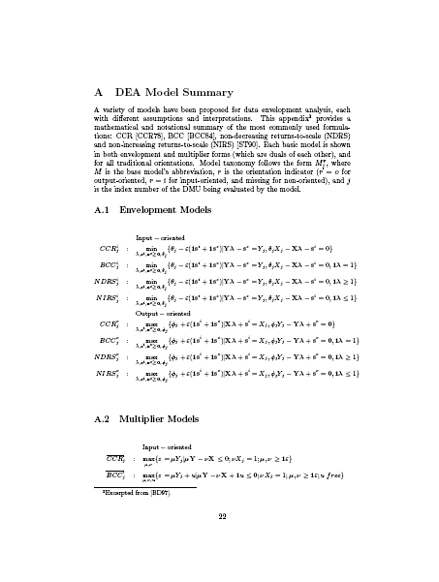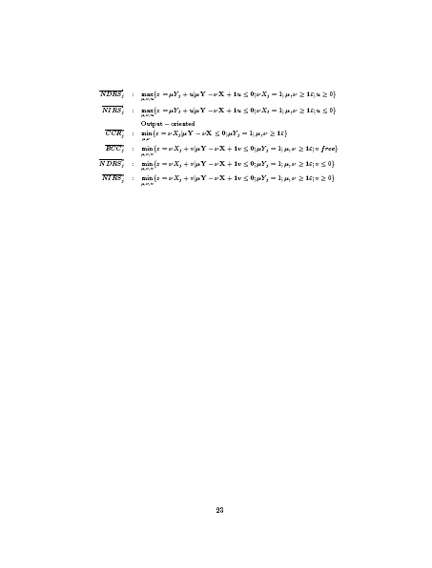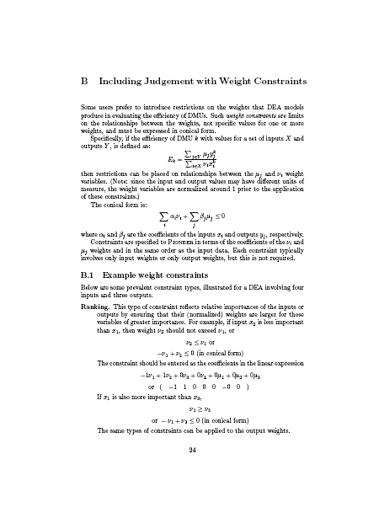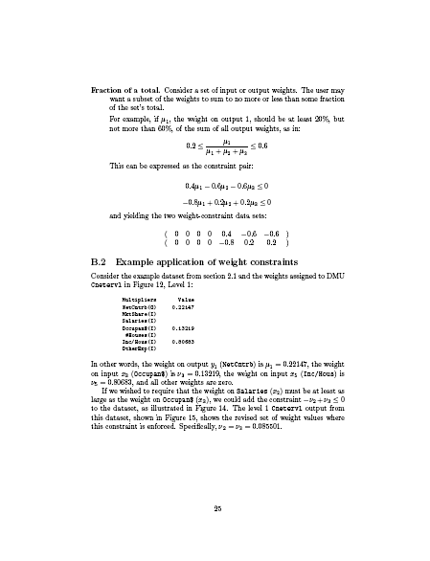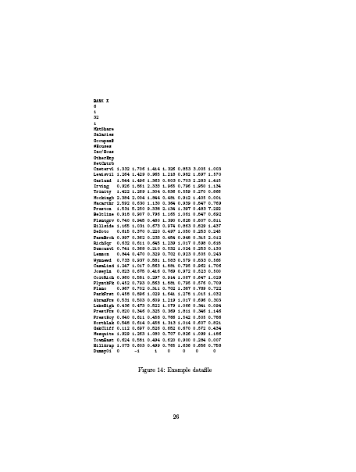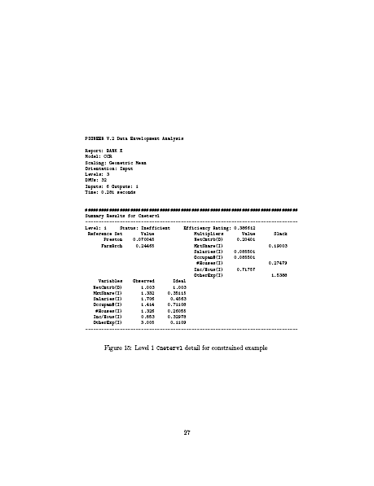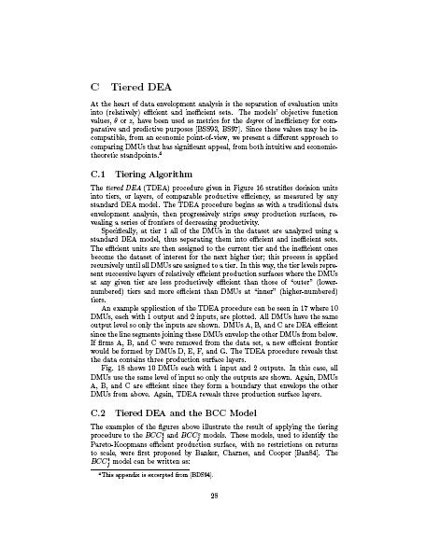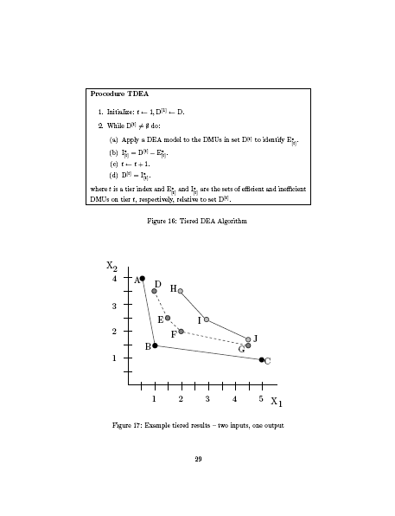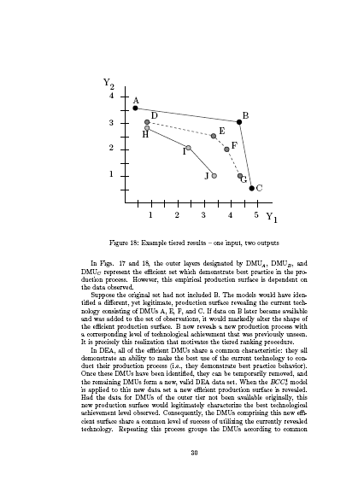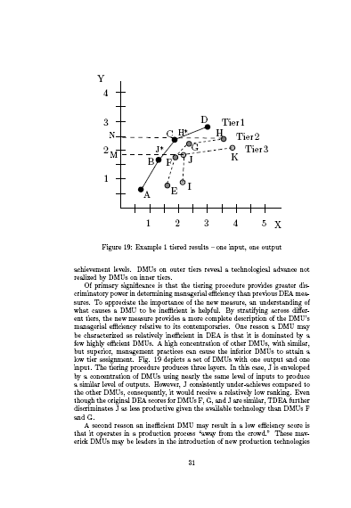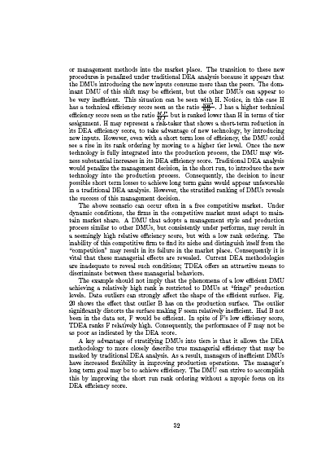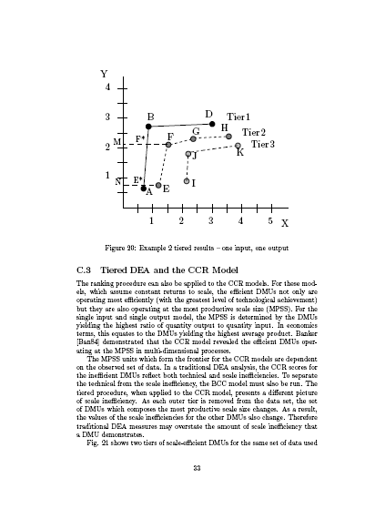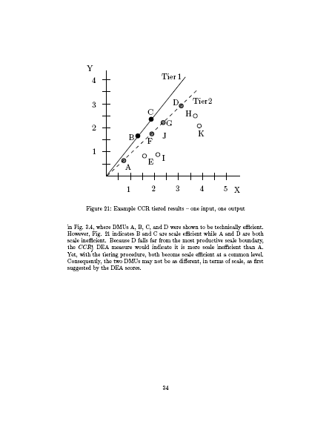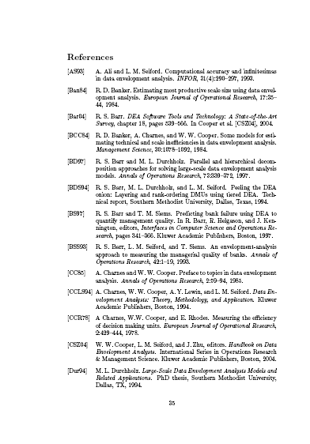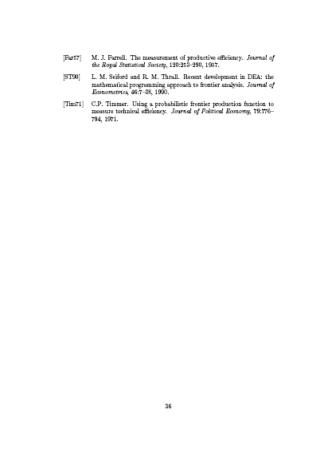

Appendix D: DEA Input Chart
Country | sizGov | legSys | sound$ | freeTr | reg | CPI | lit | humDev | GDPcap
Albania | 8.07 | 5.06 | 0.43 | 4.07 | 4.20 | 7.4 | 0.13 | 1.99 | 5316
Algeria | 4.93 | 4.85 | 3.67 | 3.70 | 4.85 | 6.9 | 3.01 | 2.67 | 7062
Angola | 0.85 | 6.84 | 5.94 | 3.03 | 4.56 | 7.8 | 3.26 | 5.54 | 2335
Argentina | 7.48 | 5.65 | 3.83 | 3.68 | 5.06 | 7.1 | 0.28 | 1.31 | 14280
Armenia | 6.26 | 4.44 | 0.57 | 3.47 | 3.63 | 7.1 | 0.06 | 2.25 | 4945
Australia | 6.77 | 1.32 | 0.54 | 2.83 | 1.88 | 1.3 | 0.1 | 0.38 | 31794
Austria | 5.18 | 1.33 | 0.46 | 2.32 | 2.78 | 1.4 | 0.1 | 0.52 | 33700
Azerbaijan | 3.64 | 4.33 | 2.90 | 3.62 | 4.14 | 7.6 | 0.12 | 2.54 | 5016
Bahrain | 6.52 | 3.87 | 0.62 | 2.70 | 2.71 | 4.3 | 1.35 | 1.34 | 21482
Bangladesh | 8.04 | 6.88 | 3.40 | 4.18 | 3.90 | 8 | 5.25 | 4.53 | 2053
Barbados | 5.22 | 3.14 | 3.77 | 4.75 | 2.80 | 3.3 | 0.1 | 1.08 | 17297
Belgium | 4.31 | 2.98 | 0.49 | 1.94 | 2.91 | 2.7 | 0.1 | 0.54 | 32119
Belize | 4.34 | 4.16 | 1.96 | 4.53 | 1.57 | 6.5 | 2.49 | 2.22 | 7109
Benin | 7.20 | 5.67 | 3.14 | 4.75 | 4.22 | 7.5 | 6.53 | 5.63 | 1141
Bolivia | 6.20 | 5.89 | 1.34 | 2.71 | 4.37 | 7.3 | 1.33 | 3.05 | 2819
Bosnia | 6.09 | 6.54 | 2.01 | 4.19 | 3.39 | 7.1 | 0.33 | 1.97 | 7032
Botswana | 5.04 | 3.20 | 1.38 | 3.09 | 2.55 | 4.4 | 1.88 | 3.46 | 12387
Brazil | 6.65 | 4.81 | 2.23 | 3.49 | 5.31 | 6.7 | 1.14 | 2 | 8402
Bulgaria | 4.95 | 4.39 | 1.24 | 2.36 | 2.89 | 6 | 0.18 | 1.76 | 9032
Burkina | 5.52 | 5.97 | 3.20 | 4.64 | 3.55 | 6.8 | 7.64 | 6.3 | 1213
Burundi | 4.68 | 6.94 | 2.70 | 5.69 | 3.22 | 7.6 | 4.07 | 5.87 | 699
Cameroon | 6.52 | 6.31 | 2.93 | 4.20 | 4.29 | 7.9 | 3.21 | 4.68 | 2299
Canada | 6.88 | 1.61 | 0.40 | 2.86 | 1.78 | 1.5 | 0.1 | 0.39 | 33375
Central | 6.32 | 7.01 | 3.20 | 5.97 | 5.09 | 7.6 | 5.14 | 6.16 | 1224
Chad | 6.45 | 7.72 | 3.88 | 4.07 | 5.19 | 8 | 7.43 | 6.12 | 1427
Chile | 7.50 | 3.01 | 0.86 | 1.60 | 1.76 | 2.7 | 0.43 | 1.33 | 12027
China | 5.00 | 4.07 | 1.78 | 2.53 | 5.17 | 6.7 | 0.91 | 2.23 | 6757
Colombia | 4.44 | 5.51 | 2.15 | 3.95 | 3.95 | 6.1 | 0.72 | 2.09 | 7304
CongoRep | 3.90 | 7.65 | 4.29 | 3.98 | 4.78 | 7.8 | 1.53 | 4.52 | 714
CostaRica | 8.01 | 3.21 | 1.11 | 2.38 | 3.41 | 5.9 | 0.51 | 1.54 | 10180
CoteD'Ivoire | 7.35 | 6.64 | 3.12 | 4.03 | 3.79 | 7.9 | 5.13 | 5.68 | 1648
Croatia | 4.34 | 4.26 | 1.68 | 3.27 | 3.36 | 6.6 | 0.19 | 1.5 | 13042
Cyprus | 7.44 | 2.51 | 0.81 | 3.16 | 4.19 | 4.4 | 0.32 | 0.97 | 22699
CzechRep | 4.49 | 3.84 | 0.70 | 2.08 | 3.12 | 5.2 | 0.1 | 1.09 | 20538
Denmark | 4.39 | 1.04 | 0.64 | 2.23 | 1.56 | 0.5 | 0.1 | 0.51 | 33973
DominicanRep | 7.80 | 5.37 | 4.42 | 3.04 | 3.63 | 7.2 | 1.3 | 2.21 | 8217
Ecuador | 8.03 | 5.94 | 4.94 | 3.42 | 4.40 | 7.7 | 0.9 | 2.28 | 4341
Egypt | 7.29 | 4.34 | 1.26 | 3.37 | 5.07 | 6.7 | 2.86 | 2.92 | 4337
ElSalvador | 8.96 | 5.17 | 0.63 | 2.82 | 2.77 | 6 | 1.94 | 2.65 | 5255
Estonia | 7.03 | 2.65 | 0.68 | 1.86 | 2.41 | 3.3 | 0.02 | 1.4 | 15478
Ethiopia | 5.86 | 5.34 | 4.24 | 4.33 | 3.75 | 7.6 | 6.41 | 5.94 | 1055
Finland | 5.03 | 0.99 | 0.48 | 2.57 | 2.53 | 0.4 | 0.1 | 0.48 | 32153
France | 4.11 | 2.47 | 0.49 | 2.62 | 2.60 | 2.6 | 0.1 | 0.48 | 30386
Gabon | 4.26 | 5.73 | 3.97 | 4.52 | 3.18 | 7 | 1.6 | 3.23 | 6954
Georgia | 7.42 | 5.05 | 0.93 | 2.56 | 2.45 | 7.2 | 0 | 2.46 | 3365
Germany | 5.82 | 1.41 | 0.53 | 2.12 | 3.53 | 2 | 0.1 | 0.65 | 29461
Ghana | 6.60 | 4.26 | 1.79 | 3.21 | 3.15 | 6.7 | 4.21 | 4.47 | 2480
Greece | 6.82 | 3.44 | 0.47 | 3.79 | 3.95 | 5.6 | 0.4 | 0.74 | 23381
Guatemala | 7.77 | 4.78 | 0.83 | 3.16 | 3.73 | 7.4 | 3.09 | 3.11 | 4568
Honduras | 8.94 | 5.15 | 1.06 | 2.77 | 3.21 | 7.5 | 2 | 3 | 3430
Hungary | 5.70 | 3.32 | 0.52 | 1.76 | 2.82 | 4.8 | 0.1 | 1.26 | 17887
Iceland | 6.94 | 1.20 | 1.38 | 4.10 | 1.24 | 0.4 | 0.1 | 0.32 | 36510
India | 7.14 | 3.88 | 3.30 | 3.18 | 3.83 | 6.7 | 3.9 | 3.81 | 3452
Indonesia | 6.36 | 6.07 | 2.82 | 2.71 | 4.17 | 7.6 | 0.96 | 2.72 | 3843
Iran | 6.79 | 3.89 | 1.76 | 3.58 | 5.24 | 7.3 | 1.76 | 2.41 | 7968
Ireland | 6.38 | 2.11 | 0.48 | 1.69 | 2.51 | 2.6 | 0.1 | 0.41 | 38505
Israel | 3.83 | 3.78 | 0.86 | 2.44 | 3.62 | 4.1 | 0.29 | 0.68 | 25864
Italy | 5.99 | 3.74 | 0.58 | 2.76 | 3.16 | 5.1 | 0.16 | 0.59 | 28529
Jamaica | 8.51 | 4.64 | 1.14 | 2.95 | 3.13 | 6.3 | 2.01 | 2.64 | 4291
Japan | 6.23 | 2.10 | 0.28 | 4.13 | 2.31 | 2.4 | 0.1 | 0.47 | 31267
Jordan | 5.53 | 3.60 | 1.06 | 2.40 | 2.55 | 4.7 | 0.89 | 2.27 | 5530
Kazakhstan | 7.77 | 3.79 | 1.79 | 3.14 | 2.89 | 7.4 | 0.05 | 2.06 | 7857
Kenya | 7.85 | 4.93 | 1.51 | 3.39 | 3.20 | 7.8 | 2.64 | 4.79 | 1240
Kuwait | 6.63 | 2.57 | 0.49 | 3.27 | 2.19 | 5.2 | 0.67 | 1.09 | 26321
KyrgyzRepublic | 8.05 | 5.39 | 1.31 | 3.22 | 3.32 | 7.8 | 0.13 | 3.04 | 1927
Latvia | 5.98 | 3.11 | 1.26 | 2.60 | 2.65 | 5.3 | 0.03 | 1.45 | 13646
Lesotho | 7.10 | 5.35 | 2.09 | 3.81 | 3.56 | 6.8 | 1.78 | 4.51 | 3335
Lithuania | 6.67 | 3.18 | 1.13 | 2.49 | 2.89 | 5.2 | 0.04 | 1.38 | 14494
Luxembourg | 4.93 | 1.89 | 1.01 | 1.84 | 2.28 | 1.4 | 0.1 | 0.56 | 60228
Macedonia | 6.05 | 5.65 | 1.82 | 3.67 | 2.86 | 7.3 | 0.39 | 1.99 | 7200
Madagascar | 6.92 | 6.68 | 2.67 | 3.54 | 4.23 | 6.9 | 2.93 | 4.67 | 923
Malawi | 5.41 | 4.75 | 4.69 | 5.04 | 3.82 | 7.3 | 3.59 | 5.63 | 667
Malaysia | 5.50 | 3.15 | 3.98 | 2.45 | 2.34 | 5 | 1.13 | 1.89 | 10882
Mali | 7.33 | 5.49 | 3.53 | 3.75 | 3.91 | 7.2 | 7.6 | 6.2 | 1033
Malta | 5.91 | 2.25 | 0.47 | 2.57 | 2.98 | 3.6 | 1.21 | 1.22 | 19189
Mauritania | 5.78 | 4.56 | 2.91 | 3.42 | 3.33 | 6.9 | 4.88 | 4.5 | 2234
Mauritius | 7.16 | 4.14 | 1.46 | 2.62 | 2.65 | 4.9 | 1.57 | 1.96 | 12715
Mexico | 7.33 | 4.55 | 1.76 | 2.86 | 3.28 | 6.7 | 0.84 | 1.71 | 10751
Moldova | 6.84 | 4.28 | 3.03 | 3.21 | 3.76 | 6.8 | 0.09 | 2.92 | 2100
Mongolia | 7.52 | 4.20 | 1.33 | 2.99 | 2.91 | 7.2 | 0.22 | 3 | 2107
Morocco | 6.68 | 3.90 | 3.11 | 4.13 | 4.36 | 6.8 | 4.77 | 3.54 | 4555
Mozambique | 4.67 | 5.87 | 2.49 | 3.42 | 4.04 | 7.2 | 6.13 | 6.16 | 1242
Namibia | 6.09 | 2.68 | 3.76 | 3.55 | 2.25 | 5.9 | 1.5 | 3.5 | 7586
Nepal | 5.26 | 6.04 | 3.42 | 4.51 | 4.54 | 7.5 | 5.14 | 4.66 | 1550
Netherlands | 4.06 | 1.51 | 0.31 | 1.67 | 2.31 | 1.3 | 0.1 | 0.47 | 32684
NewZealand | 6.70 | 1.10 | 0.65 | 2.21 | 1.35 | 0.4 | 0.1 | 0.57 | 24996
Nicaragua | 7.52 | 5.68 | 0.94 | 2.91 | 3.02 | 7.4 | 2.33 | 2.9 | 3674
Niger | 3.04 | 5.68 | 3.45 | 5.54 | 5.02 | 7.7 | 7.13 | 6.26 | 781
Nigeria | 3.97 | 6.02 | 2.62 | 2.78 | 3.14 | 7.8 | 3.09 | 5.3 | 1128
Norway | 5.80 | 1.09 | 1.10 | 3.38 | 2.52 | 1.2 | 0.1 | 0.32 | 41420
Oman | 5.51 | 2.95 | 0.67 | 2.87 | 2.44 | 4.6 | 1.86 | 1.86 | 15602
Pakistan | 7.01 | 5.69 | 3.55 | 4.09 | 3.44 | 7.8 | 5.01 | 4.49 | 2370
Panama | 8.37 | 4.79 | 0.89 | 2.59 | 3.02 | 6.9 | 0.81 | 1.88 | 7605
Paraguay | 7.50 | 6.57 | 1.80 | 2.28 | 4.86 | 7.4 | 0.65 | 2.45 | 4642
Peru | 8.27 | 5.00 | 1.24 | 2.69 | 3.56 | 6.7 | 1.21 | 2.27 | 6039
Philippines | 7.12 | 5.10 | 1.87 | 2.83 | 3.72 | 7.5 | 0.74 | 2.29 | 5137
Poland | 5.34 | 4.17 | 0.46 | 3.16 | 3.64 | 6.3 | 0.1 | 1.3 | 13847
Portugal | 5.71 | 2.79 | 0.68 | 2.67 | 3.78 | 3.4 | 0.62 | 1.03 | 20410
Romania | 5.54 | 4.49 | 1.31 | 2.88 | 3.55 | 6.9 | 0.27 | 1.87 | 9060
Russia | 5.64 | 4.27 | 2.54 | 4.00 | 4.21 | 7.5 | 0.06 | 1.98 | 10845
Rwanda | 4.87 | 6.96 | 3.21 | 5.61 | 2.92 | 7.5 | 3.51 | 5.48 | 1206
Senegal | 6.07 | 6.45 | 3.06 | 3.87 | 4.43 | 6.7 | 6.07 | 5.01 | 1792
SierraLeone | 7.13 | 6.83 | 2.76 | 4.74 | 4.57 | 7.8 | 6.52 | 6.64 | 806
Singapore | 7.86 | 1.57 | 1.01 | 0.65 | 1.78 | 0.6 | 0.75 | 0.78 | 29663
Slovenia | 2.48 | 3.95 | 1.06 | 2.77 | 2.80 | 3.6 | 0.03 | 0.83 | 22273
SouthAfrica | 6.97 | 3.45 | 2.24 | 3.30 | 2.85 | 5.4 | 1.76 | 3.26 | 11110
Spain | 6.69 | 3.29 | 0.51 | 2.84 | 3.14 | 3.2 | 0.1 | 0.51 | 27169
SriLanka | 7.03 | 5.08 | 3.90 | 3.65 | 3.83 | 6.9 | 0.93 | 2.57 | 4595
Sweden | 3.73 | 1.59 | 0.39 | 2.28 | 2.74 | 0.8 | 0.1 | 0.44 | 32525
Switzerland | 7.89 | 1.34 | 0.44 | 3.21 | 1.88 | 0.9 | 0.1 | 0.45 | 35633
Tanzania | 5.20 | 4.06 | 0.99 | 4.07 | 3.74 | 7.8 | 3.06 | 5.33 | 744
Thailand | 7.33 | 3.80 | 3.39 | 2.49 | 2.63 | 6.4 | 0.74 | 2.19 | 8677
Togo | 6.36 | 7.54 | 3.10 | 3.83 | 5.23 | 7.6 | 4.68 | 4.88 | 1506
TrinidadTob | 7.24 | 4.96 | 1.47 | 2.84 | 2.62 | 6.8 | 0.16 | 1.86 | 14603
Tunisia | 5.31 | 3.10 | 3.02 | 3.86 | 3.15 | 5.4 | 2.57 | 2.34 | 8371
Turkey | 7.82 | 3.71 | 4.58 | 3.23 | 4.53 | 6.2 | 1.26 | 2.25 | 8407
Uganda | 7.23 | 5.72 | 1.20 | 3.67 | 2.71 | 7.3 | 3.32 | 4.95 | 1454
Ukraine | 4.06 | 4.75 | 3.40 | 3.62 | 4.08 | 7.2 | 0.06 | 2.12 | 6848
UAE | 6.21 | 3.04 | 1.68 | 1.49 | 2.55 | 3.8 | 1.13 | 1.32 | 25514
UnitedKingdom | 6.64 | 1.67 | 0.60 | 2.24 | 1.75 | 1.4 | 0.1 | 0.54 | 33238
UnitedStates | 7.13 | 2.42 | 0.34 | 2.47 | 1.69 | 2.7 | 0.1 | 0.49 | 41890
Uruguay | 7.52 | 4.43 | 2.02 | 3.01 | 3.42 | 3.6 | 0.32 | 1.48 | 9962
Venezuela | 4.99 | 6.92 | 4.36 | 4.65 | 5.25 | 7.7 | 0.7 | 2.08 | 6632
Vietnam | 4.58 | 4.18 | 3.63 | 3.05 | 4.00 | 7.4 | 0.97 | 2.67 | 3071
Zambia | 8.19 | 4.42 | 1.43 | 2.89 | 4.00 | 7.4 | 3.2 | 5.66 | 1023
Zimbabwe | 2.66 | 6.39 | 10.00 | 7.27 | 5.65 | 7.6 | 1.06 | 4.87 | 2038

Appendix E: DEA Model with 8 Inputs
Globalization
8
1
126
8
sizGov
legSys
sound$
freeTr
reg
CPI
lit
humDev
GDPcap
Albania 8.07 5.06 0.43 4.07 4.20 7.4 0.13 1.99 5316
Algeria 4.93 4.85 3.67 3.70 4.85 6.9 3.01 2.67 7062
Angola 0.85 6.84 5.94 3.03 4.56 7.8 3.26 5.54 2335
Argentina 7.48 5.65 3.83 3.68 5.06 7.1 0.28 1.31 14280
Armenia 6.26 4.44 0.57 3.47 3.63 7.1 0.06 2.25 4945
Australia 6.77 1.32 0.54 2.83 1.88 1.3 0.1 0.38 31794
Austria 5.18 1.33 0.46 2.32 2.78 1.4 0.1 0.52 33700
Azerbaijan 3.64 4.33 2.90 3.62 4.14 7.6 0.12 2.54 5016
Bahrain 6.52 3.87 0.62 2.70 2.71 4.3 1.35 1.34 21482
Bangladesh 8.04 6.88 3.40 4.18 3.90 8 5.25 4.53 2053
Barbados 5.22 3.14 3.77 4.75 2.80 3.3 0.1 1.08 17297
Belgium 4.31 2.98 0.49 1.94 2.91 2.7 0.1 0.54 32119
Belize 4.34 4.16 1.96 4.53 1.57 6.5 2.49 2.22 7109
Benin 7.20 5.67 3.14 4.75 4.22 7.5 6.53 5.63 1141
Bolivia 6.20 5.89 1.34 2.71 4.37 7.3 1.33 3.05 2819
Bosnia 6.09 6.54 2.01 4.19 3.39 7.1 0.33 1.97 7032
Botswana 5.04 3.20 1.38 3.09 2.55 4.4 1.88 3.46 12387
Brazil 6.65 4.81 2.23 3.49 5.31 6.7 1.14 2 8402
Bulgaria 4.95 4.39 1.24 2.36 2.89 6 0.18 1.76 9032
Burkina 5.52 5.97 3.20 4.64 3.55 6.8 7.64 6.3 1213
Burundi 4.68 6.94 2.70 5.69 3.22 7.6 4.07 5.87 699
Cameroon 6.52 6.31 2.93 4.20 4.29 7.9 3.21 4.68 2299
Canada 6.88 1.61 0.40 2.86 1.78 1.5 0.1 0.39 33375
Central 6.32 7.01 3.20 5.97 5.09 7.6 5.14 6.16 1224
Chad 6.45 7.72 3.88 4.07 5.19 8 7.43 6.12 1427
Chile 7.50 3.01 0.86 1.60 1.76 2.7 0.43 1.33 12027
China 5.00 4.07 1.78 2.53 5.17 6.7 0.91 2.23 6757
Colombia 4.44 5.51 2.15 3.95 3.95 6.1 0.72 2.09 7304
Congo 3.90 7.65 4.29 3.98 4.78 7.8 1.53 4.52 714
CostaRica 8.01 3.21 1.11 2.38 3.41 5.9 0.51 1.54 10180
CoteD'Ivoire 7.35 6.64 3.12 4.03 3.79 7.9 5.13 5.68 1648
Croatia 4.34 4.26 1.68 3.27 3.36 6.6 0.19 1.5 13042
Cyprus 7.44 2.51 0.81 3.16 4.19 4.4 0.32 0.97 22699
CzechRep 4.49 3.84 0.70 2.08 3.12 5.2 0.1 1.09 20538
Denmark 4.39 1.04 0.64 2.23 1.56 0.5 0.1 0.51 33973
DominicanRep 7.80 5.37 4.42 3.04 3.63 7.2 1.3 2.21 8217
Ecuador 8.03 5.94 4.94 3.42 4.40 7.7 0.9 2.28 4341
Egypt 7.29 4.34 1.26 3.37 5.07 6.7 2.86 2.92 4337
ElSalvador 8.96 5.17 0.63 2.82 2.77 6 1.94 2.65 5255
Estonia 7.03 2.65 0.68 1.86 2.41 3.3 0.02 1.4 15478
Ethiopia 5.86 5.34 4.24 4.33 3.75 7.6 6.41 5.94 1055
Finland 5.03 0.99 0.48 2.57 2.53 0.4 0.1 0.48 32153
France 4.11 2.47 0.49 2.62 2.60 2.6 0.1 0.48 30386
Gabon 4.26 5.73 3.97 4.52 3.18 7 1.6 3.23 6954
Georgia 7.42 5.05 0.93 2.56 2.45 7.2 0 2.46 3365
Germany 5.82 1.41 0.53 2.12 3.53 2 0.1 0.65 29461
Ghana 6.60 4.26 1.79 3.21 3.15 6.7 4.21 4.47 2480
Greece 6.82 3.44 0.47 3.79 3.95 5.6 0.4 0.74 23381
Guatemala 7.77 4.78 0.83 3.16 3.73 7.4 3.09 3.11 4568
Honduras 8.94 5.15 1.06 2.77 3.21 7.5 2 3 3430
Hungary 5.70 3.32 0.52 1.76 2.82 4.8 0.1 1.26 17887
Iceland 6.94 1.20 1.38 4.10 1.24 0.4 0.1 0.32 36510
India 7.14 3.88 3.30 3.18 3.83 6.7 3.9 3.81 3452
Indonesia 6.36 6.07 2.82 2.71 4.17 7.6 0.96 2.72 3843
Iran 6.79 3.89 1.76 3.58 5.24 7.3 1.76 2.41 7968
Ireland 6.38 2.11 0.48 1.69 2.51 2.6 0.1 0.41 38505
Israel 3.83 3.78 0.86 2.44 3.62 4.1 0.29 0.68 25864
Italy 5.99 3.74 0.58 2.76 3.16 5.1 0.16 0.59 28529
Jamaica 8.51 4.64 1.14 2.95 3.13 6.3 2.01 2.64 4291
Japan 6.23 2.10 0.28 4.13 2.31 2.4 0.1 0.47 31267
Jordan 5.53 3.60 1.06 2.40 2.55 4.7 0.89 2.27 5530
Kazakhstan 7.77 3.79 1.79 3.14 2.89 7.4 0.05 2.06 7857
Kenya 7.85 4.93 1.51 3.39 3.20 7.8 2.64 4.79 1240
Kuwait 6.63 2.57 0.49 3.27 2.19 5.2 0.67 1.09 26321
KyrgyzRepublic 8.05 5.39 1.31 3.22 3.32 7.8 0.13 3.04 1927
Latvia 5.98 3.11 1.26 2.60 2.65 5.3 0.03 1.45 13646
Lesotho 7.10 5.35 2.09 3.81 3.56 6.8 1.78 4.51 3335
Lithuania 6.67 3.18 1.13 2.49 2.89 5.2 0.04 1.38 14494
Luxembourg 4.93 1.89 1.01 1.84 2.28 1.4 0.1 0.56 60228
Macedonia 6.05 5.65 1.82 3.67 2.86 7.3 0.39 1.99 7200
Madagascar 6.92 6.68 2.67 3.54 4.23 6.9 2.93 4.67 923
Malawi 5.41 4.75 4.69 5.04 3.82 7.3 3.59 5.63 667
Malaysia 5.50 3.15 3.98 2.45 2.34 5 1.13 1.89 10882
Mali 7.33 5.49 3.53 3.75 3.91 7.2 7.6 6.2 1033
Malta 5.91 2.25 0.47 2.57 2.98 3.6 1.21 1.22 19189
Mauritania 5.78 4.56 2.91 3.42 3.33 6.9 4.88 4.5 2234
Mauritius 7.16 4.14 1.46 2.62 2.65 4.9 1.57 1.96 12715
Mexico 7.33 4.55 1.76 2.86 3.28 6.7 0.84 1.71 10751
Moldova 6.84 4.28 3.03 3.21 3.76 6.8 0.09 2.92 2100
Mongolia 7.52 4.20 1.33 2.99 2.91 7.2 0.22 3 2107
Morocco 6.68 3.90 3.11 4.13 4.36 6.8 4.77 3.54 4555
Mozambique 4.67 5.87 2.49 3.42 4.04 7.2 6.13 6.16 1242
Namibia 6.09 2.68 3.76 3.55 2.25 5.9 1.5 3.5 7586
Nepal 5.26 6.04 3.42 4.51 4.54 7.5 5.14 4.66 1550
Netherlands 4.06 1.51 0.31 1.67 2.31 1.3 0.1 0.47 32684
NewZealand 6.70 1.10 0.65 2.21 1.35 0.4 0.1 0.57 24996
Nicaragua 7.52 5.68 0.94 2.91 3.02 7.4 2.33 2.9 3674
Niger 3.04 5.68 3.45 5.54 5.02 7.7 7.13 6.26 781
Nigeria 3.97 6.02 2.62 2.78 3.14 7.8 3.09 5.3 1128
Norway 5.80 1.09 1.10 3.38 2.52 1.2 0.1 0.32 41420
Oman 5.51 2.95 0.67 2.87 2.44 4.6 1.86 1.86 15602
Pakistan 7.01 5.69 3.55 4.09 3.44 7.8 5.01 4.49 2370
Panama 8.37 4.79 0.89 2.59 3.02 6.9 0.81 1.88 7605
Paraguay 7.50 6.57 1.80 2.28 4.86 7.4 0.65 2.45 4642
Peru 8.27 5.00 1.24 2.69 3.56 6.7 1.21 2.27 6039
Philippines 7.12 5.10 1.87 2.83 3.72 7.5 0.74 2.29 5137
Poland 5.34 4.17 0.46 3.16 3.64 6.3 0.1 1.3 13847
Portugal 5.71 2.79 0.68 2.67 3.78 3.4 0.62 1.03 20410
Romania 5.54 4.49 1.31 2.88 3.55 6.9 0.27 1.87 9060
Russia 5.64 4.27 2.54 4.00 4.21 7.5 0.06 1.98 10845
Rwanda 4.87 6.96 3.21 5.61 2.92 7.5 3.51 5.48 1206
Senegal 6.07 6.45 3.06 3.87 4.43 6.7 6.07 5.01 1792
SierraLeone 7.13 6.83 2.76 4.74 4.57 7.8 6.52 6.64 806
Singapore 7.86 1.57 1.01 0.65 1.78 0.6 0.75 0.78 29663
Slovenia 2.48 3.95 1.06 2.77 2.80 3.6 0.03 0.83 22273
SouthAfrica 6.97 3.45 2.24 3.30 2.85 5.4 1.76 3.26 11110
Spain 6.69 3.29 0.51 2.84 3.14 3.2 0.1 0.51 27169
SriLanka 7.03 5.08 3.90 3.65 3.83 6.9 0.93 2.57 4595
Sweden 3.73 1.59 0.39 2.28 2.74 0.8 0.1 0.44 32525
Switzerland 7.89 1.34 0.44 3.21 1.88 0.9 0.1 0.45 35633
Tanzania 5.20 4.06 0.99 4.07 3.74 7.8 3.06 5.33 744
Thailand 7.33 3.80 3.39 2.49 2.63 6.4 0.74 2.19 8677
Togo 6.36 7.54 3.10 3.83 5.23 7.6 4.68 4.88 1506
TrinidadTob 7.24 4.96 1.47 2.84 2.62 6.8 0.16 1.86 14603
Tunisia 5.31 3.10 3.02 3.86 3.15 5.4 2.57 2.34 8371
Turkey 7.82 3.71 4.58 3.23 4.53 6.2 1.26 2.25 8407
Uganda 7.23 5.72 1.20 3.67 2.71 7.3 3.32 4.95 1454
Ukraine 4.06 4.75 3.40 3.62 4.08 7.2 0.06 2.12 6848
UAE 6.21 3.04 1.68 1.49 2.55 3.8 1.13 1.32 25514
UnitedKingdom 6.64 1.67 0.60 2.24 1.75 1.4 0.1 0.54 33238
UnitedStates 7.13 2.42 0.34 2.47 1.69 2.7 0.1 0.49 41890
Uruguay 7.52 4.43 2.02 3.01 3.42 3.6 0.32 1.48 9962
Venezuela 4.99 6.92 4.36 4.65 5.25 7.7 0.7 2.08 6632
Vietnam 4.58 4.18 3.63 3.05 4.00 7.4 0.97 2.67 3071
Zambia 8.19 4.42 1.43 2.89 4.00 7.4 3.2 5.66 1023
Zimbabwe 2.66 6.39 10.00 7.27 5.65 7.6 1.06 4.87 2038
weight1 .8 -.2 -.2 -.2 -.2 -.2 -.2 -.2 0
weight2 -.2 .8 -.2 -.2 -.2 -.2 -.2 -.2 0
weight3 -.2 -.2 .8 -.2 -.2 -.2 -.2 -.2 0
weight4 -.2 -.2 -.2 .8 -.2 -.2 -.2 -.2 0
weight5 -.2 -.2 -.2 -.2 .8 -.2 -.2 -.2 0
weight6 -.2 -.2 -.2 -.2 -.2 .8 -.2 -.2 0
weight7 -.2 -.2 -.2 -.2 -.2 -.2 .8 -.2 0
weight8 -.2 -.2 -.2 -.2 -.2 -.2 -.2 .8 0

Appendix F: DEA Model Output
PIONEER V.2 Data Envelopment Analysis

Summary Report: Globalization
Model: BCC
Scaling: Geometric Mean
Orientation: Input
DMUs: 126
Time: 1.36 seconds

Name 1 2 3 4
5 6 7 8
9 10 11 12
13 14 15
Albania 0.5153 0.6225 0.7005 0.7983
0.9102 1
Algeria 0.4022 0.5031 0.5695 0.6329
0.7351 0.8246 0.8876 0.9689
1
Angola 0.3909 0.5245 0.5975 0.6574
0.7259 0.7529 0.823 0.9478
0.9793 1
Argentina 0.4561 0.5304 0.6188 0.6629
0.812 0.9592 1
Armenia 0.6093 0.733 0.8101 0.9341
1
Australia 0.9731 1
Austria 0.9027 1
Azerbaijan 0.5412 0.6797 0.7443 0.8132
0.9178 1
Bahrain 0.6105 0.7618 0.8767 0.9466
1
Bangladesh 0.3274 0.4225 0.4813 0.5328
0.5874 0.6423 0.7262 0.777
0.8237 0.8946 0.9695 1
Barbados 0.5908 0.7467 0.9483 1
Belgium 0.8691 1
Belize 0.5135 0.6326 0.707 0.8104
0.9112 1
Benin 0.3417 0.439 0.5001 0.5575
0.6101 0.6235 0.7352 0.7936
0.8337 0.8793 0.9579 1
Bolivia 0.4457 0.5507 0.6183 0.6852
0.7479 0.8622 0.9298 0.9913
1
Bosnia 0.4723 0.5525 0.6432 0.7085
0.8201 0.9168 1
Botswana 0.5826 0.7149 0.8085 0.9154
0.9875 1
Brazil 0.4042 0.502 0.5612 0.6372
0.7496 0.8402 0.9148 1
Bulgaria 0.6399 0.7885 0.8694 0.9844
1
Burkina 0.364 0.4792 0.5459 0.6068
0.666 0.6752 0.8018 0.8663
0.8998 0.9525 1
Burundi 0.3567 0.4444 0.506 0.5718
0.6182 0.6439 0.7859 0.8224
0.8782 0.9151 1
Cameroon 0.3504 0.4403 0.5016 0.5587
0.6124 0.6567 0.7532 0.8087
0.8542 0.9129 1
Canada 1
Central 0.3051 0.3903 0.4447 0.5
0.5429 0.5637 0.674 0.7166
0.7633 0.8047 0.8953 0.9843
1
Chad 0.3058 0.4052 0.4616 0.5092
0.5633 0.5915 0.6823 0.7349
0.763 0.8156 0.8693 0.9215
1
Chile 0.7026 0.8886 1
China 0.4662 0.5697 0.6337 0.7454
0.8506 0.9462 1
Colombia 0.4384 0.5387 0.6283 0.727
0.8367 0.9353 1
Congo 0.3297 0.4425 0.5041 0.5892
0.6377 0.7273 0.7628 0.8266
0.8926 0.972 1
CostaRica 0.5354 0.6604 0.7328 0.8824
0.9782 1
CoteD'Ivoire 0.3453 0.4393 0.5005 0.5564
0.611 0.6345 0.7486 0.7967
0.8238 0.8824 0.9666 1
Croatia 0.6005 0.716 0.8154 0.8801
1
Cyprus 0.5402 0.6606 0.7468 0.987
1
CzechRep 0.7625 0.9069 1
Denmark 1
DominicanRep 0.4162 0.5206 0.5819 0.6521
0.7415 0.8353 0.8771 1
Ecuador 0.379 0.4741 0.5325 0.6142
0.6963 0.782 0.8324 0.9108
0.989 1
Egypt 0.4336 0.5357 0.5944 0.6339
0.7133 0.8409 0.9423 0.9978
1
ElSalvador 0.5036 0.6229 0.7076 0.7705
0.8318 0.9835 1
Estonia 0.796 0.9491 1
Ethiopia 0.3559 0.4775 0.544 0.5985
0.6624 0.6729 0.767 0.863
0.8792 0.9418 0.998 1
Finland 1
France 0.8995 1
Gabon 0.3928 0.5096 0.5805 0.6685
0.7278 0.8225 0.879 0.9835
1
Georgia 0.6648 0.7907 0.8395 1
Germany 0.8154 0.9617 1
Ghana 0.4681 0.5783 0.6417 0.7134
0.7696 0.8089 0.974 1
Greece 0.5639 0.6863 0.8024 0.9261
1
Guatemala 0.4808 0.5941 0.6592 0.6908
0.7242 0.8764 0.9589 1
Honduras 0.4667 0.5766 0.6398 0.6755
0.7395 0.8671 0.9266 0.9816
1
Hungary 0.7919 0.9536 1
Iceland 1
India 0.3985 0.5346 0.609 0.67
0.7422 0.7998 0.8787 0.9748
1
Indonesia 0.4003 0.4988 0.5649 0.6659
0.733 0.8321 0.8816 0.9582
1
Iran 0.4164 0.5135 0.5698 0.6358
0.732 0.8197 0.9341 1
Ireland 0.9746 1
Israel 0.6976 0.8322 0.9867 1
Italy 0.6846 0.8086 0.9892 1
Jamaica 0.4771 0.5894 0.654 0.7023
0.7651 0.8966 0.9733 1
Japan 0.8753 1
Jordan 0.6135 0.758 0.8434 0.9532
1
Kazakhstan 0.556 0.6943 0.7611 0.823
0.9853 1
Kenya 0.4458 0.5507 0.6111 0.6455
0.6881 0.7726 0.9018 0.9334
0.9815 1
Kuwait 0.6655 0.8371 0.9344 1
KyrgyzRepublic 0.5111 0.6211 0.6608 0.7805
0.8567 0.9395 1
Latvia 0.6848 0.8436 0.9361 1
Lesotho 0.4046 0.497 0.5595 0.6375
0.691 0.7586 0.8636 0.9318
0.991 1
Lithuania 0.6565 0.8039 0.8965 1
Luxembourg 1
Macedonia 0.4962 0.5899 0.6743 0.7372
0.8363 0.9463 1
Madagascar 0.3629 0.4582 0.522 0.588
0.6386 0.6873 0.797 0.8493
0.8864 0.9649 1
Malawi 0.3581 0.4805 0.5474 0.6023
0.6663 0.6771 0.7572 0.8683
0.9033 0.9514 1
Malaysia 0.5853 0.7322 0.8239 0.9332
1
Mali 0.3544 0.4727 0.5385 0.5925
0.6565 0.6661 0.7761 0.8544
0.8705 0.9386 0.9976 1
Malta 0.696 0.8599 0.9542 1
Mauritania 0.4189 0.543 0.6185 0.6824
0.7542 0.7852 0.8937 0.9814
1
Mauritius 0.5179 0.6373 0.721 0.814
0.913 1
Mexico 0.4818 0.5917 0.6614 0.7442
0.8599 0.9434 1
Moldova 0.514 0.6455 0.7065 0.7808
0.8878 0.9927 1
Mongolia 0.5391 0.6629 0.7141 0.8288
0.9313 1
Morocco 0.3801 0.4987 0.5681 0.6294
0.6929 0.7724 0.8508 0.9308
0.9813 1
Mozambique 0.4067 0.5052 0.5749 0.6446
0.7022 0.7111 0.8715 0.9125
0.9583 1
Namibia 0.4836 0.649 0.7393 0.8324
0.9018 0.9859 1
Nepal 0.345 0.4524 0.5153 0.5709
0.6286 0.6716 0.758 0.8221
0.8665 0.922 1
Netherlands 1
NewZealand 1
Nicaragua 0.4842 0.5982 0.6646 0.718
0.7646 0.9235 0.9817 1
Niger 0.3432 0.4488 0.5113 0.5705
0.6237 0.6324 0.7474 0.8114
0.8622 0.8989 0.9725 1
Nigeria 0.4395 0.5443 0.6191 0.6921
0.7561 0.7712 0.934 0.9966
1
Norway 0.9175 1
Oman 0.6639 0.8203 0.9102 0.9539
1
Pakistan 0.3542 0.4666 0.5315 0.5854
0.6481 0.6959 0.7746 0.8436
0.8862 0.9439 1
Panama 0.5057 0.6348 0.7175 0.7929
0.8984 0.9927 1
Paraguay 0.4058 0.5025 0.5762 0.6469
0.7391 0.8337 0.9589 1
Peru 0.4624 0.5713 0.6413 0.7049
0.783 0.895 0.9536 1
Philippines 0.4408 0.5375 0.6056 0.7072
0.7779 0.8653 0.9437 1
Poland 0.6553 0.7866 0.917 1
Portugal 0.6082 0.76 0.8641 1
Romania 0.5453 0.6727 0.7403 0.8385
0.9 1
Russia 0.5052 0.626 0.6953 0.7688
0.8972 1
Rwanda 0.3488 0.4508 0.5135 0.5754
0.6269 0.6588 0.7689 0.8305
0.8815 0.9149 1
Senegal 0.3555 0.4634 0.5279 0.5861
0.6444 0.6817 0.7881 0.8448
0.8796 0.9433 1
SierraLeone 0.3318 0.4127 0.4698 0.5289
0.5739 0.5877 0.7166 0.748
0.7945 0.8279 0.9273 0.9886
1
Singapore 1
Slovenia 0.8801 1
SouthAfrica 0.4719 0.6049 0.6891 0.7677
0.8435 0.9037 1
Spain 0.7016 0.8325 1
SriLanka 0.4002 0.5006 0.5621 0.6724
0.7344 0.8234 0.8628 0.9714
1
Sweden 1
Switzerland 1
Tanzania 0.5015 0.6196 0.6875 0.7205
0.7553 0.8667 1
Thailand 0.4988 0.6239 0.6973 0.8265
0.9114 0.997 1
Togo 0.3266 0.4166 0.4746 0.5333
0.5797 0.6333 0.7265 0.7711
0.8138 0.8988 0.9629 1
TrinidadTob 0.5628 0.6832 0.7646 0.8489
0.9706 1
Tunisia 0.4834 0.6165 0.7023 0.7941
0.8725 1
Turkey 0.4209 0.5264 0.5887 0.6808
0.773 0.8645 0.9401 1
Uganda 0.4594 0.5675 0.6335 0.6855
0.7219 0.8071 0.9237 0.973
1
Ukraine 0.546 0.669 0.7497 0.8118
0.9339 1
UAE 0.6541 0.8182 0.9272 1
UnitedKingdom 0.9589 1
UnitedStates 1
Uruguay 0.5144 0.6238 0.7335 0.8906
1
Venezuela 0.3827 0.4577 0.5317 0.5922
0.7042 0.7931 0.8698 1
Vietnam 0.4543 0.5683 0.6352 0.7532
0.8172 0.9069 0.9437 1
Zambia 0.449 0.5547 0.6155 0.6522
0.6942 0.7759 0.9176 0.951
1
Zimbabwe 0.3029 0.3997 0.4553 0.5674
0.6278 0.7093 0.7442 0.8668
0.9277 1
Efficient: 11 9 6 11
10 13 14 13
12 7 10 7
3 0 0

Appendix G: DEA Ranking Model Inputs
Globalization
8
1
134
8
sizGov
legSys
sound$
freeTr
reg
CPI
lit
humDev
GDPcap
Albania 8.07 5.06 0.43 4.07 4.20 7.4 0.13 1.99 5316
Algeria 4.93 4.85 3.67 3.70 4.85 6.9 3.01 2.67 7062
Angola 0.85 6.84 5.94 3.03 4.56 7.8 3.26 5.54 2335
Argentina 7.48 5.65 3.83 3.68 5.06 7.1 0.28 1.31 14280
Armenia 6.26 4.44 0.57 3.47 3.63 7.1 0.06 2.25 4945
Australia 6.77 1.32 0.54 2.83 1.88 1.3 0.1 0.38 31794
Austria 5.18 1.33 0.46 2.32 2.78 1.4 0.1 0.52 33700
Azerbaijan 3.64 4.33 2.90 3.62 4.14 7.6 0.12 2.54 5016
Bahrain 6.52 3.87 0.62 2.70 2.71 4.3 1.35 1.34 21482
Bangladesh 8.04 6.88 3.40 4.18 3.90 8 5.25 4.53 2053
Barbados 5.22 3.14 3.77 4.75 2.80 3.3 0.1 1.08 17297
Belgium 4.31 2.98 0.49 1.94 2.91 2.7 0.1 0.54 32119
Belize 4.34 4.16 1.96 4.53 1.57 6.5 2.49 2.22 7109
Benin 7.20 5.67 3.14 4.75 4.22 7.5 6.53 5.63 1141
Bolivia 6.20 5.89 1.34 2.71 4.37 7.3 1.33 3.05 2819
Bosnia 6.09 6.54 2.01 4.19 3.39 7.1 0.33 1.97 7032
Botswana 5.04 3.20 1.38 3.09 2.55 4.4 1.88 3.46 12387
Brazil 6.65 4.81 2.23 3.49 5.31 6.7 1.14 2 8402
Bulgaria 4.95 4.39 1.24 2.36 2.89 6 0.18 1.76 9032
Burkina 5.52 5.97 3.20 4.64 3.55 6.8 7.64 6.3 1213
Burundi 4.68 6.94 2.70 5.69 3.22 7.6 4.07 5.87 699
Cameroon 6.52 6.31 2.93 4.20 4.29 7.9 3.21 4.68 2299
Canada 6.88 1.61 0.40 2.86 1.78 1.5 0.1 0.39 33375
Central 6.32 7.01 3.20 5.97 5.09 7.6 5.14 6.16 1224
Chad 6.45 7.72 3.88 4.07 5.19 8 7.43 6.12 1427
Chile 7.50 3.01 0.86 1.60 1.76 2.7 0.43 1.33 12027
China 5.00 4.07 1.78 2.53 5.17 6.7 0.91 2.23 6757
Colombia 4.44 5.51 2.15 3.95 3.95 6.1 0.72 2.09 7304
Congo 3.90 7.65 4.29 3.98 4.78 7.8 1.53 4.52 714
CostaRica 8.01 3.21 1.11 2.38 3.41 5.9 0.51 1.54 10180
CoteD'Ivoire 7.35 6.64 3.12 4.03 3.79 7.9 5.13 5.68 1648
Croatia 4.34 4.26 1.68 3.27 3.36 6.6 0.19 1.5 13042
Cyprus 7.44 2.51 0.81 3.16 4.19 4.4 0.32 0.97 22699
CzechRep 4.49 3.84 0.70 2.08 3.12 5.2 0.1 1.09 20538
Denmark 4.39 1.04 0.64 2.23 1.56 0.5 0.1 0.51 33973
DominicanRep 7.80 5.37 4.42 3.04 3.63 7.2 1.3 2.21 8217
Ecuador 8.03 5.94 4.94 3.42 4.40 7.7 0.9 2.28 4341
Egypt 7.29 4.34 1.26 3.37 5.07 6.7 2.86 2.92 4337
ElSalvador 8.96 5.17 0.63 2.82 2.77 6 1.94 2.65 5255
Estonia 7.03 2.65 0.68 1.86 2.41 3.3 0.02 1.4 15478
Ethiopia 5.86 5.34 4.24 4.33 3.75 7.6 6.41 5.94 1055
Finland 5.03 0.99 0.48 2.57 2.53 0.4 0.1 0.48 32153
France 4.11 2.47 0.49 2.62 2.60 2.6 0.1 0.48 30386
Gabon 4.26 5.73 3.97 4.52 3.18 7 1.6 3.23 6954
Georgia 7.42 5.05 0.93 2.56 2.45 7.2 0 2.46 3365
Germany 5.82 1.41 0.53 2.12 3.53 2 0.1 0.65 29461
Ghana 6.60 4.26 1.79 3.21 3.15 6.7 4.21 4.47 2480
Greece 6.82 3.44 0.47 3.79 3.95 5.6 0.4 0.74 23381
Guatemala 7.77 4.78 0.83 3.16 3.73 7.4 3.09 3.11 4568
Honduras 8.94 5.15 1.06 2.77 3.21 7.5 2 3 3430
Hungary 5.70 3.32 0.52 1.76 2.82 4.8 0.1 1.26 17887
Iceland 6.94 1.20 1.38 4.10 1.24 0.4 0.1 0.32 36510
India 7.14 3.88 3.30 3.18 3.83 6.7 3.9 3.81 3452
Indonesia 6.36 6.07 2.82 2.71 4.17 7.6 0.96 2.72 3843
Iran 6.79 3.89 1.76 3.58 5.24 7.3 1.76 2.41 7968
Ireland 6.38 2.11 0.48 1.69 2.51 2.6 0.1 0.41 38505
Israel 3.83 3.78 0.86 2.44 3.62 4.1 0.29 0.68 25864
Italy 5.99 3.74 0.58 2.76 3.16 5.1 0.16 0.59 28529
Jamaica 8.51 4.64 1.14 2.95 3.13 6.3 2.01 2.64 4291
Japan 6.23 2.10 0.28 4.13 2.31 2.4 0.1 0.47 31267
Jordan 5.53 3.60 1.06 2.40 2.55 4.7 0.89 2.27 5530
Kazakhstan 7.77 3.79 1.79 3.14 2.89 7.4 0.05 2.06 7857
Kenya 7.85 4.93 1.51 3.39 3.20 7.8 2.64 4.79 1240
Kuwait 6.63 2.57 0.49 3.27 2.19 5.2 0.67 1.09 26321
KyrgyzRepublic 8.05 5.39 1.31 3.22 3.32 7.8 0.13 3.04 1927
Latvia 5.98 3.11 1.26 2.60 2.65 5.3 0.03 1.45 13646
Lesotho 7.10 5.35 2.09 3.81 3.56 6.8 1.78 4.51 3335
Lithuania 6.67 3.18 1.13 2.49 2.89 5.2 0.04 1.38 14494
Luxembourg 4.93 1.89 1.01 1.84 2.28 1.4 0.1 0.56 60228
Macedonia 6.05 5.65 1.82 3.67 2.86 7.3 0.39 1.99 7200
Madagascar 6.92 6.68 2.67 3.54 4.23 6.9 2.93 4.67 923
Malawi 5.41 4.75 4.69 5.04 3.82 7.3 3.59 5.63 667
Malaysia 5.50 3.15 3.98 2.45 2.34 5 1.13 1.89 10882
Mali 7.33 5.49 3.53 3.75 3.91 7.2 7.6 6.2 1033
Malta 5.91 2.25 0.47 2.57 2.98 3.6 1.21 1.22 19189
Mauritania 5.78 4.56 2.91 3.42 3.33 6.9 4.88 4.5 2234
Mauritius 7.16 4.14 1.46 2.62 2.65 4.9 1.57 1.96 12715
Mexico 7.33 4.55 1.76 2.86 3.28 6.7 0.84 1.71 10751
Moldova 6.84 4.28 3.03 3.21 3.76 6.8 0.09 2.92 2100
Mongolia 7.52 4.20 1.33 2.99 2.91 7.2 0.22 3 2107
Morocco 6.68 3.90 3.11 4.13 4.36 6.8 4.77 3.54 4555
Mozambique 4.67 5.87 2.49 3.42 4.04 7.2 6.13 6.16 1242
Namibia 6.09 2.68 3.76 3.55 2.25 5.9 1.5 3.5 7586
Nepal 5.26 6.04 3.42 4.51 4.54 7.5 5.14 4.66 1550
Netherlands 4.06 1.51 0.31 1.67 2.31 1.3 0.1 0.47 32684
NewZealand 6.70 1.10 0.65 2.21 1.35 0.4 0.1 0.57 24996
Nicaragua 7.52 5.68 0.94 2.91 3.02 7.4 2.33 2.9 3674
Niger 3.04 5.68 3.45 5.54 5.02 7.7 7.13 6.26 781
Nigeria 3.97 6.02 2.62 2.78 3.14 7.8 3.09 5.3 1128
Norway 5.80 1.09 1.10 3.38 2.52 1.2 0.1 0.32 41420
Oman 5.51 2.95 0.67 2.87 2.44 4.6 1.86 1.86 15602
Pakistan 7.01 5.69 3.55 4.09 3.44 7.8 5.01 4.49 2370
Panama 8.37 4.79 0.89 2.59 3.02 6.9 0.81 1.88 7605
Paraguay 7.50 6.57 1.80 2.28 4.86 7.4 0.65 2.45 4642
Peru 8.27 5.00 1.24 2.69 3.56 6.7 1.21 2.27 6039
Philippines 7.12 5.10 1.87 2.83 3.72 7.5 0.74 2.29 5137
Poland 5.34 4.17 0.46 3.16 3.64 6.3 0.1 1.3 13847
Portugal 5.71 2.79 0.68 2.67 3.78 3.4 0.62 1.03 20410
Romania 5.54 4.49 1.31 2.88 3.55 6.9 0.27 1.87 9060
Russia 5.64 4.27 2.54 4.00 4.21 7.5 0.06 1.98 10845
Rwanda 4.87 6.96 3.21 5.61 2.92 7.5 3.51 5.48 1206
Senegal 6.07 6.45 3.06 3.87 4.43 6.7 6.07 5.01 1792
SierraLeone 7.13 6.83 2.76 4.74 4.57 7.8 6.52 6.64 806
Singapore 7.86 1.57 1.01 0.65 1.78 0.6 0.75 0.78 29663
Slovenia 2.48 3.95 1.06 2.77 2.80 3.6 0.03 0.83 22273
SouthAfrica 6.97 3.45 2.24 3.30 2.85 5.4 1.76 3.26 11110
Spain 6.69 3.29 0.51 2.84 3.14 3.2 0.1 0.51 27169
SriLanka 7.03 5.08 3.90 3.65 3.83 6.9 0.93 2.57 4595
Sweden 3.73 1.59 0.39 2.28 2.74 0.8 0.1 0.44 32525
Switzerland 7.89 1.34 0.44 3.21 1.88 0.9 0.1 0.45 35633
Tanzania 5.20 4.06 0.99 4.07 3.74 7.8 3.06 5.33 744
Thailand 7.33 3.80 3.39 2.49 2.63 6.4 0.74 2.19 8677
Togo 6.36 7.54 3.10 3.83 5.23 7.6 4.68 4.88 1506
TrinidadTob 7.24 4.96 1.47 2.84 2.62 6.8 0.16 1.86 14603
Tunisia 5.31 3.10 3.02 3.86 3.15 5.4 2.57 2.34 8371
Turkey 7.82 3.71 4.58 3.23 4.53 6.2 1.26 2.25 8407
Uganda 7.23 5.72 1.20 3.67 2.71 7.3 3.32 4.95 1454
Ukraine 4.06 4.75 3.40 3.62 4.08 7.2 0.06 2.12 6848
UAE 6.21 3.04 1.68 1.49 2.55 3.8 1.13 1.32 25514
UnitedKingdom 6.64 1.67 0.60 2.24 1.75 1.4 0.1 0.54 33238
UnitedStates 7.13 2.42 0.34 2.47 1.69 2.7 0.1 0.49 41890
Uruguay 7.52 4.43 2.02 3.01 3.42 3.6 0.32 1.48 9962
Venezuela 4.99 6.92 4.36 4.65 5.25 7.7 0.7 2.08 6632
Vietnam 4.58 4.18 3.63 3.05 4.00 7.4 0.97 2.67 3071
Zambia 8.19 4.42 1.43 2.89 4.00 7.4 3.2 5.66 1023
Zimbabwe 2.66 6.39 10.00 7.27 5.65 7.6 1.06 4.87 2038
Dummy1 .1 .5 .5 .5 .5 .5 .5 .5 40000
Dummy2 .5 .1 .5 .5 .5 .5 .5 .5 40000
Dummy3 .5 .5 .1 .5 .5 .5 .5 .5 40000
Dummy4 .5 .5 .5 .1 .5 .5 .5 .5 40000
Dummy5 .5 .5 .5 .5 .1 .5 .5 .5 40000
Dummy6 .5 .5 .5 .5 .5 .1 .5 .5 40000
Dummy7 .5 .5 .5 .5 .5 .5 .1 .5 40000
Dummy8 .5 .5 .5 .5 .5 .5 .5 .1 40000
weight1 .8 -.2 -.2 -.2 -.2 -.2 -.2 -.2 0
weight2 -.2 .8 -.2 -.2 -.2 -.2 -.2 -.2 0
weight3 -.2 -.2 .8 -.2 -.2 -.2 -.2 -.2 0
weight4 -.2 -.2 -.2 .8 -.2 -.2 -.2 -.2 0
weight5 -.2 -.2 -.2 -.2 .8 -.2 -.2 -.2 0
weight6 -.2 -.2 -.2 -.2 -.2 .8 -.2 -.2 0
weight7 -.2 -.2 -.2 -.2 -.2 -.2 .8 -.2 0
weight8 -.2 -.2 -.2 -.2 -.2 -.2 -.2 .8 0

Appendix H: DEA Ranking Model Output
PIONEER V.2 Data Envelopment Analysis

Summary Report: Globalization
Model: BCC
Scaling: Geometric Mean
Orientation: Input
DMUs: 134
Time: 0.094 seconds

Name 1
Albania 0.2518
Algeria 0.1165
Angola 0.1006
Argentina 0.1638
Armenia 0.2682
Australia 0.7286
Austria 0.7054
Azerbaijan 0.1878
Bahrain 0.2436
Bangladesh 0.09154
Barbados 0.2538
Belgium 0.507
Belize 0.164
Benin 0.08697
Bolivia 0.1648
Bosnia 0.1996
Botswana 0.1712
Brazil 0.1577
Bulgaria 0.2861
Burkina 0.09015
Burundi 0.09647
Cameroon 0.1042
Canada 0.7097
Central 0.08063
Chad 0.07885
Chile 0.3566
China 0.1874
Colombia 0.1753
Congo 0.1109
CostaRica 0.2635
CoteD'Ivoire 0.09012
Croatia 0.2451
Cyprus 0.3201
CzechRep 0.3695
Denmark 0.8
DominicanRep 0.1345
Ecuador 0.1303
Egypt 0.1408
ElSalvador 0.1867
Estonia 0.4079
Ethiopia 0.08849
Finland 0.9178
France 0.4988
Gabon 0.1261
Georgia 0.3004
Germany 0.5912
Ghana 0.1199
Greece 0.2985
Guatemala 0.1476
Honduras 0.168
Hungary 0.4024
Iceland 0.7203
India 0.1148
Indonesia 0.1538
Iran 0.1551
Ireland 0.5716
Israel 0.3477
Italy 0.3709
Jamaica 0.1726
Japan 0.5849
Jordan 0.229
Kazakhstan 0.2466
Kenya 0.1319
Kuwait 0.3166
KyrgyzRepublic 0.2224
Latvia 0.3167
Lesotho 0.1306
Lithuania 0.3232
Luxembourg 1
Macedonia 0.2147
Madagascar 0.1105
Malawi 0.09452
Malaysia 0.1799
Mali 0.08844
Malta 0.2802
Mauritania 0.1087
Mauritius 0.1974
Mexico 0.2015
Moldova 0.1789
Mongolia 0.2266
Morocco 0.1063
Mozambique 0.0988
Namibia 0.1449
Nepal 0.09304
Netherlands 0.7591
NewZealand 0.7797
Nicaragua 0.1641
Niger 0.08622
Nigeria 0.1215
Norway 0.6539
Oman 0.2199
Pakistan 0.09684
Panama 0.2326
Paraguay 0.1855
Peru 0.1896
Philippines 0.1885
Poland 0.3167
Portugal 0.2952
Romania 0.2451
Russia 0.1958
Rwanda 0.09908
Senegal 0.09177
SierraLeone 0.08113
Singapore 0.4745
Slovenia 0.3895
SouthAfrica 0.1541
Spain 0.4206
SriLanka 0.1378
Sweden 0.7907
Switzerland 0.7956
Tanzania 0.1327
Thailand 0.1765
Togo 0.09285
TrinidadTob 0.2681
Tunisia 0.1428
Turkey 0.1354
Uganda 0.1247
Ukraine 0.1846
UAE 0.2454
UnitedKingdom 0.6183
UnitedStates 0.6319
Uruguay 0.2315
Venezuela 0.1334
Vietnam 0.1439
Zambia 0.1244
Zimbabwe 0.09776
Dummy1 0.982
Dummy2 1
Dummy3 1
Dummy4 1
Dummy5 1
Dummy6 1
Dummy7 1
Dummy8 1
Efficient: 8

Appendix I: Clusters of Countries
Less Developed(1&2) | Emerging (4) | Developed (3)
Burkina Faso | Albania | Australia
Central Afr. Rep. | Algeria | Austria
Chad | Argentina | Barbados
Mali | Armenia | Belgium
Niger | Azerbaijan | Canada
Sierra Leone | Bahrain | Chile
Angola | Belize | Cyprus
Bangladesh | Bolivia | Czech Rep.
Benin | Bosnia and Herzegovina | Denmark
Burundi | Botswana | Estonia
Cameroon | Brazil | Finland
Congo, Rep. Of | Bulgaria | France
Cote d'Ivoire | China | Germany
Ethiopia | Colombia | Hungary
Madagascar | Costa Rica | Iceland
Malawi | Croatia | Ireland
Mauritania | Dominican Rep. | Israel
Mozambique | Ecuador | Italy
Nepal | Egypt | Japan
Nigeria | El Salvador | Kuwait
Pakistan | Gabon | Latvia
Rwanda | Georgia | Lithuania
Senegal | Ghana | Luxembourg
Togo | Greece | Malta
Zambia | Guatemala | Netherlands
Zimbabwe | Honduras | New Zealand
 | India | Norway
 | Indonesia | Portugal
 | Iran | Singapore
 | Jamaica | Slovenia
 | Jordan | Spain
 | Kazakhstan | Sweden
 | Kenya | Switzerland
 | Kyrgyz Republic | Unit. Arab Em.
 | Lesotho | United Kingdom
 | Macedonia | United States
 | Malaysia
 | Mauritius
 | Mexico
 | Moldova
 | Mongolia
 | Morocco
 | Namibia
 | Nicaragua
 | Oman
 | Panama
 | Paraguay
 | Peru
 | Philippines
 | Poland
 | Romania
 | Russia
 | South Africa
 | Sri Lanka
 | Tanzania
 | Thailand
 | Trinidad & Tob.
 | Tunisia
 | Turkey
 | Uganda
 | Ukraine
 | Uruguay
 | Venezuela
 | Vietnam

Appendix J: Comparison Analysis Graphs for Clusters
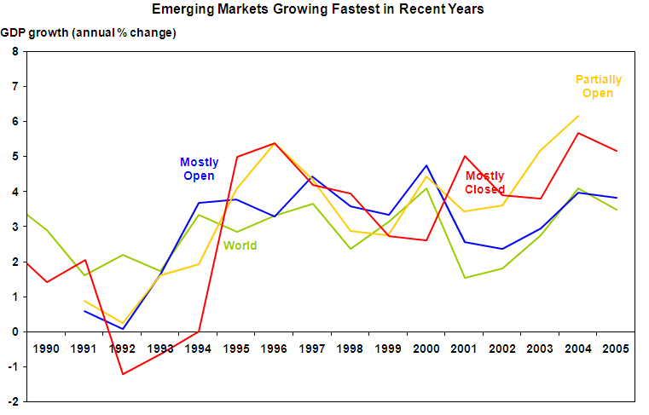
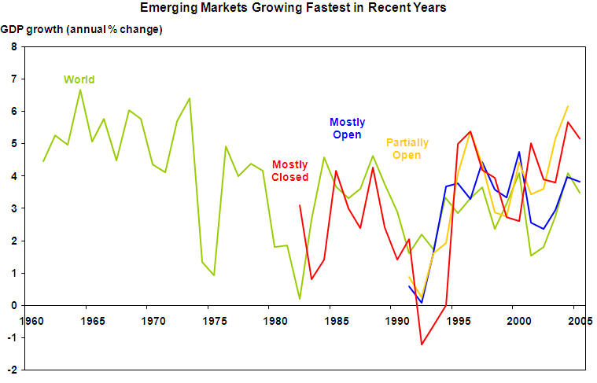
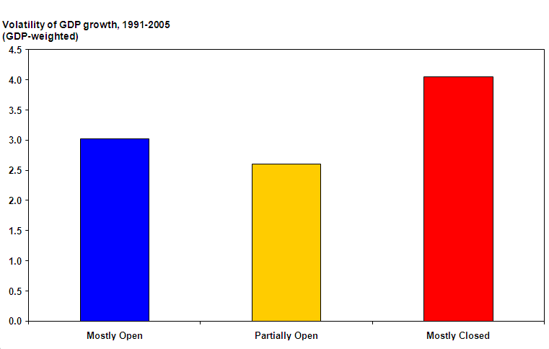
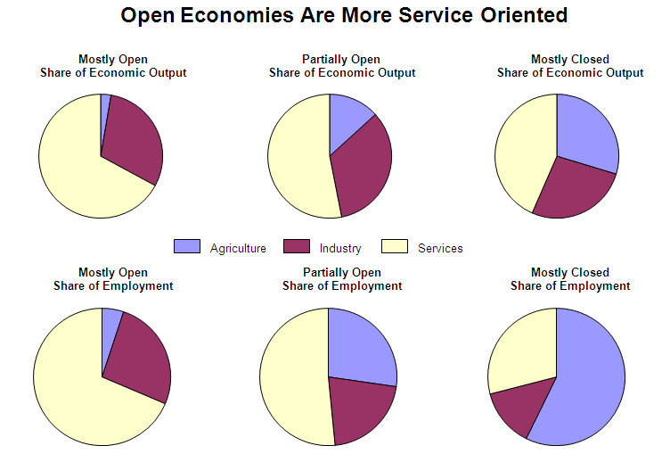

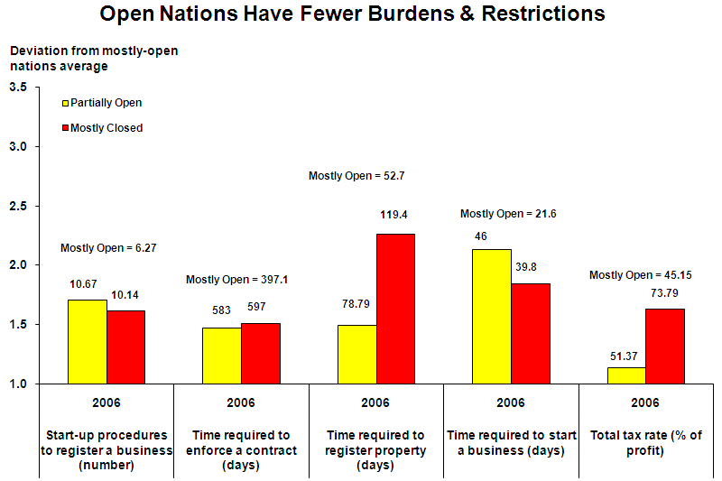

Appendix K: DEA Countries and Levels
Level | Name | 1 | 2 | 3 | 4 | 5 | 6 | 7 | 8 | 9 | 10 | 11 | 12 | 13
1 | Canada | 1
1 | Denmark | 1
1 | Finland | 1
1 | Iceland | 1
1 | Luxembourg | 1
1 | Netherlands | 1
1 | New Zealand | 1
1 | Singapore | 1
1 | Sweden | 1
1 | Switzerland | 1
1 | United States | 1
2 | United Kingdom | 0.9589 | 1
2 | Australia | 0.9731 | 1
2 | Austria | 0.9027 | 1
2 | Belgium | 0.8691 | 1
2 | France | 0.8995 | 1
2 | Ireland | 0.9746 | 1
2 | Japan | 0.8753 | 1
2 | Norway | 0.9175 | 1
2 | Slovenia | 0.8801 | 1
3 | Chile | 0.7026 | 0.8886 | 1
3 | Czech Rep | 0.7625 | 0.9069 | 1
3 | Estonia | 0.796 | 0.9491 | 1
3 | Germany | 0.8154 | 0.9617 | 1
3 | Hungary | 0.7919 | 0.9536 | 1
3 | Spain | 0.7016 | 0.8325 | 1
4 | Barbados | 0.5908 | 0.7467 | 0.9483 | 1
4 | Georgia | 0.6648 | 0.7907 | 0.8395 | 1
4 | Israel | 0.6976 | 0.8322 | 0.9867 | 1
4 | Italy | 0.6846 | 0.8086 | 0.9892 | 1
4 | Kuwait | 0.6655 | 0.8371 | 0.9344 | 1
4 | Latvia | 0.6848 | 0.8436 | 0.9361 | 1
4 | Lithuania | 0.6565 | 0.8039 | 0.8965 | 1
4 | Malta | 0.696 | 0.8599 | 0.9542 | 1
4 | Poland | 0.6553 | 0.7866 | 0.917 | 1
4 | Portugal | 0.6082 | 0.76 | 0.8641 | 1
4 | UAE | 0.6541 | 0.8182 | 0.9272 | 1
5 | Armenia | 0.6093 | 0.733 | 0.8101 | 0.9341 | 1
5 | Bahrain | 0.6105 | 0.7618 | 0.8767 | 0.9466 | 1
5 | Bulgaria | 0.6399 | 0.7885 | 0.8694 | 0.9844 | 1
5 | Croatia | 0.6005 | 0.716 | 0.8154 | 0.8801 | 1
5 | Cyprus | 0.5402 | 0.6606 | 0.7468 | 0.987 | 1
5 | Greece | 0.5639 | 0.6863 | 0.8024 | 0.9261 | 1
5 | Jordan | 0.6135 | 0.758 | 0.8434 | 0.9532 | 1
5 | Malaysia | 0.5853 | 0.7322 | 0.8239 | 0.9332 | 1
5 | Oman | 0.6639 | 0.8203 | 0.9102 | 0.9539 | 1
5 | Uruguay | 0.5144 | 0.6238 | 0.7335 | 0.8906 | 1
6 | Albania | 0.5153 | 0.6225 | 0.7005 | 0.7983 | 0.9102 | 1
6 | Azerbaijan | 0.5412 | 0.6797 | 0.7443 | 0.8132 | 0.9178 | 1
6 | Belize | 0.5135 | 0.6326 | 0.707 | 0.8104 | 0.9112 | 1
6 | Botswana | 0.5826 | 0.7149 | 0.8085 | 0.9154 | 0.9875 | 1
6 | Costa Rica | 0.5354 | 0.6604 | 0.7328 | 0.8824 | 0.9782 | 1
6 | Kazakhstan | 0.556 | 0.6943 | 0.7611 | 0.823 | 0.9853 | 1
6 | Mauritius | 0.5179 | 0.6373 | 0.721 | 0.814 | 0.913 | 1
6 | Mongolia | 0.5391 | 0.6629 | 0.7141 | 0.8288 | 0.9313 | 1
6 | Romania | 0.5453 | 0.6727 | 0.7403 | 0.8385 | 0.9 | 1
6 | Russia | 0.5052 | 0.626 | 0.6953 | 0.7688 | 0.8972 | 1
6 | Trinidad Tob | 0.5628 | 0.6832 | 0.7646 | 0.8489 | 0.9706 | 1
6 | Tunisia | 0.4834 | 0.6165 | 0.7023 | 0.7941 | 0.8725 | 1
6 | Ukraine | 0.546 | 0.669 | 0.7497 | 0.8118 | 0.9339 | 1
7 | Argentina | 0.4561 | 0.5304 | 0.6188 | 0.6629 | 0.812 | 0.9592 | 1
7 | Bosnia | 0.4723 | 0.5525 | 0.6432 | 0.7085 | 0.8201 | 0.9168 | 1
7 | China | 0.4662 | 0.5697 | 0.6337 | 0.7454 | 0.8506 | 0.9462 | 1
7 | Colombia | 0.4384 | 0.5387 | 0.6283 | 0.727 | 0.8367 | 0.9353 | 1
7 | El Salvador | 0.5036 | 0.6229 | 0.7076 | 0.7705 | 0.8318 | 0.9835 | 1
7 | Kyrgyz Republic | 0.5111 | 0.6211 | 0.6608 | 0.7805 | 0.8567 | 0.9395 | 1
7 | Macedonia | 0.4962 | 0.5899 | 0.6743 | 0.7372 | 0.8363 | 0.9463 | 1
7 | Mexico | 0.4818 | 0.5917 | 0.6614 | 0.7442 | 0.8599 | 0.9434 | 1
7 | Moldova | 0.514 | 0.6455 | 0.7065 | 0.7808 | 0.8878 | 0.9927 | 1
7 | Namibia | 0.4836 | 0.649 | 0.7393 | 0.8324 | 0.9018 | 0.9859 | 1
7 | Panama | 0.5057 | 0.6348 | 0.7175 | 0.7929 | 0.8984 | 0.9927 | 1
7 | South Africa | 0.4719 | 0.6049 | 0.6891 | 0.7677 | 0.8435 | 0.9037 | 1
7 | Tanzania | 0.5015 | 0.6196 | 0.6875 | 0.7205 | 0.7553 | 0.8667 | 1
7 | Thailand | 0.4988 | 0.6239 | 0.6973 | 0.8265 | 0.9114 | 0.997 | 1
8 | Brazil | 0.4042 | 0.502 | 0.5612 | 0.6372 | 0.7496 | 0.8402 | 0.9148 | 1
8 | Dominican Rep | 0.4162 | 0.5206 | 0.5819 | 0.6521 | 0.7415 | 0.8353 | 0.8771 | 1
8 | Ghana | 0.4681 | 0.5783 | 0.6417 | 0.7134 | 0.7696 | 0.8089 | 0.974 | 1
8 | Guatemala | 0.4808 | 0.5941 | 0.6592 | 0.6908 | 0.7242 | 0.8764 | 0.9589 | 1
8 | Iran | 0.4164 | 0.5135 | 0.5698 | 0.6358 | 0.732 | 0.8197 | 0.9341 | 1
8 | Jamaica | 0.4771 | 0.5894 | 0.654 | 0.7023 | 0.7651 | 0.8966 | 0.9733 | 1
8 | Nicaragua | 0.4842 | 0.5982 | 0.6646 | 0.718 | 0.7646 | 0.9235 | 0.9817 | 1
8 | Paraguay | 0.4058 | 0.5025 | 0.5762 | 0.6469 | 0.7391 | 0.8337 | 0.9589 | 1
8 | Peru | 0.4624 | 0.5713 | 0.6413 | 0.7049 | 0.783 | 0.895 | 0.9536 | 1
8 | Philippines | 0.4408 | 0.5375 | 0.6056 | 0.7072 | 0.7779 | 0.8653 | 0.9437 | 1
8 | Turkey | 0.4209 | 0.5264 | 0.5887 | 0.6808 | 0.773 | 0.8645 | 0.9401 | 1
8 | Venezuela | 0.3827 | 0.4577 | 0.5317 | 0.5922 | 0.7042 | 0.7931 | 0.8698 | 1
8 | Vietnam | 0.4543 | 0.5683 | 0.6352 | 0.7532 | 0.8172 | 0.9069 | 0.9437 | 1
9 | Algeria | 0.4022 | 0.5031 | 0.5695 | 0.6329 | 0.7351 | 0.8246 | 0.8876 | 0.9689 | 1
9 | Bolivia | 0.4457 | 0.5507 | 0.6183 | 0.6852 | 0.7479 | 0.8622 | 0.9298 | 0.9913 | 1
9 | Egypt | 0.4336 | 0.5357 | 0.5944 | 0.6339 | 0.7133 | 0.8409 | 0.9423 | 0.9978 | 1
9 | Gabon | 0.3928 | 0.5096 | 0.5805 | 0.6685 | 0.7278 | 0.8225 | 0.879 | 0.9835 | 1
9 | Honduras | 0.4667 | 0.5766 | 0.6398 | 0.6755 | 0.7395 | 0.8671 | 0.9266 | 0.9816 | 1
9 | India | 0.3985 | 0.5346 | 0.609 | 0.67 | 0.7422 | 0.7998 | 0.8787 | 0.9748 | 1
9 | Indonesia | 0.4003 | 0.4988 | 0.5649 | 0.6659 | 0.733 | 0.8321 | 0.8816 | 0.9582 | 1
9 | Mauritania | 0.4189 | 0.543 | 0.6185 | 0.6824 | 0.7542 | 0.7852 | 0.8937 | 0.9814 | 1
9 | Nigeria | 0.4395 | 0.5443 | 0.6191 | 0.6921 | 0.7561 | 0.7712 | 0.934 | 0.9966 | 1
9 | SriLanka | 0.4002 | 0.5006 | 0.5621 | 0.6724 | 0.7344 | 0.8234 | 0.8628 | 0.9714 | 1
9 | Uganda | 0.4594 | 0.5675 | 0.6335 | 0.6855 | 0.7219 | 0.8071 | 0.9237 | 0.973 | 1
9 | Zambia | 0.449 | 0.5547 | 0.6155 | 0.6522 | 0.6942 | 0.7759 | 0.9176 | 0.951 | 1
10 | Angola | 0.3909 | 0.5245 | 0.5975 | 0.6574 | 0.7259 | 0.7529 | 0.823 | 0.9478 | 0.9793 | 1
10 | Ecuador | 0.379 | 0.4741 | 0.5325 | 0.6142 | 0.6963 | 0.782 | 0.8324 | 0.9108 | 0.989 | 1
10 | Kenya | 0.4458 | 0.5507 | 0.6111 | 0.6455 | 0.6881 | 0.7726 | 0.9018 | 0.9334 | 0.9815 | 1
10 | Lesotho | 0.4046 | 0.497 | 0.5595 | 0.6375 | 0.691 | 0.7586 | 0.8636 | 0.9318 | 0.991 | 1
10 | Morocco | 0.3801 | 0.4987 | 0.5681 | 0.6294 | 0.6929 | 0.7724 | 0.8508 | 0.9308 | 0.9813 | 1
10 | Mozambique | 0.4067 | 0.5052 | 0.5749 | 0.6446 | 0.7022 | 0.7111 | 0.8715 | 0.9125 | 0.9583 | 1
10 | Zimbabwe | 0.3029 | 0.3997 | 0.4553 | 0.5674 | 0.6278 | 0.7093 | 0.7442 | 0.8668 | 0.9277 | 1
11 | Burkina | 0.364 | 0.4792 | 0.5459 | 0.6068 | 0.666 | 0.6752 | 0.8018 | 0.8663 | 0.8998 | 0.9525 | 1
11 | Burundi | 0.3567 | 0.4444 | 0.506 | 0.5718 | 0.6182 | 0.6439 | 0.7859 | 0.8224 | 0.8782 | 0.9151 | 1
11 | Cameroon | 0.3504 | 0.4403 | 0.5016 | 0.5587 | 0.6124 | 0.6567 | 0.7532 | 0.8087 | 0.8542 | 0.9129 | 1
11 | Congo | 0.3297 | 0.4425 | 0.5041 | 0.5892 | 0.6377 | 0.7273 | 0.7628 | 0.8266 | 0.8926 | 0.972 | 1
11 | Madagascar | 0.3629 | 0.4582 | 0.522 | 0.588 | 0.6386 | 0.6873 | 0.797 | 0.8493 | 0.8864 | 0.9649 | 1
11 | Malawi | 0.3581 | 0.4805 | 0.5474 | 0.6023 | 0.6663 | 0.6771 | 0.7572 | 0.8683 | 0.9033 | 0.9514 | 1
11 | Nepal | 0.345 | 0.4524 | 0.5153 | 0.5709 | 0.6286 | 0.6716 | 0.758 | 0.8221 | 0.8665 | 0.922 | 1
11 | Pakistan | 0.3542 | 0.4666 | 0.5315 | 0.5854 | 0.6481 | 0.6959 | 0.7746 | 0.8436 | 0.8862 | 0.9439 | 1
11 | Rwanda | 0.3488 | 0.4508 | 0.5135 | 0.5754 | 0.6269 | 0.6588 | 0.7689 | 0.8305 | 0.8815 | 0.9149 | 1
11 | Senegal | 0.3555 | 0.4634 | 0.5279 | 0.5861 | 0.6444 | 0.6817 | 0.7881 | 0.8448 | 0.8796 | 0.9433 | 1
12 | Bangladesh | 0.3274 | 0.4225 | 0.4813 | 0.5328 | 0.5874 | 0.6423 | 0.7262 | 0.777 | 0.8237 | 0.8946 | 0.9695 | 1
12 | Benin | 0.3417 | 0.439 | 0.5001 | 0.5575 | 0.6101 | 0.6235 | 0.7352 | 0.7936 | 0.8337 | 0.8793 | 0.9579 | 1
12 | Cote D'Ivoire | 0.3453 | 0.4393 | 0.5005 | 0.5564 | 0.611 | 0.6345 | 0.7486 | 0.7967 | 0.8238 | 0.8824 | 0.9666 | 1
12 | Ethiopia | 0.3559 | 0.4775 | 0.544 | 0.5985 | 0.6624 | 0.6729 | 0.767 | 0.863 | 0.8792 | 0.9418 | 0.998 | 1
12 | Mali | 0.3544 | 0.4727 | 0.5385 | 0.5925 | 0.6565 | 0.6661 | 0.7761 | 0.8544 | 0.8705 | 0.9386 | 0.9976 | 1
12 | Niger | 0.3432 | 0.4488 | 0.5113 | 0.5705 | 0.6237 | 0.6324 | 0.7474 | 0.8114 | 0.8622 | 0.8989 | 0.9725 | 1
12 | Togo | 0.3266 | 0.4166 | 0.4746 | 0.5333 | 0.5797 | 0.6333 | 0.7265 | 0.7711 | 0.8138 | 0.8988 | 0.9629 | 1
13 | Central | 0.3051 | 0.3903 | 0.4447 | 0.5 | 0.5429 | 0.5637 | 0.674 | 0.7166 | 0.7633 | 0.8047 | 0.8953 | 0.9843 | 1
13 | Chad | 0.3058 | 0.4052 | 0.4616 | 0.5092 | 0.5633 | 0.5915 | 0.6823 | 0.7349 | 0.763 | 0.8156 | 0.8693 | 0.9215 | 1
13 | Sierra Leone | 0.3318 | 0.4127 | 0.4698 | 0.5289 | 0.5739 | 0.5877 | 0.7166 | 0.748 | 0.7945 | 0.8279 | 0.9273 | 0.9886 | 1
15 | Efficient: | 11 | 9 | 6 | 11 | 10 | 13 | 14 | 13 | 12 | 7 | 10 | 7 | 3

Appendix L: DEA Country Ranking
Ranking | Country | Efficiency
1 | Luxembourg | 1.0000
2 | Finland | 0.9178
3 | Denmark | 0.8000
4 | Switzerland | 0.7956
5 | Sweden | 0.7907
6 | NewZealand | 0.7797
7 | Netherlands | 0.7591
8 | Australia | 0.7286
9 | Iceland | 0.7203
10 | Canada | 0.7097
11 | Austria | 0.7054
12 | Norway | 0.6539
13 | UnitedStates | 0.6319
14 | UnitedKingdom | 0.6183
15 | Germany | 0.5912
16 | Japan | 0.5849
17 | Ireland | 0.5716
18 | Belgium | 0.5070
19 | France | 0.4988
20 | Singapore | 0.4745
21 | Spain | 0.4206
22 | Estonia | 0.4079
23 | Hungary | 0.4024
24 | Slovenia | 0.3895
25 | Italy | 0.3709
26 | CzechRep | 0.3695
27 | Chile | 0.3566
28 | Israel | 0.3477
29 | Lithuania | 0.3232
30 | Cyprus | 0.3201
31 | Latvia | 0.3167
32 | Poland | 0.3167
33 | Kuwait | 0.3166
34 | Georgia | 0.3004
35 | Greece | 0.2985
36 | Portugal | 0.2952
37 | Bulgaria | 0.2861
38 | Malta | 0.2802
39 | Armenia | 0.2682
40 | TrinidadTob | 0.2681
41 | CostaRica | 0.2635
42 | Barbados | 0.2538
43 | Albania | 0.2518
44 | Kazakhstan | 0.2466
45 | UAE | 0.2454
46 | Croatia | 0.2451
47 | Romania | 0.2451
48 | Bahrain | 0.2436
49 | Panama | 0.2326
50 | Uruguay | 0.2315
51 | Jordan | 0.2290
52 | Mongolia | 0.2266
53 | KyrgyzRepublic | 0.2224
54 | Oman | 0.2199
55 | Macedonia | 0.2147
56 | Mexico | 0.2015
57 | Bosnia | 0.1996
58 | Mauritius | 0.1974
59 | Russia | 0.1958
60 | Peru | 0.1896
61 | Philippines | 0.1885
62 | Azerbaijan | 0.1878
63 | China | 0.1874
64 | ElSalvador | 0.1867
65 | Paraguay | 0.1855
66 | Ukraine | 0.1846
67 | Malaysia | 0.1799
68 | Moldova | 0.1789
69 | Thailand | 0.1765
70 | Colombia | 0.1753
71 | Jamaica | 0.1726
72 | Botswana | 0.1712
73 | Honduras | 0.1680
74 | Bolivia | 0.1648
75 | Nicaragua | 0.1641
76 | Belize | 0.1640
77 | Argentina | 0.1638
78 | Brazil | 0.1577
79 | Iran | 0.1551
80 | SouthAfrica | 0.1541
81 | Indonesia | 0.1538
82 | Guatemala | 0.1476
83 | Namibia | 0.1449
84 | Vietnam | 0.1439
85 | Tunisia | 0.1428
86 | Egypt | 0.1408
87 | SriLanka | 0.1378
88 | Turkey | 0.1354
89 | DominicanRep | 0.1345
90 | Venezuela | 0.1334
91 | Tanzania | 0.1327
92 | Kenya | 0.1319
93 | Lesotho | 0.1306
94 | Ecuador | 0.1303
95 | Gabon | 0.1261
96 | Uganda | 0.1247
97 | Zambia | 0.1244
98 | Nigeria | 0.1215
99 | Ghana | 0.1199
100 | Algeria | 0.1165
101 | India | 0.1148
102 | Congo | 0.1109
103 | Madagascar | 0.1105
104 | Mauritania | 0.1087
105 | Morocco | 0.1063
106 | Cameroon | 0.1042
107 | Angola | 0.1006
108 | Rwanda | 0.0991
109 | Mozambique | 0.0988
110 | Zimbabwe | 0.0978
111 | Pakistan | 0.0968
112 | Burundi | 0.0965
113 | Malawi | 0.0945
114 | Nepal | 0.0930
115 | Togo | 0.0929
116 | Senegal | 0.0918
117 | Bangladesh | 0.0915
118 | Burkina | 0.0902
119 | CoteD'Ivoire | 0.0901
120 | Ethiopia | 0.0885
121 | Mali | 0.0884
122 | Benin | 0.0870
123 | Niger | 0.0862
124 | SierraLeone | 0.0811
125 | Central | 0.0806
126 | Chad | 0.0789

Appendix M: Multiple Regression Analysis Graphs

Appendix N: Correlational Values of Modeling Variables
 | Dependent | Indep1 | Indep2 | Indep3 | Indep4 | Indep5 | Indep6 | Indep7 | Indep8
Dependent | 1
Indep1 | -0.12262 | 1
Indep2 | 0.814955 | -0.01053 | 1
Indep3 | 0.549806 | 0.242778 | 0.588516 | 1
Indep4 | 0.506073 | 0.174704 | 0.576864 | 0.638949 | 1
Indep5 | 0.595646 | 0.083707 | 0.685601 | 0.564401 | 0.492787 | 1
Indep6 | 0.900122 | -0.09934 | 0.874807 | 0.547813 | 0.530208 | 0.68554 | 1
Indep7 | 0.561302 | -0.01224 | 0.572224 | 0.441802 | 0.529322 | 0.419241 | 0.497638 | 1
Indep8 | 0.782126 | 0.029803 | 0.75888 | 0.587611 | 0.628514 | 0.523343 | 0.725291 | 0.870801 | 1

Appendix O: Scatter Plot Comparison Graphs for Modeling Variables vs. GDP per Capita

