Arlington Police Department
Crime Coverage Problem
SMU Senior Design

Dr. Thomas Siems
Semester Project
EMIS 4362 - Spring 2011

Authors:
Blake Robinson & Ron Andrews
Project Sponsors & Advisors:
Bill Edmonds, Jim Mallard, & Chief Bowman

Table of Contents

Table of Contents 3
Executive Summary 4
Problem Background & Description 5
Analysis of Situation 6
Statistical Data Analysis (Cells 1 through 472 Combined) 7
Statistical Data Analysis (Cell 206) 8
Statistical Data Analysis (Crime Concentration) 9
Statistical Data Analysis (Crime Concentration Cont.) 10
Arlington Police Department District Coverage Model 11
Basic Assumptions: 11
Decision Variables: 11
Mathematical Formulation & Explanation 12
Formulation Results and Analysis 13
Formulation Results and Analysis Continued 15
Recommendations & Results 16
Extensions on Results 17
Appendices 18

Executive Summary
The Arlington Police Department is responsible for policing the city of Arlington to achieve a safer community. The policing of the city is divided roughly into four main areas (north, south, east, and west) with each respective area possessing its own police station. The Arlington Police Department requested insight into the placement of the police stations to see if they were effectively located to process the level one crimes that originate from each main area. If a main area was not adequately covered, areas could be hypothetically redrawn to accommodate effective policing.
Our method of analysis included the use of in-depth data analysis and a pure network model that had the potential to take into consideration Euclidean distances, time schedules, crime severity and political issues. Our findings indicated that the placement of police stations given current population levels were placed reasonably close to where our model suggested they should be placed. It was also discovered that complex issues such as political issues and crime severity are hard to quantify within a model given due to the ambiguous nature of the data.

Problem Background & Description
A major goal of the Arlington Police Department is to reduce part one crime by twenty five percent. Part one crime includes burglary, theft, murder, homicides and rape. By reducing this major source of crime, Arlington will be a safer community. In order to effectively handle this crime and have a more effective presence, Arlington police officers need to be able to respond to incidents in a timely manner and anticipate where potential crimes may take place.
The Arlington Police Department collects information on each reported crime such as time, location, severity and type of crime. This information is then entered into a database where it can be used for future reference. While the Arlington Police Department knows generally what kind of crimes are being committed, it does not have sufficient insight into A) crime by officer shift, B) concentrations of crime within the city and C) type of crime committed per incident, to name a few. In trying to achieve the goal of reducing part one crimes, this type of data would be helpful in trying to determine the correct type of model. It was apparent that an upfront data analysis would be necessary.
By being able to place police stations correctly in the "center" of crime centers, major crime can be addressed more effectively. Given inadequate data analysis, the Arlington Police Department did not know if their police stations were optimally placed within their respective regions. The purpose of this study is to generate the appropriate demarcations and data analysis to answer the placement question and to propose "optimal" or “acceptable” boundary lines of the districts given the input variables.

Analysis of Situation
We took a top down approach to the situation first asking pertinent questions then drilled down from there. Our first task was to analyze and make sense of the data that the Arlington Police Department was able to provide us. The data we were provided with came from the Arlington Police Department's management information system which was able to give us raw numbers on numbers of crime incidences, type, time and the like. From there, we had to filter the data to only include class one crimes (burglaries, thefts, murders, homicides and rapes) as these crimes have the most impact on Arlington Police Department resource allocation. Once we had the class one crimes isolated, we could run a statistical analysis to answer such questions as where the concentrations of crimes were taking place by time and location and why certain areas of Arlington experienced higher concentrations of crime than others. The data below is the analysis work for cells 1 through 472, the outlier cell 206, and cell concentration area.
After our data was classified and filtered, we were able to map the crimes using a Geographic Information System (GIS) to overlay the crimes on a map of Arlington to visually see their proximity to the four regions (north, south east and west) and their respective police stations. GIS works by taking crime report GPS X/Y coordinates provided by the Arlington Police Department's MIS and then placing them on a coordinate map. GIS is spatio-temporal meaning that the system can relate events by not only location but by time as well. This is important when trying to correlate crimes in a certain location by time.
In order to make the map of Arlington more manageable, we divided the city of Arlington into 472 1/2 mile by 1/2 miles X/Y cells. This size was chosen so it could potentially include a few crime incidences. Using a smaller square mile cell could potentially be more accurate; however, the number of cells increased significantly. For example: When you compare a large to medium pizza, the area of the pie increases significantly, yet the circumference only increases marginally. This caused a dramatic increase in processing time and created a project that is potentially too complex to solve within the time frame available.

Statistical Data Analysis (Cells 1 through 472 Combined)
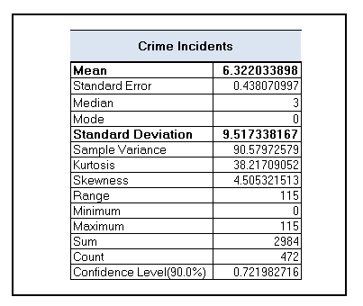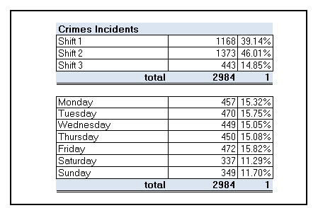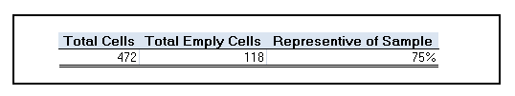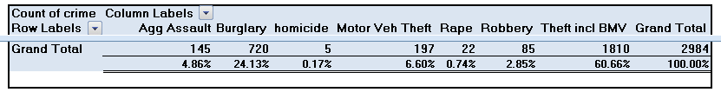

Statistical Data Analysis (Cell 206)
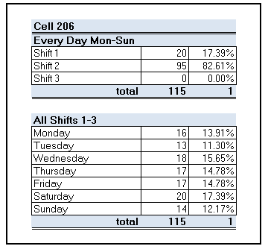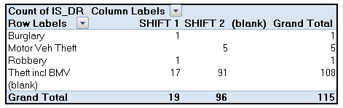

Statistical Data Analysis (Crime Concentration)

Statistical Data Analysis (Crime Concentration Cont.)
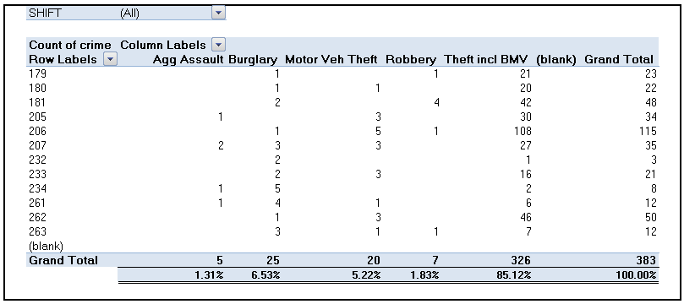

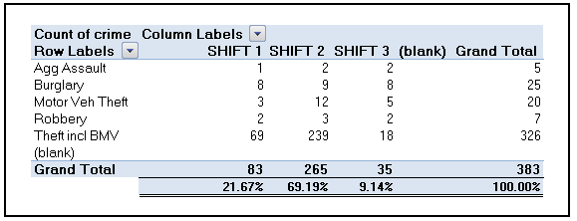

Arlington Police Department District Coverage Model
There are many factors that help determine the boundaries for each police district for the Arlington Police Department. The constraints consist of distance, time, volume, political, and operational; however, these constraints can be ambiguous at times. In order to simplify this scenario, we assumed and used Euclidean distances (miles) from cell to each police district. Also, each cell can only be assigned to one district.
The statistical and data analysis helps determine areas with high incident concentration in certain cell blocks. To help combat this problem, districts with higher volumes of resources may be better suited to help manage continuing problem areas.
A network flow model approach was determined the best option to help Arlington Police Department manage their boundaries for each district. The specific model was a pure network flow “assignment” model. The pure networks are an inflow of 1 unit and an outflow of 1 unit. In other words, the units remain the same throughout the network. Pure networks are precisely “total flow in equals total flow out.
$$total flow in-total flow out=specififed net demand$$
The pure network model has three types of nodes: Source (Supply), sink (demand), and or transshipment nodes. Arcs connecting the nodes are decision variables $x_{ij}$ that produce flow from node to node. The figure below shows the lower and upper bounds on each arc and the specific cost associated to allowing flow from node i to j.

Basic Assumptions:
- Each cell is only assigned to one district
- Each district can only be assigned to 118 cells each (Even Distribution)

Decision Variables:

Mathematical Formulation & Explanation
The ampl model below is a basic pure network model formulation. The model below generates 1,888 variables, 476 constraints and 1 objective function. The two constraints, subject to supply and subject to demand, generate the 476 constraints in the model and var x {i in o, j in D} generate the 1,888 variables. This model operates on the flow in = flow out model previously stated above. The objective function minimizes the distance from each cell to each district in order create an optimal coverage boundary for each district. The Ampl data and output below are a small sample of the full data and output. The full Ampl data and output can be found in the appendix.
Ampl Model:
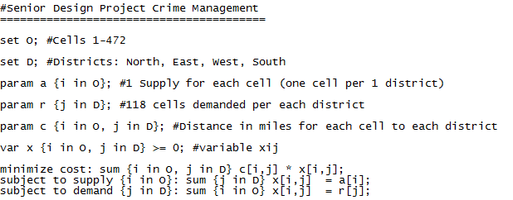
Ampl Data:
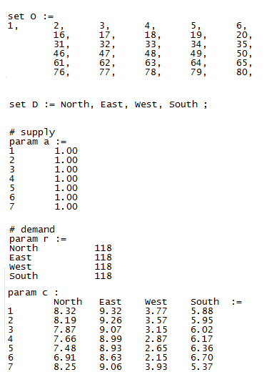

Formulation Results and Analysis
Ampl Output:
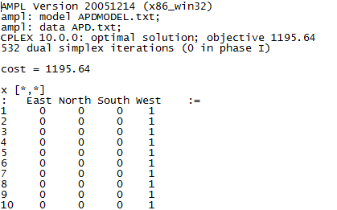

The model assumed that each district would receive 118 cells to provide an even distribution. The output was very accurate when determining the new boundaries. The image below is a rough estimate of the change of boundaries. The excel tables explain precisely what district lost and received new cells.

Formulation Results and Analysis Continued
This model can be used for starting or making minor changes to the current boundaries for Arlington Police Department. The ambiguous constraints stated above make it hard to specifically determine the cost for assigning each cell to a district. Using the distance allows for a “great jumping off point” and then further “tweaking” the boundaries manually based on the listed constraints above creates an optimal or “acceptable” boundary for the Arlington Police Department. In essence, districts with higher volume of resources may be more suited than others to manage higher concentrations of incidents in certain cell blocks.

Recommendations & Results
Arlington Police Department’s main goal is to effectively reduce crime by 25% over a period of time. Our approach was to gather insight and gain an understanding of where certain crimes are occurring and of what type. The data analysis is just one step to gaining the understanding of certain crime concentration areas (or Target Areas) with the support of the GIS tool. The GIS tool will provide a mapping visualization for APD to use in order to allocate resources to certain cells/grids. Additionally, the pure network model aspect allows the APD to effectively make changes to the district boundaries to help manage crime in certain locations.
In essence, the use of the GIS tool, the data analysis, and network model are all valuable resources in order to help manage and get a handle on part one crime. There is no clear cut 100% solution that can help reduce crime 25% over night. These proposed solutions above are steps in the continuing process to effectively reduce crime. The plans below can help provide some impact on the nature of the most common crime – Motor Vehicle Theft and Burglary in a Motor Vehicle.
Plans to help reduce crime incidents in target location:
Immediate Impact
- Police towers
- Higher Police presence
- Reminding safety cards on vehicle windshields

Long Term
- Centralized and monitored entrance to mall
- Parking Garage vs Parking Lot

Plans for utilization of assignment network model
- Minor changes in district boundaries

Extensions on Results
The above data analysis and modeling can further be enhanced by providing additional constraints and limitations.
Plans for FUTURE utilization of data analysis and GIS
- Detailed real-time GPS reporting crime tool
- Utilize all data points in the GIS tool to find 100% accurate crime concentration areas (Limited to processing time for our current sample)

Plans for FUTURE utilization of assignment network model
- Develop a weighted classification system to assign a number to each cell in order to achieve or satisfy the ambiguous constraints
- Model a new 5th district if city begins to grow

Appendices

Reference A:

