Call Center Scheduling

Federal Reserve Bank of Dallas



2011

Alex Grosjean & Brianna Bauer

Southern Methodist University

5/9/2011

**Tables of Contents**

**Management Summary ..................................................................... 03**

**Background & Description of the Problem ..................................... 05**

**Analysis of the Situation .................................................................... 08**

**Technical Description of the Model .................................................. 09**

Integer Programming Model Overview ………………………………….. 09

Model Inputs ……………………………………………………………… 10

The Actual Model………………………………………….……… 13

Variables ………………………………………………………….. 14

Constraints ………………………………………………………... 16

**Analysis and Managerial Interpretation .......................................... 18**

**Conclusion and Critique .................................................................... 22**

**Contact Information ........................................................................... 25**

**Management Summary**

The project we explored is the GoDirect call center scheduling problem given to us by the Federal Reserve Bank of Dallas. Every month, the Treasury sends out roughly ten million physical checks for Social Security payments and other benefits. On average, it costs them about one dollar apiece to send these checks via snail mail. As a cost saving method, the Treasury is now requiring these recipients to use direct deposit methods, and will eventually cease to send out physical checks. This is where the GoDirect program comes in. GoDirect is both a call center and a website which helps the recipients switch over to direct deposits, which only cost about 9 cents per person. The return on investment for this project is expected to be ten years. The Call Center needs to find a way to best schedule employees to handle these incoming calls, thus our goal is to design a model to minimize the cost associated with the call center.

            The program we used when developing our model was the Premium Solver in Microsoft Excel. We used Excel because it is easily readable for the client and easy to change the inputs for given days. We had three types of variables, all symbolizing possible schedules for the employees, which are permanent full time, temporary full time, and temporary with a five hour shift. The schedule uses 15-minute intervals, with employees starting at 7:00 a.m. and able to arrive every thirty minutes until 9:30, and the last shift starts at 10:15 a.m.

Our constraints needed to ensure that the number of employees we schedule needs to be greater than or equal to the amount that are needed, which is based on the historical data we were given. We also needed to take into account the maximum seat capacity of 325, and make sure the numbers were both integer and positive. Our objective function minimizes the number of employees needed, which will minimize cost to the call center.

We concluded that the given a required number of permanent employees of 37, that the optimum number of temporary employees will vary based on the day of the week and time of the month. We took this into account in our model and have given the user the option to choose day of the week and the number of expected calls. From there our program will calculate the solution. We also found that the more 5 hour employees that the call center can hire, as opposed to full time, the better the solution will be.

**Background & Description of the Problem**

            The Federal Reserve has just set a deadline for the switch from paper check to direct deposit, and everyone is required to switch to direct deposit by May 2013. Pamphlets are sent out with the monthly checks on the first and third of the month, as well as each Wednesday. People have two choices when they decide to switch to direct deposit: the call center or the website. About 25% of the people switching use the website and the remaining 75% make a phone call to the call center.

As will be shown by the call curve, calls into the call center peak on Wednesdays and Thursdays of the month so it is necessary to have more temporary workers on those days. There is also a downward-sloping trend throughout the month, with the highest number of calls incoming within the first week of each month. This is because the majority of checks are sent at the beginning of the month, and the rest are distributed accordingly. Below is a graph for the total number of calls per day for the month of March.

The required change to fully implement only direct deposits will drastically increase the call volume over the next two years, which is why the call center has switched locations to a much larger venue. They now have 325 available call stations to utilize, so our model must staff up to 288 temporary employees. Also, the call center hours are 7:00 a.m. to 7:00 p.m. Monday through Friday, while the website is open twenty-four hours a day.

The problem at hand was to design a call-scheduling model to determine the number of permanent and temporary employees that are needed on any given day in the month. As seen by the graph below, calls start off slow in the morning, peak during the middle of the day, and slowly trickle off in the evening. The data shown is for March, for each 30 minute interval on a low and high volume call day.

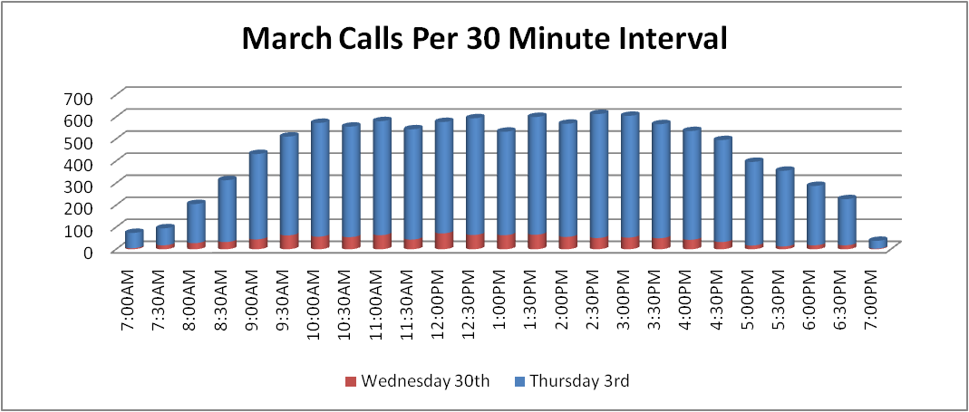

Furthermore, it is required that all permanent employees work eight hours and forty-five minutes per day, five days a week. This includes two fifteen-minute breaks and a forty-five minute lunch break. Temporary employees can work either an eight hour and forty-five minute shift, similar to the permanent employee shifts, or a five-hour shift with no lunch break. The model needs to accommodate the above constraints, while still fulfilling the call curve in the above graph.

Full-time shifts for the call center start every half hour from 7:00 a.m. to 9:30 a.m. with one additional shift starting at 10:15 a.m. Lunches are between 10:30 and 1:45, and breaks can be anywhere throughout the day. An agent has to work at least 165 minutes before they can have their lunch break. For part-time temporary employees, they can start every half hour, from 7:00 a.m. to 2:00 p.m. and receive no lunch break.

They currently have 37 permanent employees and require that number to remain unchanged. Our goal is to use past months’ call volumes to predict the number of temporary employees needed, how many hours they work, and the exact times of their shifts. We want to minimize the number of employees, thus minimizing the cost to the call center.

**Analysis of the Situation**

The data we used is the March Interval Call Data that we collected from our client. We used this data to create a call curve that would predict the percentage of calls per day that the call center would receive during a given thirty-minute period. This data is multiplied by the expected calls input, and divided by the calls per agent per thirty minute period, which gives the number of employees needed during that thirty-minute period.

For our model, we created an Excel spreadsheet using 15-minute intervals from 7:00 a.m. to 7:00 p.m. We took into account a forty-five minute lunch break for all full time employees. There are three varieties of employees: full time permanent, full time temporary, and part time temporary. Full time is eight hours forty-five minutes, and part time is five hours. These times are not allowed to change. Taking into account the fact that an agent needs to work 165 minutes prior to their lunch break, we came up with 117 possible schedules that fall within the criteria.

Next we needed to decide what constraints were needed. There are only 325 seats in the call center, so the total amount of employees at any time cannot exceed that. There also needs to be exactly 37 permanent agents. We also set constraints for the minimum and maximum for each type of agent. Lastly, all solutions must be both greater than or equal to zero and must also be integer values.

**Technical Description of the Model**

**Integer Programming Model Overview:**

The model was built completely on excel simply for the ease of use and availability of resources to the managers at the Federal Reserve Bank of Dallas. We decided to utilize the Premium Solver in Microsoft Excel to solve this call center scheduling problem. We initially tried to use the regular Solver, but the model proved to be too complex since the regular solver can only handle 100 variables and we had 117 in the end. As stated before, we chose Excel because it is easier for the client to read and understand, and also makes it accessible for the user to change the inputs involved.

The model is split into two pages or tabs on Excel: “*Overview*” and “*The Model*”. The tab, *Overview*, contains the inputs that the client can easily change and update based on needs, forecasted values, and available resources of permanent and temporary employees. It also displays the output once the model has finished solving for the optimal solution. The tab, *The Model*, contains all of the information for excel to run the actual model, pulling inputs from the *Overview* tab. These will be discussed in further detail below.

The objective of the model is to minimize the number of the employees based on their designated weights determined by the client. We are using tentative weights for our model now, but as stated before, these are the inputs so they can be changed at any time. As of now, there are 37 permanent employees and the client insists on this number remaining constant. Our model, therefore, will focus on scheduling these 37 permanent employees and finding out how many temporary employees are needed on any given day along with their perspective schedules.

**The Inputs:**

Before we can begin modeling, we needed to look at the past history that was given to us in order to determine the call curve input, which is displayed on the bottom half of the *Overview* tab. We were given the amount of calls per agent per 30-minute time period, which was 3.75 and were given the calls per day throughout the month of March. Dividing the number of calls per 30 minute time period by the total number of calls per day, we were able to create a call curve percentage for March, which a snippet of can be found below:



After the client has changed the call curve to reflect forecasts and predictions for the upcoming month, he will then focus on inputting both predictions and historical data into the Inputs Section of the model:



Under Primary Inputs, the client can update the calls per agent per 30 minute interval, which is based on historical data and estimates. It is the average amount of calls that employees can handle during a given 30 minutes. Generally, the lower the number the better, as it is ultimately the turnover of calls from start to finish. Next, the client inputs the estimated calls on a given day. Our client informed us that he already had an efficient way of predicting incoming calls, so he simply takes those predictions and inputs them here. He can then select the month of the year, which does not change any data, but is used for records and updates the outputs label. He also selects the day of the month, which pulls data from the call curves and inputs it into the actual model. It is a simple drop down box, making it convenient to change for different call curves throughout a month, and also allows the client to use an average of all days or a total average for the month. This will directly affect the actual model, and changes row EB of *The Model* tab, which will be further addressed later.

The Secondary Inputs should not change very often but include the estimated cost or weight of permanent and temporary employees, along with the minimum and maximum number available to use on a given day or give month. Since our client informed us that he has 37 permanent employees and does not expect that to change, this is relatively constant. The cost or weight of the temporary employees for our model is based simply on an 8 hour shift: a full time works 8/8 hours (1.00) and a part-time works 5/8 hours (.625). Also available to change is the maximum seats available.

We have inputs already set in this model, but it is imperative to note that the answers will change as the client changes these inputs. Our inputs are only estimates of what our client might expect to solve on a daily problem for March. It does not reflect any actual answers or predictions, but simply an easy-to-use format, in which our client can change the above key variables to get the optimal answers.

**The Actual Model:**

The actual model is a simple integer linear-programming model, using Excel’s Premium Solver, with 117 variables and 292 constraints.

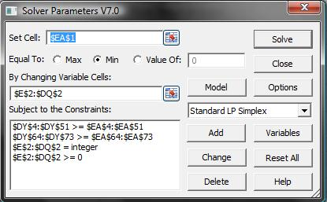

The objective function found in cell EA1 of *The Model* tab, simply minimizes the number of employees times the cost or weight of that particular employee (whether full time permanent, full time temporary or part time temporary), and is listed as Set Cell in the solver function.

The Variables and Constraints listed in the above pictured Solver Parameters will be discussed below.

**The Variables:**

The Variables are found in cells E2 through DQ2 on *The Model* tab. These cells represent the number of employees, whether full time permanent (P1 – P51), full time temporary (T1 – T51) or part time temporary (PTTA1 – PTTA15) that start at a particular time, with a particular lunch break. The “X”’s in each column underneath the employee variables represent the times that the employee is working. The yellow cells from row 18 to row 30 represent the time that an employee *CAN* take a lunch break, although different employees take different lunch breaks. A small example is pictured below.

To give an example, column E represent employee P1, which is a full time permanent employee that starts at 7:00 AM, takes a 45 minute lunch break at 10:30 AM, and ends his or her shift at 3:45 PM. Column BD represents the same schedule, except for a full time temporary employee, in the sense that Possible Employee Schedule PX = TX, for X = 1- 51. Finally, column DC represents PTTA1, which is part time temporary employee 1, who starts at 7:00 AM, and ends at 12:00PM. The part time temporary employees do not have a lunch break. This constitutes all 117 Variables.

Here is a tiny snippet of what the variables on the excel spreadsheet look like, only displaying permanent employees P1 through P22, out of a total of 117 variables.



After the model is run, these variables will tell the specifics of each employee, such as when the employee starts and ends their shifts and when each employee can start his or her 45 minute lunch break. If a particular schedule is used, the corresponding cells in Row 2, “Number of Employees” will be highlighted green, such as those displayed under P5.

**The Constraints:**

 The Constraintsare found on the far right hand side of *The Model* worksheet, and can be distinguished into four different types of constraints: (1) Agents needed >= Agents Required; (2) Minimum and Maximum Employees Available; (3) Integer Variables; and (4) Non-Negativity.

First, we have the constraints found in cells DY4 through EA51. These represent the constraint that the number of agents working (left hand side) is greater than or equal to the number of agents required (right hand side). The left hand side on Excel employs the simple =SUMIF function, stating that if there is an “X” is the corresponding row, then sum up the number of employees working during that time. The right hand side essentially takes the given call curve, multiples it by the estimated number of total calls for the day, and divides by the calls per agent per 30 minute interval, subject to a maximum seat capacity available in the call center given on the *Overview* tab. Column EB pulls the call curve data found on the *Overview* tab, based on which day is selected. The picture on the right represents a snippet of this.

The next set of constraints is found in cells DY64 through EA73. These represent the minimum and maximum number of each type of employee available. These are pictured below:



The model also states that all of the employee variables are integer, and are non-negative. These are simply built into the solver parameters, and do not need to be pictured.

This concludes our description of our model, including both the *Overview* tab and *The Model* tab.

**Analysis and Managerial Interpretation**

After the client clicks the Solve button, using Microsoft’s Premium Solver, the model solves for the optimal solution, based on the given inputs. The resulting data is output into both *The Model* sheet and into the *Overview* sheet, on a table called Employee Schedule Outputs for “Day” in “Month”.



This table on the *Overview* sheet gives a simple and easy to read summary of the number of each type of employee that will work during each shift. Using the inputs shown earlier in the paper in the model gave the above pictured outputs. The solution is that there should be 37 of the full time permanent employees, 65 of the full time temporary employees and 277 of the 5-hour temporary employees, for a total of 379 employees on the first Wednesday in March.

In a more specific sense, looking at *The Model* tab we found that 6 full time permanent employees should work schedule P5; 1 should work P15; 2 for P18; 1 for P23; 4 for P24; 4 for P25; 2 for P25; 5 for P27; 1 for P28; 1 for P29; 1 for P30; 1 for P31; 7 for P34; 1 for P39. For full time temporary employees, 2 should work for T1; 1 for T2; 2 for T3; 1 for T4; 2 for T5; 22 for T8; 4 for T14; 1 for T21; 14 for T23; 8 for T31; and 8 for T42. For part time temporary employees, 24 for PTTA1; 11 for PTTA2; 40 for PTTA3; 20 for PTTA4; 44 for PTTA5; 10 for PTTA6; 23 for PTTA9; 7 for PTTA11; 8 for PTTA12; 11 for PTTA13; 13 for PTTA14; and 66 for PTTA15. The number of people on a lunch break during any given time ranged from 2 to 39.

In reality, the call center will most likely not be able to staff this many 5 hour temporary employees, which would alter the solution, but would also increase the amount of error in the model. Thus, a couple of facts should be noted based on our given inputs and outputs. First, it is without a doubt that the more 5 hour temporary employees used, the less the error. The problem with this is that there may only be a given number allowed, say for example, 20 of the 5 hour temporary employees, which would change the solution to:



At the same time, this almost doubles the amount of error. Error for this model was defined as the amount of agents staffed minus the amount of agents required. The total number of employees was cut from 397 to 297. The number of people at lunch at any given time ranged from 39 to 81. It all depends on what the call center can change based on given resources, and how much they can relax certain minimum and maximum assumptions and requirements.

One of the factors not included in our model, but is a large underlying factor in answering the phone calls is when employees can take their breaks. We noticed that between the hours of 9:00 a.m. and 11:30 a.m., also along with 1:45 p.m. and 4:45 p.m. that there were large numbers for the errors. As a reminder, error for us is defined as staffed agents based on our model minus agents required. One way that would greatly combat this large error is for employees to only be able to take breaks during these time periods. With less people working during those time periods, our errors would be greatly reduced, especially since each employee is allotted two 15 minute breaks per day.

**Conclusion and Critique**

**Project Summary:**

For our senior design project this semester, we worked with the Federal Reserve Bank of Dallas to design a call center scheduling model for their GoDirect program. We were given past data from the call center and were asked to schedule three types of employees: full time permanent, full time temporary, and part time temporary. The objective of the model was to minimize the cost to the company by scheduling the minimum amount of employees that will effectively take the optimum amount of phone calls in a given time period. We used Premium Solver in Microsoft Excel to create a model that allows our client to input the number of expected calls and the day of the week, which in turn outputs the optimal schedule for the employees. We concluded that although the optimum number and schedule of the employees depends on the inputs, the most effective way to schedule employees is to hire as many part time employees as they are capable.

**Critique:**

Although we feel that we did the best we could based on the available data given to us, we feel that this model could be expanded much more thoroughly if we were given more data. One of the best ways to get a more optimal number and a smaller error would be to relax the limits on temporary scheduled employees. The more part time temporary employees that they could hire, the more optimal the solution will become as it decreases the amount of error.

Another thing we could have factored in our model but we did not was to minimize the error while also minimizing the amount of employees at the same time. We could not come up with any efficient way to solve for this in Excel other than trial and error. The only way to do this would to be to limit the minimum and maximum amount of employees, and set upper limits for the amount of employees that could work at a given time.

Furthermore, one of the biggest constraints of our model is the constraint saying that scheduled employees must be greater than or equal to employees required. In reality, a call center company probably does not expect that the wait time during peak hours would be the same as the wait during off-peak times, which is what our model assumes. In doing such, it says that employees required is a hard constraint. This could be relaxed a little bit in a different method: by inputting only about 90% of estimated calls on a given day on the *Overview* inputs sheet. For example, if the management forecasted that there would be about 16,000, we would use (16000 * .90) 14,400 as the input for the estimated calls on a given day and then solve for the answer. Doing such, it would reduce the absolute average error, thus reducing excess costs and total amount of employees required for the day. It reduced our error from 239.016 to 183.321, which is a significant increase. In more practical terms, the call center would be understaffed in the morning causing it to be a little backed up in the morning, but throughout the day the staff would slowly increase and allow for the increased staff members to catch up on the phone calls and reduce the wait time of customers.

Looking at a sample solution from our model, showing the total amount of employees staffed, assuming 16,000 incoming calls on a day on March 3rd, versus the amount of calls per 30 minute interval, we find the two graphs to be very similar:

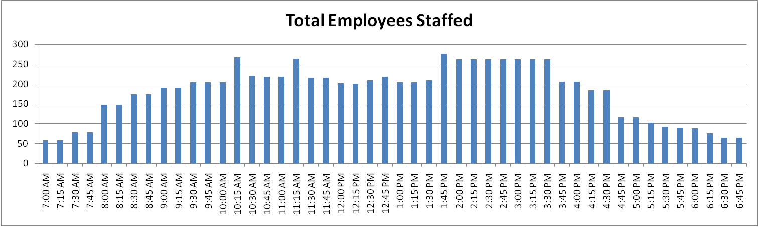



This shows that our model is working fairly well at performing its jobs of staffing based on estimated incoming calls for a given day.

Overall, we feel that we built a sufficient model in that we met the client’s expectations. By using our model, along with what Mr. Johnson called the “Gut Feeling”, we feel that the Federal Reserve Bank of Dallas could cut costs and still increase productivity of the agents for the call center.

**Contact Information**

**Personnel:**

**Alex Grosjean**

Program Developer

SMU Class of 2011

E-mail: [LinxuSx@gmail.com](mailto:LinxuSx@gmail.com)

**Brianna Bauer**

Program Developer

SMU Class of 2011

E-mail: [bbauer@smu.edu](mailto:bbauer@smu.edu)

**Dr. Jeffrey Kennington**

E-mail: [jlk@lyle.smu.edu](mailto:jlk@lyle.smu.edu)

**Dr. Tom Siems**

E-mail: [siems@lyle.smu.edu](mailto:siems@lyle.smu.edu)

**Contacts at Federal Reserve Bank:**

**Omar Johnson**

Business Reporting Analyst

Go Direct® Processing Center

E-mail: [Omar.Johnson@dal.frb.org](mailto:Omar.Johnson@dal.frb.org)

**Robert Mahalik**

Go Direct® Processing Center

E-mail: [Robert.Mahalik@dal.frb.org](mailto:Robert.Mahalik@dal.frb.org)