Spring
11
Lennox Industries: Attrition Probabilities
08
Fall
Maddie Kamp and Diana Batten Southern Methodist University Senior Design Project – Spring 2011
Table of Contents
Management Summary 1
Background and Description of Project 1
Analysis of the Situation 2
Technical Description of the Model 5
Analysis and Managerial Interpretation 9
Conclusions and Critique 10
Appendix I – “TTEST Std. Deviation and Manual Customer Groups” 11
Appendix II – “2008-2010 Quarterly Data – without percent correct” 12
Appendix III – “Three Period Outlook – 2010 Monthly” 13
Appendix IV – “ Three Period Outlook (Red, Red.Orange) – 2010 Monthly” 15
Appendix V – “Three Period Outlook (Reds Only) – 2010 Monthly” 16
Appendix VI – “Two Period Outlook – 2010 Monthly” 17

Management Summary
Lennox Industries is a residential and commercial heating and air-conditioning company. They currently have about 13-15% market share in about 80 countries. Lennox is unique in that they operate as both the manufacturer and distributer of their products. Thus, they sell directly to their customers, who are contractors in many cases, with no middle distribution company. This direct relationship to the customer means that they are responsible not only for bringing in their own customers, but also retaining their existing customer base. As a result, Lennox has realized that there is an opportunity to acquire a method to monitor customer transactions in order to be alerted of future attrition. If they can determine that a customer is showing signs of attrition, then a sales representative can contact the customer and proceed with steps that Lennox has in place for such an instance.
With this in mind, our project was to determine if there was any correlation of customers buying patterns in relation to attrition. We were given transaction level data for a core group of 4,500 customers spanning over the years 2008, 2009, and 2010. Over the course of our project we used Microsoft Access to organize the data and Microsoft Excel to analyze the data. Our final model deliverables for Lennox are in Excel format. We also included our updated Access data file of the organized transaction data. After organizing our data in Access into monthly, quarterly, and annual summaries of revenue per customer, we were able to move into Excel to analyze the data.
The first step of analysis was discovering which variables would be significant in predicting attrition. The most significant variable that indicates customer attrition is the dollar revenue amount. This conclusion was reached after logically eliminating the other variables through data mining and discussion with Rebecca Roberts. From this idea, we created our own rankings per period for the customers based upon revenue alone. These rankings were achieved through the Markov Process, which will be explained later in the report. This process also removed the seasonality from our data, which was an important step forward.
Through further examination of tracing the customers’ paths through the Markov rankings of each period, we were able to develop a method to conditionally format the signals of attrition within the Excel worksheet. The signals are based upon movement of the customer up-and-down the rankings. The parameters for attrition are customizable by the user. Finally, we were able to measure the percent correctness of our model. We were able to do this by looking three periods out from the first sign of attrition to verify that another signal of attrition occurred, i.e. they are still attriting. Therefore, if another signal of attrition occurred within three time periods of the initial trigger, then we count our assessment as a true forecast.

Background and Description of Project
About six months before we began the project, Lennox wanted to become more aware of when customers were leaving their system. As they do not sell their products on a contractual basis, they have no formal warning before a customer discontinues purchasing. It is important to note that about 1,000 customers drive nearly 60% of their revenue. Thus, they were rightfully concerned about customers leaving them with no warning. Lennox began to model the data that they had gathered in order to see what was happening. After that, they wanted to look forward and try to prevent customers from leaving by forecasting such attrition. Lennox Industries wanted this project to be a “proof of concept” on whether further investment in predictive analysis would be beneficial. In essence, our senior design project needed to examine buying patterns and determine if changes within them are indicators of attrition. If we could do that, then it would be possible to also create a system that would signal Lennox that a customer was attriting.
It is important to note that seasonality of sales is a significant factor within the heating and cooling industry. April, May, and June see a tremendous spike in sales figures for several reasons. First, people who are looking to replace their old unit would rather replace it before summer than risk having a breakdown in the middle of the hottest months of the year. Second, statistics show that people usually replace both their heating and cooling units together, so that would explain the significant increases in sales figures during those peak months before summer. Another reason may be that the housing market also increases in these months, as the summer is a good time during the year for families to move. Thus, in the months before summer each of these houses need heating and air-conditioning units too. These are just a few of the reasons for the seasonality of the industry. In examining our sales data, we could see huge fluctuations in our sales figures that indicated seasonality. One of our objectives was to find a way to account for the seasonality in our model so that the fluctuations wouldn’t corrupt our methods of recognizing attrition.
Another decision we had to face was how to define attrition because there were many options in the outset of the project. Attrition could mean a particular dollar amount drop in revenue, but that dollar drop may have different meanings for customers of different spending brackets. For example, some customers bring in $200,000 while others bring in $5,000. Attrition could also be interpreted as the number of periods in which no purchase was made. Or it could be the number of consecutive revenue drops. In this way, defining attrition was one of the decisions we had to consider.
We were also asked to determine what, if any, are the significant variables when it comes to forecasting attrition. The transactions we were provided with contained many variables: Disguised ID (Customer ID), Material Part Number, Sales Doc # (Order Number), Line Item, SaTy (Order Type), Date Created On, Net Value (Revenue), Order Quantity, and Customer Location among others. This involved getting familiar with the data and logically tracing out and discussing the contenders with Rebecca Roberts. Once we decided on our contenders, we needed to test them to see what would actually have a correlation.

Analysis of the Situation
Our general approach to the problem of forecasting customer attrition in Lennox began with data mining to organize the transaction level data we were given for 2008 through 2010 and to better familiarize ourselves with the task at hand. We sorted the data by month and by quarter for each customer in various ways in both Microsoft Access and Excel. From sorting the data, we also broke the customers up into groups based on their individual buying patterns so as to better analyze customers similar to one another. After we researched various models including discriminate model analysis, decision tree analysis, and decomposing the information to encompass seasonality, we decided to try and take seasonality out of our modeling to put all of the customers on a more even comparison basis. We wanted to accomplish this through using the Markov Process and initially testing overlap between final segments, also known as customer type, with T-tests. The Markov Process and breaking up the revenue data for each customer into deciles for each time period became the basis for our model in Microsoft Excel. We chose to do this because the deciles gave us a way to better analyze the data we were given in addition to better see drops in revenue and potential attrition of customers, while accounting for seasonality by entirely taking it out.
In Excel, our model helps management to see the “triggers” of when a customer may be attriting. We have broken up the calculations between multiple sheets within Excel workbooks that include calculations for the number of decile transitions from period to period, decile transition percentages and probabilities, conditional statements that allow the user to enter in the decile drop that they would like to view analysis for, and lastly what percent correct the analysis is for the conditional statements. In an additional Excel workbook, the percent ZMPO, or promotional orders, can be calculated for a given set of customer’s revenue data using both basic excel functions and pivot tables, which will both yield the same result. We kept both the pivot table analysis and excel functions so that the user can pick which type of analysis they prefer to work with. Also within this same workbook, the user can enter in the desired percentage for ZMPO orders, when compared to total orders for an individual customer that he or she would like to analyze. Currently, the percent ZMPO orders can be calculated for 12 periods, but this, as well as our other calculations, has the ability to accommodate longer or shorter time periods.
The assumptions we have had from the beginning of the project include that Lennox will provide us with all of the data to assist us in creating and testing an appropriate model. Additionally, if supplementary data is necessary for the completion of the project, we assumed that Lennox would provide that to our team.
One example of calculations in our percent ZMPO workbook is for customer C1. C1 has total 2010 revenue of $8,527,145.89. This is calculated from transaction level data entered in the initial worksheet using a SUMIF statement, or a pivot table, which both search for the unique customer identification number and sum the revenue for that customer. Additionally, 27.95% of C1’s orders are promotional, which is calculated by summing the transaction level data if the customer is C1 and if the order type is ZMPO using an IFERROR statement. A screen shot of one of the worksheets can be seen below. As mentioned previously, the user can enter in the percent wanted for ZMPO orders that he or she would like to analyze. In an additional worksheet the user can see which customers meet the criteria entered with a greater than or equal to percentage that the user entered. The user may also analyze data for customers based on filtering for location. This we thought was helpful because of the various weather patterns Lennox may encounter in different areas of the United States and Canada. A winter in Texas is very different than in New York or Minnesota, and therefore would cause different buying patterns across customers depending on their individual location.

Figure 1
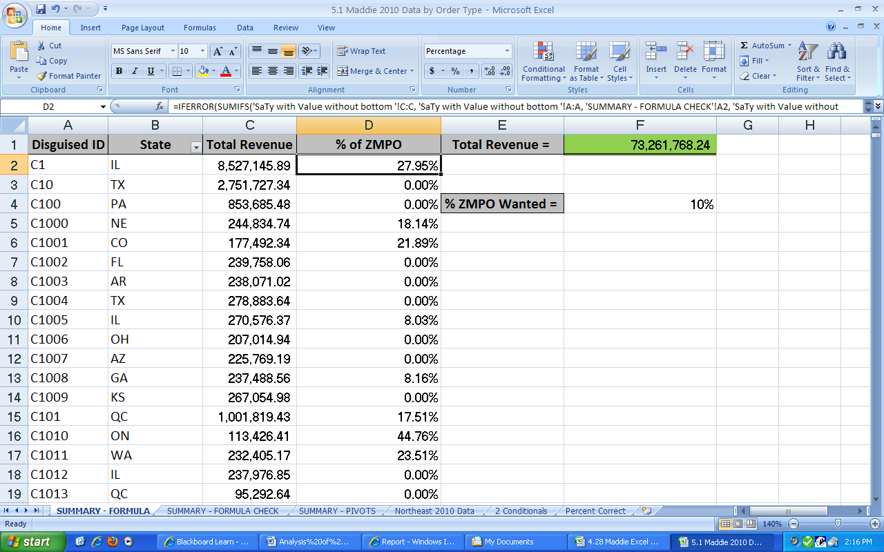
A second example can be seen in the screen shot below for customers. The user may enter in the number of decile drops they wish to see analyzed with the cells that are conditionally formatted in red. This conditional formatting will show the user periods over which the individual customer drops greater than or equal to the number entered by the user. Additionally, the user may enter in the numbers for which they wish to see customers that have sales greater than or equal to a specific decile, but then drop in the next period to a decile less than or equal to the second entry by the user. These cells are then conditionally formatted in purple in column C. We then have calculated for columns A and B to tell the user whether either of the criteria the user enters are met or not with true/false statements. For example, as seen below, customer C2038 dropped greater than 3 deciles between February and March 2008, and again between July and August 2008; therefore, both March and August are formatted red and column A says TRUE. However, C2038 is not highlighted purple because it did not drop from decile to 10 to 3 over one period, and so column B says FALSE.

Figure 2
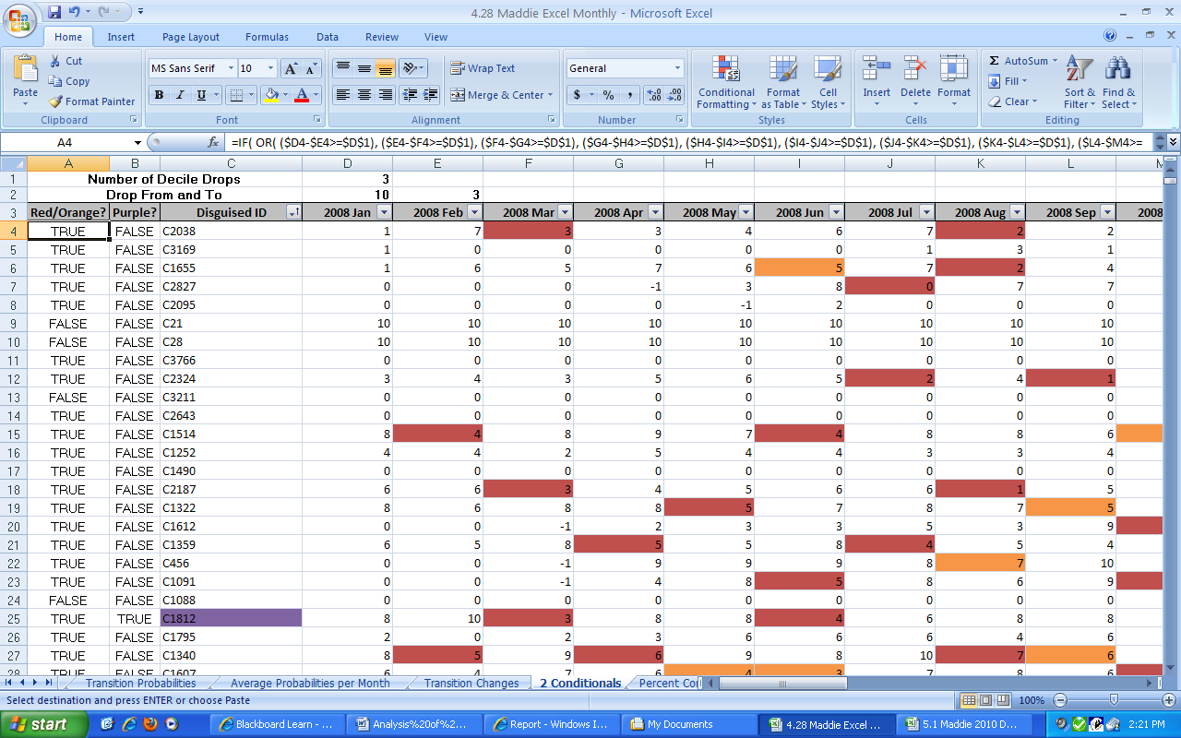

Technical Description of the Model
First, the transaction data needs to be summarized per customer over the chosen time period using Microsoft Access. Our file, “5.4 Data File,” shows the queries we used to pull information from in order to make our summary tables. Once a summary table is made in Access, it can then be exported into Excel. This data can then be plugged into our Excel model.
Our Excel models are stored in several different files. We have our T-test Excel workbook called “TTest and Std. Deviation and Manual Customer Groups,” our Attrition Excel workbooks, and our Regional Order Type Excel workbook called “Order Type and Geographic Region - 2010.” The Attrition Excel workbook has five different formats: “2008-2010 Quarterly Data without Percent Correct,” “Two Period Outlook – 2010 Monthly,” “Three Period Outlook – 2010 Monthly,” “Three Period Outlook (Red Only),” and “Three Period Outlook (Red, Red/Orange).” As the model is explained, we will reference the appropriate workbook and convey the appropriate Appendix to refer to.
Though the T-test isn’t a part of our actual model and it isn’t automated to update based upon new revenue information the way that our other files do, it is important to include because it helped us to understand the Final Segment categorization better. TTEST is a function in Excel which helps to determine how likely it is that two samples have come from the same two underlying populations. The larger the number, the more overlap there is in the populations of the samples that are being compared. We originally thought that both the Final Segment categorization and the Net Value (revenue dollars) would be the two values that would help us to build a predictive model; however, once we examined the data closer, it became apparent that something was not accurate with the Final Segment assignments. The following is how we dealt with that uncertainty about the Final Segment assignments. When the excel workbook, “TTest and Std. Deviation and Manual Customer Groups,” is opened you will see that it has ten sheets in it. Refer to Appendix I. The two sheets which are most important are called, “2008-2010 Without Bottom 10%,” and “TTEST & STDEV.” First, we took out the bottom 10% of revenue earners in order to remove the “outliers” from our equations as was recommended to us by Rebecca Roberts. This bottom 10% was calculated in the “Comparison 2008-2010 Quarterly” sheet by calculating the SUM of all three years revenues for each customer and then computing which customers were in the bottom 10% of that.
Once we had those customers and their Final Segment categorization, we were able to use that information to build T-test matrices for each quarter for 2010. These matrices were built to test by how much the Final Segment categorization overlaps in the sample revenue amounts. In the “TTEST & STDEV,” there are matrices to calculate this; the closer that the number is to 1, the more overlap exists. If the number is 1, then it perfectly overlaps and thus is the same sample revenue population. Hence, the diagonal is all 1s. If you scroll down, then you will see a set of matrices titled “TTEST Results WITHOUT Bottom 10%.” This is the set that you want to examine.
From the TTEST matrices we learned that some of the categories have a significant overlap. We brought this information to Rebecca Roberts and learned that a customer can have multiple categories. We also learned that the categories are re-assigned each year, so the T-test’s for the years before 2010 would be incorrect assignments of the categories. Thus we removed those T-test’s from our final product. We also learned that Lennox will soon begin updating those Final Segments every six months as opposed to every year. Given all of this information, we decided that the Final Segments category was not reliable and steady enough to use as an input in our attrition analysis.
Thus, we began to think about ways to create our own segments of customers based upon revenue alone. At the same time, we needed to consider the seasonality of the data and how that would affect a model. This is how we came to decide upon the Markov Process. We have several versions of this process for Lennox. We first started by applying it to both quarterly and monthly data, but later were advised by Rebecca Roberts to focus upon the monthly data. For this reason the quarterly data in the workbook “2008-2010 Quarterly Data – without percent correct” is not as complete a model as the monthly data. Refer to Appendix II. The monthly data calculates how correct the model is and the quarterly does not have that in it due to time constraints. We will walk you through the workbook called “Three Period Outlook – 2010 Monthly” to describe the way the model works because we believe that this is the version that gives the most accurate results. Refer to Appendix III. The differences available in the other workbooks will be explained further on.
Upon opening the workbook, the first sheet is called “Starting Data.” This is where the information on your customers can be inserted into the model. It is important to note that every other column is calculating the appropriate decile for that specific customer in that time period. The formula used to calculate the appropriate decile is: =ROUNDUP(PERCENTRANK(BC$2:BC$3928,BC2,),1)*10. The possible assignments for deciles are 10, 9, 8, 7, 6, 5, 4, 3, 2, 1, and 0. We also chose to manually insert -1s as deciles in the period before a new customer arrives. This way we can keep track of when a customer is first arriving versus the customer left Lennox for a time and is now buying again.
It is important to note that from here the rest of the sheets will automatically update for the appropriate decile information because they are linked. The deciles will get stored in the “Deciles – Monthly” sheet. Then the number of transitions from month to month will be calculated in the “Transitions” sheet. Here is an example of the formulas within the number of transition matrices: =COUNTIFS('Deciles - Monthly'!$B$2:$B$4081,10,'Deciles - Monthly'!$C$2:$C$4081,9). This particular formula is calculating the number of 10s in column B of the “Deciles – Monthly” sheet which also have a 9 in column C. Thus, it displays the number of decile 10s that move to decile 9s in one quarter. The rest of the sheet does the same type of formula.
Then there are two sheets which are slightly different. The “Transition Percentages” sheet calculates the number of customers out of all of the customers who move from a specific decile to another specific decile. The formula used is: =Transitions!B3/Transitions!$N$3. This basically signifies the number of customers who moved from a 10 to a 10 in one quarter divided by the total number of transitions in the relevant Transition matrix. For example, 3.50% of all the transitions that happened from Jan 2008 to Feb 2008 were movements from a decile of 10 to a decile of 10. The “Transition Probabilities” sheet is a different measurement. It measures that out of the people who start out as a certain decile, that particular percentage becomes this other particular decile. For example, in transition from Jan 2008 to Feb 2010, 6.71% of the customers who started as a decile of 10 in Jan dropped to a decile of 8 in Feb.
To make the probabilities more meaningful and applicable in the business sense, we also calculated the average probabilities per month across time. This is in the sheet titled, “Average Probabilities per Month.” Another potentially useful calculation is in the “Transition Changes” sheet. This simply displays the decile change up or down from month to month for each customer. Here is the formula used: =IF('Deciles - Monthly'!C2=-1,"",'Deciles - Monthly'!C2-'Deciles - Monthly'!B2). Notice that it is a decile change amount and that if the customer was marked -1, or new arrival, the previous period then no change is recorded yet. This way the numbers are not skewed with new arrivals going from a -1 to 10 which would have recorded an 11-decile increase for that customer.
Finally we reach the three sheets which are the most important in our model. “2 Conditionals” and “Test” sheets have three conditional formulas within them. One displays the orange color when a customer drops deciles in three consecutive periods. The basic formula for the oranges (taken from the “2 Conditionals” sheet) is: =AND(($F4<$E4),($E4<$D4)). The red color is displayed when there is a consecutive period with a decile drop greater than or equal to the number that the user selects to enter into the D1 cell. The basic formula for the reds (taken from the “2 Conditionals” sheet) is: =($D6-$E6>=$D$1). The purple color is displayed in the Disguised ID column when there is are consecutive periods in which the first period is greater than or equal to the number that the user selects to enter into the D2 cell and the second period is less than or equal to the number that the user enters into the E2 cell.
Once we got the attrition “triggers” to work correctly, we just needed to figure out how to test the correctness of our model. To do so we created the “Test” sheet. Within this sheet, to the right of the decile columns for each period, we used additional columns to hold the values TRUE or FALSE for whether the customer actually attrited. A sample of that formula is: =IF(AND(E4=FALSE,G4=FALSE), (IF( IF( OR( (H4-J4>=$D$1), AND((J4<H4),(H4<F4)) ), TRUE, FALSE)=TRUE, IF( OR( AND((N4<L4),(L4<J4)), AND((L4<J4),(J4<H4)), AND((P4<N4),(N4<L4)), (L4-N4>=$D$1), (J4-L4>=$D$1), (N4-P4>=$D$1)), TRUE, FALSE), FALSE)), FALSE). This basically says, if this is the first “trigger” of attrition from the customer (i.e. if all the columns before it are false and the cell after it is red or orange), then check the three periods out from there and see if an orange or red sign of attrition appears again. If a second sign of attrition appears within the next three periods then our model was correct and the customer did attrit. If within three periods after the initial “trigger,” there is not a red or orange cell, then that means that the first signal was essentially a “false-positive” and our model errored. It is important to note that we had to limit the “Test” sheet to Nov 2009 through Dec 2010 because excel reached its processing limit with this particular formula over all three years.
To calculate the actual percent correctness of our model, we created the “Percent Correct” sheet. This calculation is done in two instances. The first is in calculating the Red/Orange Attrition. We created a column in the “Test” sheet which returns TRUE if the Red or Orange conditional formula is met. The formula for this statement is simply an extension of the above formulas in that it checks for each instance in each column. Then by counting all of the TRUEs in that column, we know the number of customers that our model labeled as attriting according to the attrition rules of the Reds (Number of Decile Drops) and of the Oranges (Three Consecutive Periods of Drops). Then we count the TRUEs from all of the columns formulas listed in the above paragraph. By dividing the two, we obtain the percent correct assessment of our model for that particular decile drop amount.
In a similar fashion, the purple (Drop From and To) can be tested to see what percent actually did attrit. If the customer with the purple indicator displays a red or orange within three periods then it did actually attrit. The number of customers for which this happened is calculated as “Count if Attrition” with the formula: =COUNTIFS(Test!E4:E3930, TRUE, Test!B4:B3930, TRUE) + COUNTIFS(Test!G4:G3930, TRUE, Test!B4:B3930, TRUE) + COUNTIFS(Test!I4:I3930, TRUE, Test!B4:B3930, TRUE) + COUNTIFS(Test!K4:K3930, TRUE, Test!B4:B3930, TRUE) + COUNTIFS(Test!M4:M3930, TRUE, Test!B4:B3930, TRUE) + COUNTIFS(Test!O4:O3930, TRUE, Test!B4:B3930, TRUE) + COUNTIFS(Test!Q4:Q3930,TRUE, Test!B4:B3930, TRUE) + COUNTIFS(Test!S4:S3930,TRUE, Test!B4:B3930, TRUE) + COUNTIFS(Test!U4:U3930,TRUE, Test!B4:B3930, TRUE) + COUNTIFS(Test!W4:W3930, TRUE, Test!B4:B3930, TRUE) + COUNTIFS(Test!Y4:Y3930, TRUE, Test!B4:B3930, TRUE) + COUNTIFS(Test!AA4:AA3930,TRUE, Test!B4:B3930, TRUE). Thus, it only counts the customer if it is both purple and red/orange.
Once we figured out how to make all of these calculations, we tested out a few other things to see if it improved the correctness of our model. In fact, we had originally tested the correctness of our model based on a two period outlook, but then when we tried the three periods it gave a much better percent correctness. Refer to the “Two Period Outlook -2010 Monthly” in Appendix VI. We also realized that the “Three Period Outlook – 2010 Monthly” workbook was really testing the percent correctness that reds and oranges would show red and/or orange signs of attrition. We thought that maybe we should test for the percent correctness that just reds would show red and/or orange signs of attrition. This is evidenced in the excel workbook “Three Period Outlook (Red, Red.Orange) – 2010 Monthly.” Refer to Appendix IV. It turns out that this model is a little less correct than our previous one. Then we thought to try just percent correctness of reds to reds. We did this in the excel workbook “Three Period Outlook (Reds Only) – 2010 Monthly.” Refer to Appendix V. We found that the percentage correct was even weaker with reds only. Thus, we recommend using the “Three Period Outlook – 2010 Monthly” workbook as that model has the best percent correctness.
The “Order Type and Geographic Region – 2010” was not part of the final model in the same way as the Two or Three Period Outlook; however, we thought again it was an important file to include in the deliverables because of its potential to extend to other data Lennox may have or further analysis. The user can enter in transaction level data on the “Starting Data” sheet, including the Disguised ID, SaTY, and Revenue from the particular order. Then additional information also must be entered on the second sheet “Summary-Formula” including the Disguised ID and state the customer is in. From there, in “Summary-Formula,” the total revenue dollars for the year for each customer is calculated using the formula =SUMIF('STARTING DATA'!$A$1:$A$65535, 'SUMMARY - FORMULA'!A2, 'STARTING DATA'!$C:$C). Additionally, the user has the ability to enter in the percent of a customer’s orders that are ZMPO that they wish to analyze. Therefore, the percent ZMPO is then calculated using =IFERROR(SUMIFS('STARTING DATA'!C:C, 'STARTING DATA'!A:A, 'SUMMARY - FORMULA CHECK'!A3, 'STARTING DATA'!B:B,'SUMMARY - FORMULA CHECK'!$D$1)/C3,0). The IFERROR checks to see if there are orders that are ZMPO and calculates the percentage if this statement is true, otherwise the statement returns zero. These calculations can also be done using pivot tables, which will yield the same results and are also shown in the workbook.

Analysis and Managerial Interpretation
We were originally concerned with the variability in buying patterns from period to period as we began to look at monthly data. So, the creation of our worksheet that calculated percent ZMPO and is able to sort by state was in the hope that we could group customers based on their geographic location and their order types to limit the amount of variability and jumping from decile to decile each period. However, we found that the variability did not necessarily decrease. We looked at customers in the Northeast, according to the states listed by the Census Bureau, and then at customers whose percent ZMPO ordering was greater than x% in 2010. There were less than 10 customers that were in the Northeast that had greater than or equal to 10% ZMPO orders, and less than 5 customers that were in the same location but had greater than or equal to 20% ZMPO orders (out of approximately 360 customers in the area). The variability in purchasing patterns continued and was not consistent between ZMPO purchasers and non-ZMPO purchasers. Even limiting the geographic location to analyzing customers in the Northeastern states buying patterns were still scattered. This means that the order types for customers do not necessarily help to show consistency for customers, and this is not a big contributing factor to attrition in our model. Our recommendation is also similar for looking at data by geographic location monthly. Because the data is erratic, for more consistency it is better to analyze longer time periods such as quarterly data.
Additionally, with our most recent analysis, which included looking at data that had decile drops between periods, we completed some test cases to explain and use as examples. From this analysis, of which the background was explained in the technical description of our model, we concluded that there is a higher percentage of correctness when using the three period outlook model. This statement is true for both the percent correct from “Number of Decile Drops” and “Drop From and To,” both of which the variable is entered by the user. Our recommendation to management is to be more proactive rather than waiting three periods before acting with a sales team. With a higher percentage of correctness in our model, this means there was more attrition with customers, or at least the customer had not improved deciles over three periods, but rather was in a lower decile three periods out than when the trigger went off. We also found that incorporating all of our triggers (red and orange conditional formatting) was the most correct in prediction as well. Simply using just the red indicators and looking two or three periods out gave the least percentage correct in predicting attrition, and looking at red turning into red or orange in the future by two or three periods was higher, but not quite as high of a percentage as using both red and orange indicators as triggers and then using them again as an assessment two or three periods out. Therefore, we additionally recommend using all of the triggers within our model, both red and orange, rather than simply using one or the other to better predict attrition because there are higher percentages of correct predictions using both.
Overall recommendations to management:
- Use the three period outlook for higher percentages in “Percent Correct”
- Use both the red and orange indicators as triggers of attrition
- Expand analysis to other geographic locations and potentially other order types (not just ZMPO)

Conclusions and Critique
Overall, we found that the most important part of our work and benefit to Lennox is the ability for customization. The user has the ability to enter in his or her preferences for defining attrition with the decile drops and can look at how the data is affected two or three periods into future periods, which the workbooks we created automatically calculate the numbers the user wishes to see. This leaves Lennox with ability for expansion on our work to incorporate more customers’ data, expansion out to other geographic locations or order types, and overall to view the data in many different ways depending on what the user is interested in analyzing. The different entries a user may enter will then affect the “percent correct” variable we have defined.
Based on our analysis and testing of various cases, we recommend to management to expand our work to encompass more of their customers and test the new data to see the various outcomes that the triggers we have set in place give. The analysis shows that there is potential for management and the sales team to catch customers before he or she begins to attrite, which a proof of concept is one of the overall goals.
However, at the end of our calculations and analysis, we found that we could not have both the two and three period outlooks in the same workbook because the calculations were becoming too much for Microsoft Excel to handle and processing and calculation times were long. Therefore, because of the processing limitations in Excel, we would recommend trying to move the analysis to another program that can process more information, such as SAS, for further study if trying to incorporate additional large amounts data or more calculations.

Appendix I – “TTEST Std. Deviation and Manual Customer Groups”

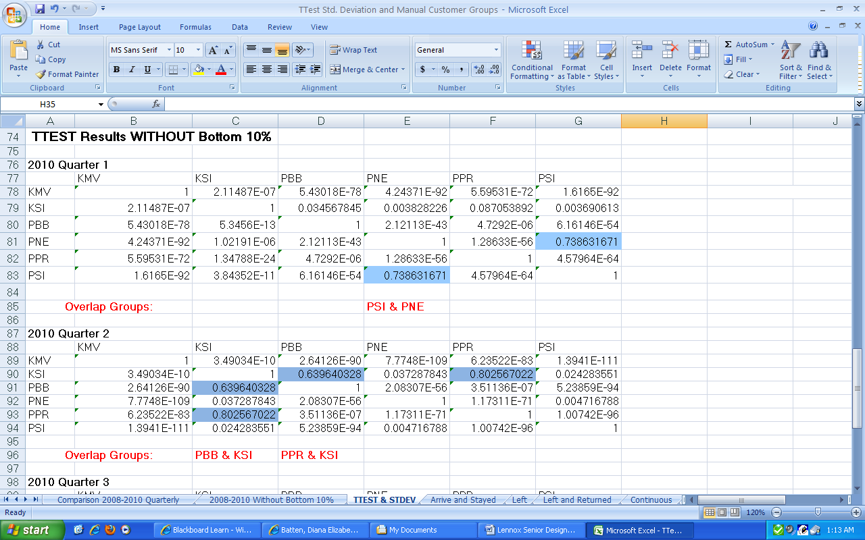

Appendix II – “2008-2010 Quarterly Data – without percent correct”

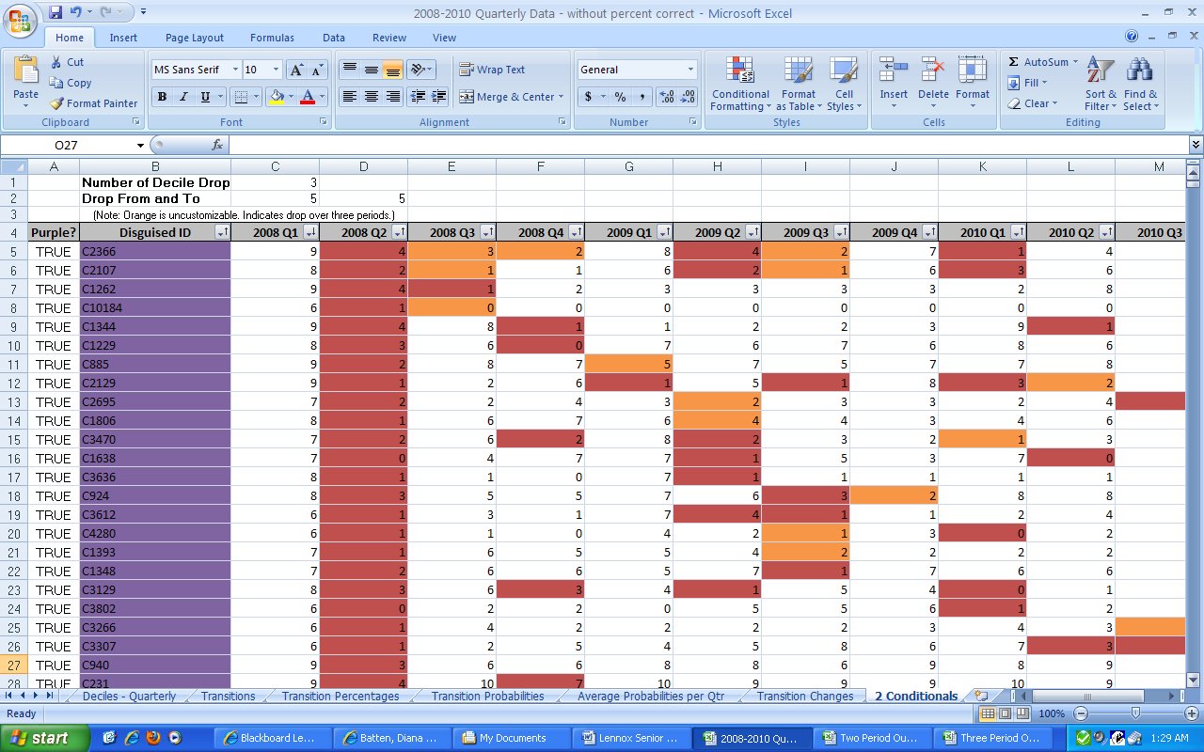

Appendix III – “Three Period Outlook – 2010 Monthly”

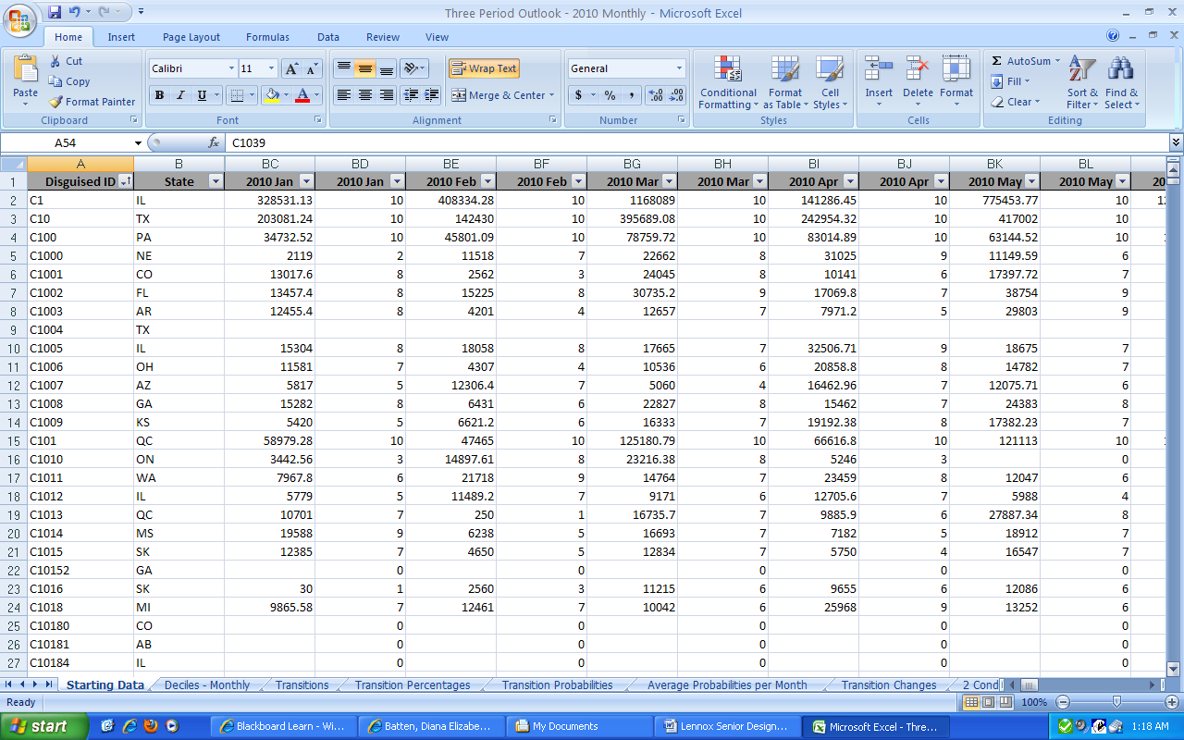
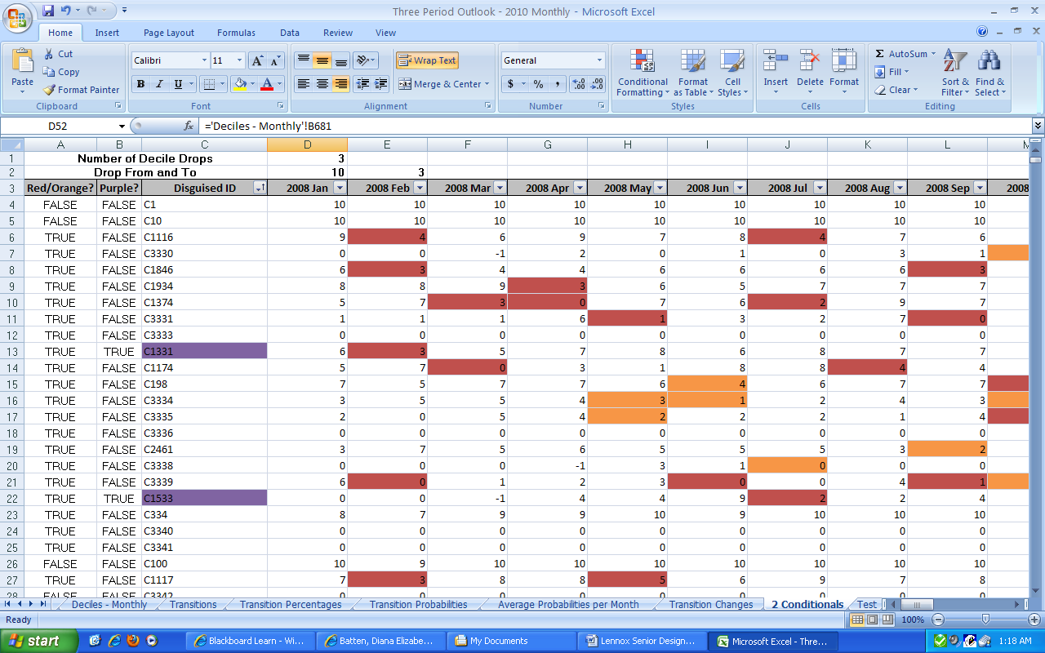
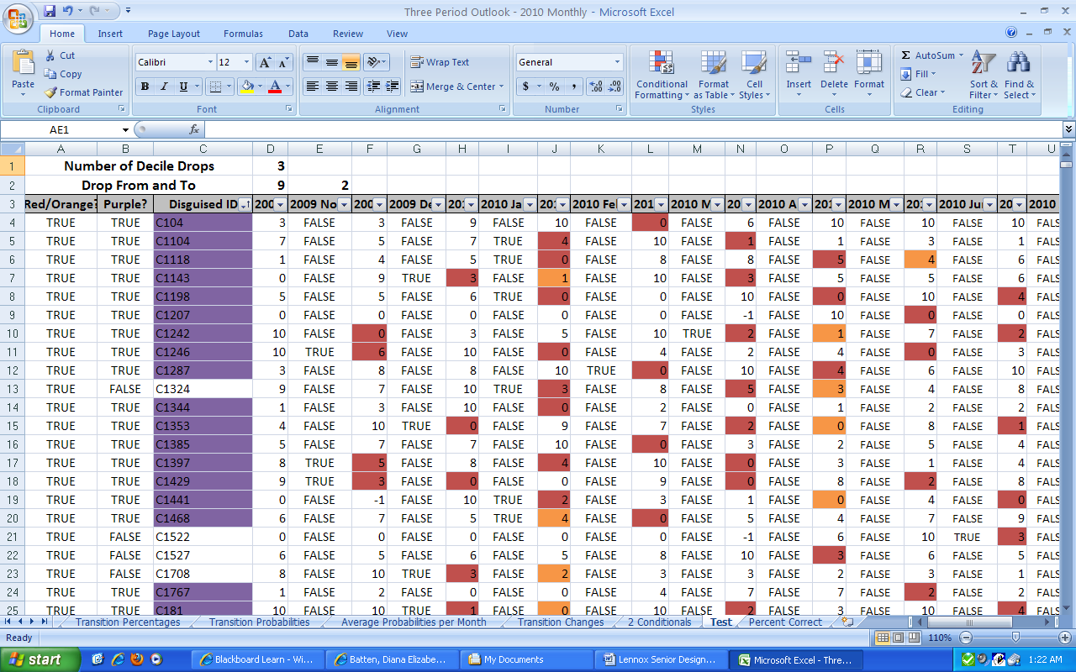
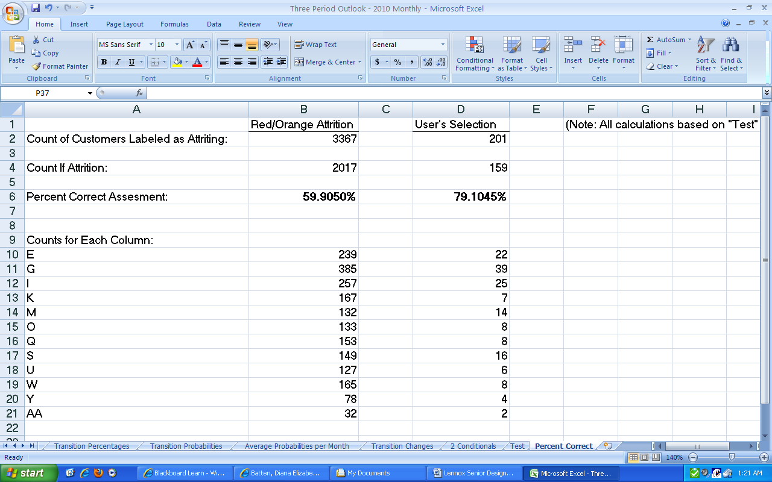

Appendix IV – “ Three Period Outlook (Red, Red.Orange) – 2010 Monthly”

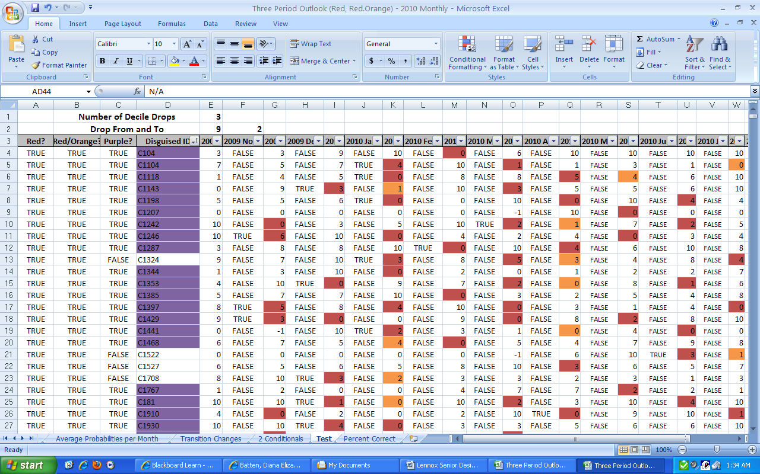
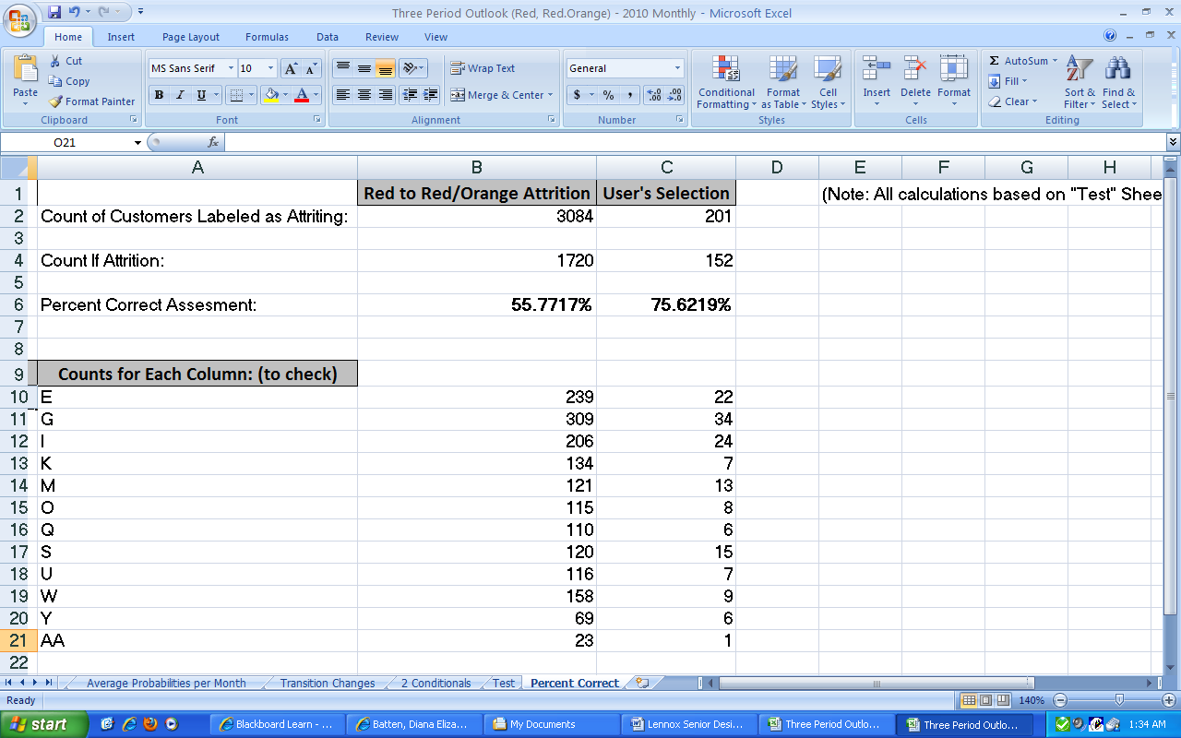

Appendix V – “Three Period Outlook (Reds Only) – 2010 Monthly”

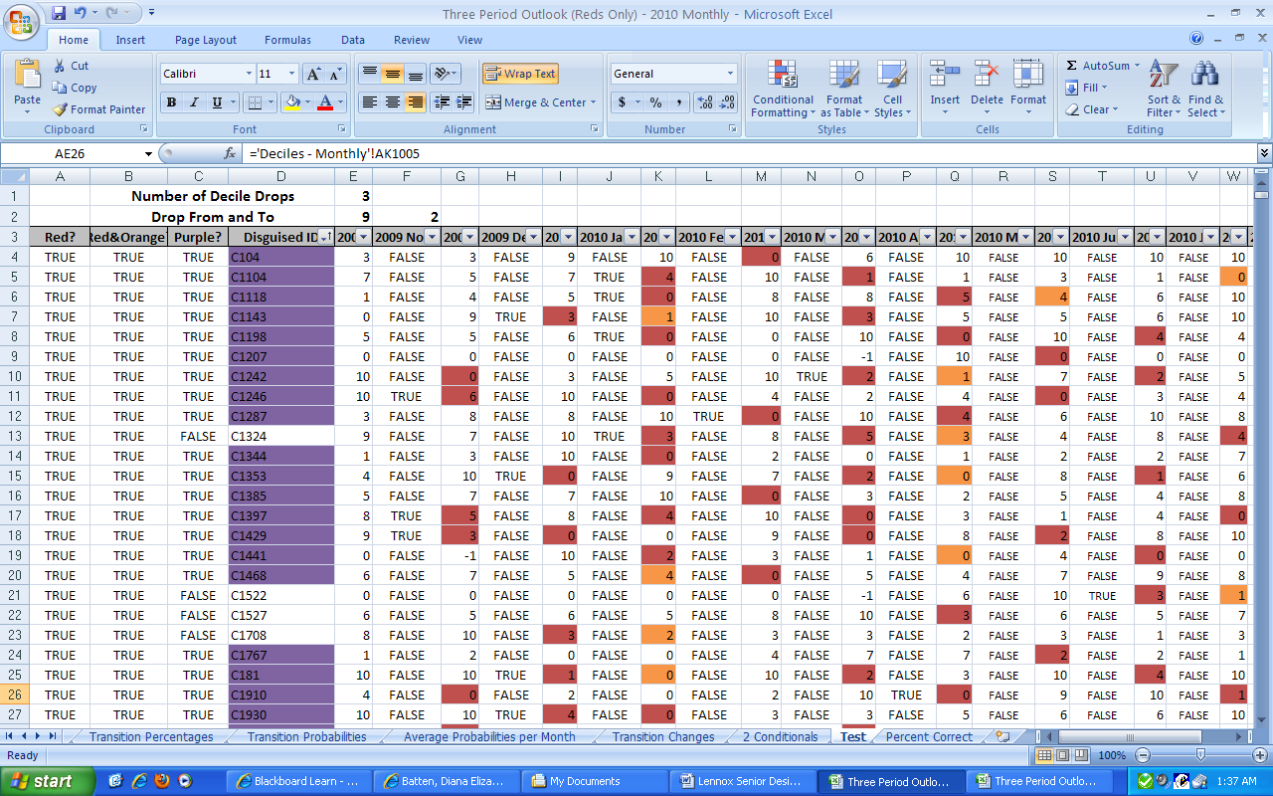
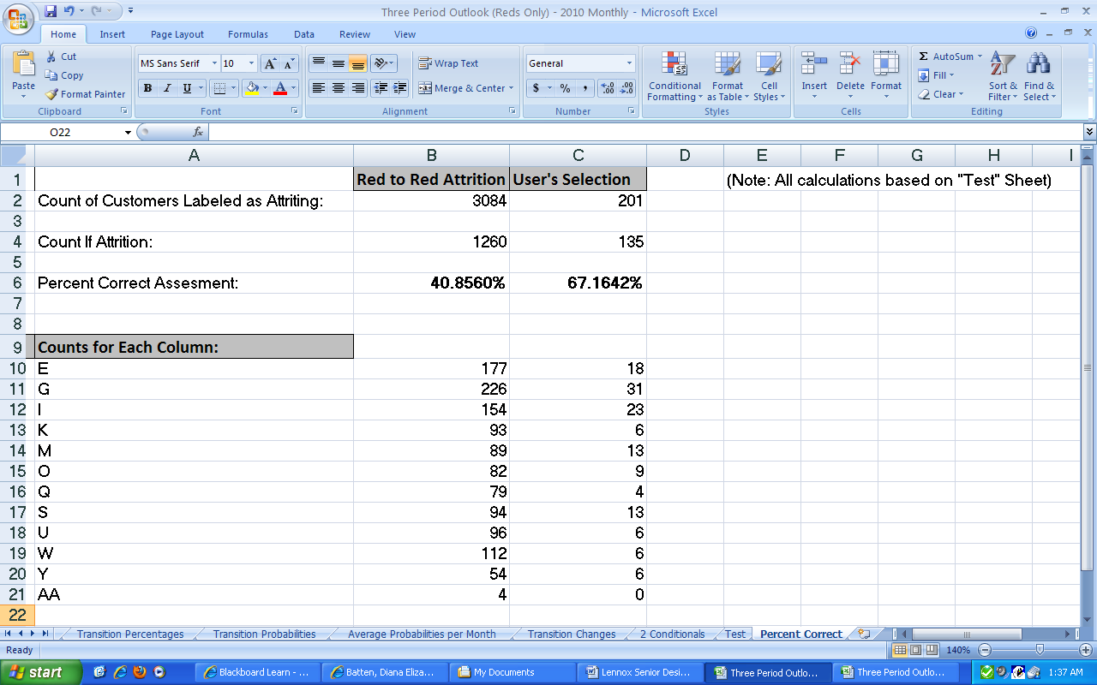

Appendix VI – “Two Period Outlook – 2010 Monthly”

